**Sustainable Livelihood Program Management Information System with SMS Notification**

A Capstone Project Proposal

Presented to the

Faculty of College of Computer Studies

Laguna State Polytechnic University

Santa Cruz Campus

In Partial Fulfillment of the Requirements for the Degree

**BACHELOR OF SCIENCE IN INFORMATION TECHNOLOGY**

By

**GABATBAT JOEVIC C.**

**MERCADO AIDAN P.**

**SOLIS SYAN KARVIY M.**

**VISION**

The Laguna State Polytechnic University is a center of sustainable development initiatives transforming lives and communities.

**MISSION**

LSPU provides quality education through responsive instruction, distinctive research, sustainable extension, and production services for improved quality of life.

**QUALITY POLICY**

LSPU provides quality education through responsive instruction, distinctive research, sustainable extension, and production services. Thus, we are committed with continual improvement to meet applicable requirements to provide quality, efficient and effective services to the university stakeholders’ highest level of satisfaction through an excellent management system imbued with utmost integrity, professionalism, and innovation.

**GOALS OF THE COLLEGE OF COMPUTER STUDIES**

The College of Computer Studies aims to develop globally competitive graduates equipped with the knowledge, skills, and values necessary for Information Technology Education programs undertaking instruction, research, extensions and production.

**OBJECTIVES OF BACHELOR OF SCIENCE IN INFORMATION TECHNOLOGY**

**Instruction**

1. To provide theoretical and technical skill through instruction, seminars, and workshops.
2. To expose students to globally competitive IT atmosphere.
3. To develop locally and globally competitive graduates with desirable work values and attitudes.
4. To initiate creative and innovative professional enhancement among instructors and student through skill training, on-the-job training industry.

**Research and Development**

1. Strengthen competencies of both instructors and students in the field of research that will serve as a basis for technological problem-solving.
2. Conduct information technology survey, interview and feasibility studies meet the demands of the changing world through information technologies and processes.
3. Produce IT researchers to serve as a self-generating critical mass of human resources for research and development in Information Technology area.

**Extensions**

1. Forge critical linkage with local and foreign partners to support the activities of the department.
2. Conduct outreached program such as basic and advance computer literacy program and the like.
3. Create training plans and information technology packages to supply the need of the community.
4. Provide assistance for the project development.

**Production**

1. Produce information system and technologies that can be used as an income generating project of the college.
2. Produce information system and technologies that can be used as an income generating project of the college.

****Republic of the Philippines

Laguna State Polytechnic University

Province of Laguna

**COLLEGE OF COMPUTER STUDIES**

**APPROVAL SHEET**

This Capstone Project entitled **“Sustainable Livelihood Program Management Information System with SMS Notification”** prepared and submitted by **Gabatbat Joevic C., Mercado Aidan P.** and **Solis Syan Karviy M.** in partial fulfillment of the requirements for the degree Bachelor of Science in Information Technology is hereby recommended for approval and acceptance.

**MIA VILLARICA, DIT**

Adviser

Date

=============================================================

APPROVED by the Committee on Final Oral Examination with a grade of ____ on **_________.**

**ALLIANA M. ABLAN**

Technical Editor

**MARK BERNARDINO, MSCS**

Specialization Expert

**MARIA LAUREEN MIRANDA**

Chairman

**CEAZAR D. PAMIN, Ph. D.**

Language Critic

**BENJAMIN ARJONA, Ed. D**

Statistician

=============================================================

ACCEPTED and APPROVED in partial fulfillment of the requirements in Bachelor of Science in Information Technology.

Date

**REYNALEN C. JUSTO, MM-ITM, LPT**

Associate Dean, CCS

**RINA J. ARCIGAL, Ed. D**

Chairperson, Research and Development

Research Contribution Number

**ACKNOWLEDGEMENT**

The researchers would like to express their special thanks and deepest gratitude to the honorable people who gave guidance and support in their journey and for having a golden opportunity to complete their task throughout the completion of the study.

To **MIA V. VILLARICA,** Research Adviser, we thank her for giving us her guidance and support for our thesis.

To **MARK BERNANDINO,** Subject Specialist, we thank him for his advice in the betterment of our system.

To **ALLIANA M. MIRANDA,** Technical Editor, we thank her in making our thesis paper better than we ever could.

To **CAEZAR PAMIN,** Language Critic, we thank him for making our thesis paper right.

To **BENJAMIN ARJONA,** Statistician, we thank him for the calculations made in our thesis.

To the **PANELISTS,** we thank them for giving us the chance to present our study.

To the **DSWD office** and the **HEAD OF MSWDO,** Client, we thank them for accepting and approving as our clients and in giving their full cooperation during the testing and evaluation of our system.

To the **RESPONDENTS,** we thank them for giving us their time in their busy schedule to help us in our evaluation.

To our **FELLOW CLASSMATES** and **SCHOOLMATES** especially **TYRON, BENZ, EUGENE, JOELSON** and **OLIVER,** we thank them because without them, we might not have been able to finish our thesis on time.

To our **FRIENDS** particularly **BENZ,** we thank them for giving us their help without any hesitation.

To **FAMILY,** our **PARENTS, SIBLINGS,** and **RELATIVES,** we thank them with all our heart for believing in us and giving all their unconditional love and never-ending support in finishing our studies. We love you all!

To our **ALMIGTHY GOD** and **CREATOR OF ALL,** we thank Him for keeping us safe throughout our journey and giving us the strength and guidance, we needed for the success of our study. To God Be the Glory!

**Abstract**

The study entitled “Sustainable Livelihood Program Management Information System with SMS Notification” falls under the e-government that utilizes the use of information technology to improve the services provided by the government to the public. Through the use of the research methodology which is the Agile Model, the system called “Sustainable Livelihood Program Management Information System with SMS Notification” was developed. The study focused on providing the citizen of Sta.Cruz, Laguna with online registration for different programs under the Sustainable Livelihood Program in which they were able to choose what preferable program they want, to centralize all of the data and information of different livelihood programs in the Municipality of Sta. Cruz, Laguna and to reduce the volume people who comes back and forth just to file their request and forms for the program. To evaluate the said system, a total number of 30 respondents were asked to answer the questionnaire provided by the researchers. The researchers used Technology Acceptance Model with the combination of ISO for the evaluated questionnaire and Black Box Testing for software testing. Purposive sampling technique was used by the researchers in order to produce a sample out of the respondents that have been chosen. As for the results of the evaluation, the researchers used the Likert Scale in order to evaluate the user acceptance of the developed system whether it helps to improve the current process of the client positively. The overall result of the criteria used in the questionnaire is 4.441 and the verbal interpretation is highly acceptable.

**Keywords:** Sustainable Livelihood Program, e-government, Technology Acceptance Model, Black Box Testing, Purposive sampling

**TABLE OF CONTENTS**

**Preliminaries Pages**

Title Page …………………………………………………………...…...…......i

Vision, Mission, Quality Policy, Goals and Objectives ……………….….......ii

Approval Sheet ………………………………………………………...…......iii

Acknowledgement ……………………………………………………............iv

Abstract …………………………………………………………………….....v

Table of Contents ...…………………………………………………………..vi

List of Tables ……………………………………………………………….viii

List of Figures ………………………………………………………...……...ix

List of Appendices……………………………………………………………..x

Definition of Terms ……………………………………………..…………....xi

**Chapter**

**I INTRODUCTION**

* Project Context………………………………………………………...2
* Research Objective…………………………………………………….4
* Conceptual Framework………………………………………………..5
* Project Purpose………………………………………………………...6
* Scope and Limitation of the Study…………………………………….7

**II REVIEW OF RELATED LITERATURE**

* Synthesis……………………………………………………………...52
* Tech gap analysis………………………………………………….....51

**III RESEARCH METHODOLOGY**

* Research Design……………………………………………………...55
* Population of the Study………………………………………………55
* Sampling Design……………………………………………………..56
* Data Collection Instrument…………………………………………..57
* Statistical Treatment………………………………………………….58
* Project Design…………………………………………………..........60

**IV RESULTS AND DISCUSSION**

* Research Objectives…………………………………………….........73

**V SUMMARY, CONCLUSION AND RECOMMENDATION, AND LITERATURE CITED**

* Summary……………………………………………………………..95
* Conclusions…………………………………………………………..95
* Recommendation……………………………………………………..96

**BIBLIOGRAPHY**…………………………………………………..97

**LIST OF TABLES**

**Tables**

1. Population of respondents…………………………………………………………56

2. Likert Scale………………………………………………………………………..59

3. Testing table……………………………………………………………………….65

4. Testing table……………………………………………………………………….66

5. Testing table……………………………………………………………………….67

6. Tester table………………………………………………………………………...67

7. Quality Factors…………………………………………………………………….68

8. Perceived Ease of Use……………………………………………………………..68

9. Experience……………………………………………………………....................69

10. Perceived Usefulness…………………………………………………………….69

11. Attitude Towards Using………………………………………………………….70

12. Behavioural Intention to Use……………………………………………………..70

13. Actual Use………………………………………………………………………..71

14. Black Box Testing result…………………………………………………………79

15. Black Box Testing result…………………………………………………………80

16. Black Box Testing result…………………………………………………………81

17. Quality Factors result…………………………………………………………….83

18.Perceived Ease of Use result……………………………………………………...85

19. Experience result…………………………………………………………………86

20. Perceived Usefulness result………………………………………………………87

21. Attitude Towards Using result………………………………………...................89

22. Behavioural Intention to Use result………………………………………………90

23. Actual Use result…………………………………………………………………92

24. Overall Result…………………………………………………………………….93

**LIST OF FIGURES**

**Figures**

1. Conceptual Framework………………………………………………………..5

2. Agile Methodology…………………………………………………...............61

3. (TAM) Technology Acceptance Model……………………………………...63

4. Black Box Testing……………………………………………………………64

5. Requirement phase…………………………………………………………...75

6. Design phase………………………………………………………………….76

7. Development phase…………………………………………………………..77

8. Testing phase…………………………………………………………………77

9. Black Box Testing Proof……………………………………………………..82

10. Black Box Testing Proof……………………………………………………..82

**LIST OF APPENDICES**

1. **Technical Background**
2. **Planning and Requirement Analysis Phase**

* Transcribed Interview
* Current Process Flow
* Proposed Process Flow
* Use Case Diagram

1. **Specification and Design Phase**

* System Context Diagram
* Data Flow Diagram
* Data Dictionary

1. HIPO Model
2. Project Schedule
3. Hardware and Software Resources
4. Input, Output, Report Screenshots
5. Testing and Evaluation Instruction
6. User’s Manual
7. Source Code
8. **Communication Letters and Forms**

* Request Letters
* Preproposal Approval
* Recommendation for FOD

1. **Curriculum Vitae**

**DEFINITION OF TERMS**

To understand and clarify the terms used in the study, the following are hereby defined:

**Operational Terms**

* A person responsible for running a business, organization, etc.

**Admin**

* A person who uses a computer or network service.

**User**

* Are designed to help users through a multi-step process.

**Progress tracking**

* Stands for “Short Message Service” is used to send text messages to mobile phones.

**SMS**

* Refers to a computer system consisting of hardware and software that serves as the backbone of an organization’s operations.

**Management Information System**

**Technical Terms**

* An electronic device for storing and processing data, typically in binary form, according to instructions given to it in a variable program.

**Computers**

* Is a process by which a team can manage a project by breaking it up into several stages and involving constant collaboration with stakeholders and continuous improvement and iteration at every stage.

**Agile Model**

* Is a widely-used open source general-purpose scripting languagethat is especially suited for web development and can be embedded into HTML.

**PHP**

* Is an open source relational database management system. It is based on the structured query language, which is used for adding, removing, and modifying information in the database.

**MySQL**

* Is an information systems theory that models how users come to accept and use technology.

**Technology Acceptance Model**

* Is a method of software testing that examines the functionality of an application without peering into its internal structures or working.

**Black Box Testing**

**CHAPTER I**

**INTRODUCTION**

Today in a modernized world, technology is inevitable in peoples’ everyday life. Computers and internet have become part of everyone’s daily life. When it comes to convenience, technology improves lot of things like recording of data, security, and storage of information. Apparently, the DSWD and MSWDO office in the Municipality of Sta. Cruz, Laguna have currently using manual process of implementing various livelihood programs. Door to door interviews have done to gather information on a citizen that will be the participant of the implemented livelihood program and write it on a paper. However, after gathering all the information the staff will store it on a cabinet so that, getting information will take time and hassle will occur. From this time forward, people lives in a modernized community where technology is still growing that is why through the interview done by the researchers the idea of having a system for client is a must in order for them to have a faster and easier work in terms of implementing livelihood programs.

A livelihood is a means of making a living. It encompasses people’s capabilities, assets, income and activities required to secure the necessities of life. A livelihood is sustainable when it enables people to cope with and recover from shocks and stresses (such as natural disasters and economic or social upheavals) and enhance their well-being and that of future generations without undermining the natural environment or resource base.

Nowadays on a modern economy, to aid the poverty, every municipality provides livelihood programs to reduce and inequality through job creation among poor households and by moving highly vulnerable households into sustainable livelihoods and toward economic stability.

In order to enhance the current process of the said Municipality, through the observation and interview the researchers developed a study entitled “Sustainable Livelihood Program Management Information System with SMS Notification” that can help the citizen/participants in applying faster and easier in different programs of the Municipality of Sta. Cruz, Laguna.

**Project Context**

Santa Cruz is the capital town of the province of Laguna that is a 1st class municipality. Santa Cruz is the seat of the provincial government since 1885 giving an additional administrative function over the entire province. The town is composed of 26 barangays and 21 are classified as urban barangays. Generally, the town of Santa Cruz is classified as urban municipality.

The Department of Social Welfare and Development (DSWD) is the executive department of the Philippine government that is responsible for the protection of the social welfare of rights of Filipinos and to promote social development. DSWD is mandated to provide assistance to local government units (LGUs), non-government organizations (NGOs), other national government agencies (NGAs), peoples’ organizations (POs) and other members of civil society in effectively implementing programs, projects, and services that will alleviate poverty and empower disadvantaged individuals, families and communities for an improved quality of life according to the Executive Order 15 s. 1998 as amended by Executive Order 221 (2003). There are services and programs that are handled by DSWD like the Pantawid Pamilyang Pilipino Program also known as 4Ps and Sustainable Livelihood Program (SLP).

The Municipal Social Welfare and Development Office (MSWDO) provide emergency financial assistance or referrals for free service to individuals and families who are in extremely difficult situations and have inadequate resources.

The process of implementing the Sustainable Livelihood Program is first, they are conducting a survey among the citizens in their municipality and they are sorting it to identify which people or specific individuals are going to be the target of the projects and where it will be implemented, second is after identifying it, the office will plan about the fund that will be used for the projects under the Sustainable Livelihood Program, third is the implementation of the projects created. Also, the office is accepting a request from its citizens about what kind of Sustainable Livelihood Program they prefer to take and when the office identified that there are many requests about the specific project, they will conduct a plan and they will identify what is needed for the project to be implemented.

The problem that the researchers identified based on the face-to-face interview are: (a) they don’t have a database for all the data and information, (b) all the projects under the Sustainable Livelihood Program are not centralized, (c) DSWD office and MSWDO has different priorities, (d) they have different ways of selecting participants for their project, (e) door to door interview.

The study goes to the second phase which the proponents and researchers identified from the previous study that aims to solve with the answers, 1.) How to develop and design an online application that will determine its skills so that they can be designated base on their profession? 2.) How to evaluate the user and its roles for the application system? 3.) How to test each function to develop its notification from SMS?

**Research Objectives**

Generally, the study aims to evaluate and organize their progress tracking of Sustainable Livelihood Program (SLP) of Municipality of Sta. Cruz, Laguna so that each application can have its own schedule and time for appointment and improvise the checking of validity of each requirement needed.

Specifically, it aims to:

1. To develop and design a system that will create programs for new application that the ways of selecting participants in different programs such as Sustainable Livelihood Programs (SLP) and Technical Education and Skills Development Authority (TESDA) will be applicable for all possible programs in the future.
2. To test the functionalities of the organized and developed record management and progress tracking reports and attendance monitoring based on:
3. Project Management
4. Online Application and Tracking.
5. User Management
6. Document Management
7. Report Generation
8. SMS Notification
9. To assessed the developed system in terms of acceptability and behavioral intention upon use of any related to Sustainable Livelihood Program such as:
10. Quality factors
11. Perceive ease of use
12. Experience
13. Perceive usefulness
14. Attitude towards using
15. Behavioral intention of use
16. Actual use

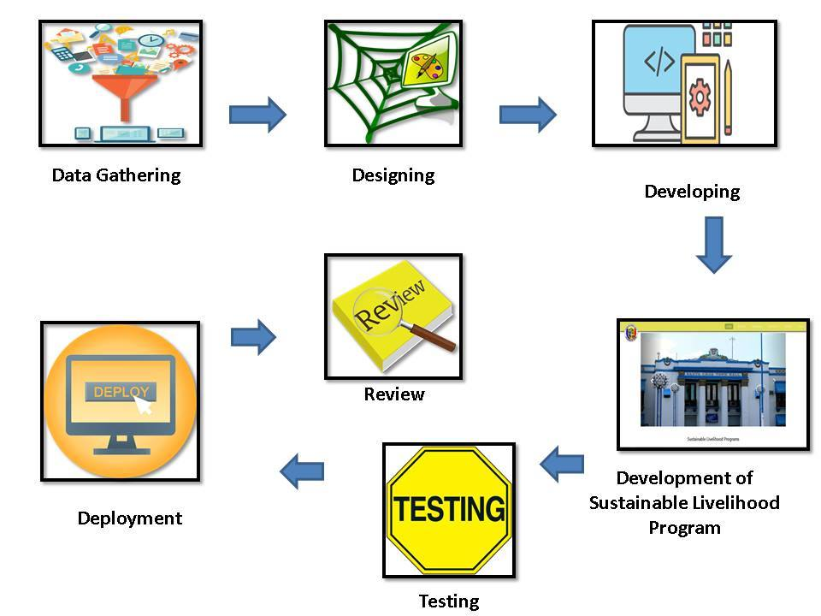

**Figure 1.** Conceptual framework of the system wherein the developers need knowledge about software-based system development and database system.

In this figure, shows how the researchershave come up with the illustration of what to be expected to find through this research. First, the researchers conducted an actual interview with the client which is the DSWD and MSWDO office of the Municipality of Sta. Cruz, Laguna to gather information about livelihood programs and also the researchers have done library research and online research to find some additional information about livelihood programs. After that, the researchers have come up with a user friendly design for the interface of the developed system so that it will be applicable for all ages because based on the interview with the client there is an age limit to the participants. Then, the researchers developed several application forms for the programs to be implemented in order for the participants to apply on the preferable livelihood program. The “Sustainable Livelihood Program Management Information System with SMS Notification” was developed.

**Project Purpose**

The purpose of this study is to provide the citizens of Sta. Cruz, Laguna with online registration for different programs under the Sustainable Livelihood Program through a user friendly and easy access system and to reduce the volume of people who comes back and forth to the Municipality of Sta. Cruz just to file their request and forms for the program that the citizen preferring.

This study will be beneficial to the following:

* **Municipality of Sta. Cruz, Laguna** – it will organize the data and information gathered in every barangay for the purpose of Sustainable Livelihood Program.
* **Administrator** – it is beneficial because they can manage and sort the data and information that they have gathered in less time compare to manual system that they are using in the past.
* **Researchers** - Developing the system helped the researchers to enhance their skills and gain more knowledge. It also builds their cooperation and enhances their team work.
* **Future Researchers** - They could use the system to get new ideas and information about the study contents. It could also be used as a reference for students and other people who will conduct a study related to this research.

**Scope and Limitation of the study**

The scope of the study basically means all those things that will be covered in the research project. It defines clearly the extent of content that will be covered by the means of the research in order to come to more logical conclusions and give conclusive and satisfactory answers to the research.

The following are the scope of the study:

* The study can track the progress of the participants in different programs and monitor their attendance each week through manual short message service (SMS).
* The study observed and conducts a survey through a door to door application to invite a following not well-educated respondent.
* The study creates a following program that will help the following respondents through the programs such as manicure, soap making and more.

However, there are limitations to the study:

* The study cannot update all the respondents due to overcrowding people in the office and they cannot accommodate all because of their different programs.
* The study can only use by admin, staff/s, and SLP participants in Sta. Cruz, Laguna
* The study cannot know its full validity of the following requirements needed because of its own unique data privacy.
* The study cannot record its full data such as Barangay Clearance, Sedula, Police Clearance, NBI, Diploma and other requirements needed for TESDA application.

**CHAPTER II  
REVIEW OF RELATED LITERATURE**

This chapter presents the related literature and studies after the thorough and in-depth search done by the researchers. This will also present different researches and other literatures from both foreign and local researchers. It focuses on several aspects that will benefit the development of this study.

**E-government** There are some reasons why e-government should be given attention. In the study of Anthopoulus, Reddick, Giannakidou, Mavridis (2016) “Why e-government projects fail? An analysis of the Healthcare gov website”. Electronic government or e-government project failure has been widely discussed in the literature. Some of the common reasons cited for project failure are design-reality gaps, ineffective project management and unrealistic planning. Research shows that more than half of e-government projects result in total or partial failures with regard to the initially grounded standards, scheduling or budgeting plans, while even more fail to meet end users' expectations.

This proves that not all the e-government system is effective because of some failures that failed to meet the end users expectation that’s why this will help the researchers study to be more effective and confront the failures that may expect in the near future.

However, in study of Rana, et. Al (2017) entitled “Citizens’ adoption of an electronic government system: towards a unified view”. This research tested the nine alternative theoretical models of technology adoption in the context of an eGov system using data collected from citizens of four selected districts in the state of Bihar in India. Analysis of the models indicates that their performance is not up to the expected level in terms of path coefficients, variance in behavioral intention, or the fit indices of the models. In response to the underperformance of the alternative theoretical models to explain the adoption of an eGov system, this research develops a unified model of electronic government adoption and tests it using the same data. The results indicate that the proposed research model outperforms all alternative models of technology adoption by explaining 77 % of variance in behavioral intention, with acceptable values of fit indices and significant relationships between each pair of hypothesized factors.

This research explained how to adapt an electronic government system using the data collected from citizens thus; this will help the researchers study to improve the proposed system for implementation.

On the other hand, a study of Abu-Shanab (2017) entitled “E-government familiarity influence on Jordanians’ perceptions” E-government is becoming an important topic and is attracting more and more research. Its adoption is determined by many factors among which user’s familiarity is not a well-researched one. Without a real longitudinal research, familiarity cannot be investigated. To explore the influence of e-government familiarity, we utilized two samples with two different objectives. Results of the first survey indicated high levels of awareness in regard to service provision, time and location, and necessity of information needed. Dimensions like digital divide (gender and accessibility) and social change were among the highly recognized topics. On the other hand, e-participation and political concepts of e-government were moderately perceived by the sample. Results of the second sample indicated a significant influence of familiarity with e-government (gained from the course content) on 14 items out of the 20 used. Also, perceived usefulness and privacy and security assurance were significant predictors of trust in e-government. Finally, all item means increased in the second stage except for one item only. Governments need to raise awareness regarding e-government initiatives and improve citizens’ familiarity with the topic.

This is another proof that implies the adoption of electronic government system wherein the government must raise the awareness regarding the e-government initiatives and improves citizens’ familiarity.

Another study by Sá, Rocha, Cota (2016) Citizens expects quality public services, and their online dimension is no exception. The quality of these services should be analyzed and accounted for, in order to maximize and develop strategies that improve the offered services, increasing the levels of satisfaction of their recipients. In this sense, this first study puts forth a systematization of the relevant bibliography, focusing on the quality of three types of services: traditional, electronic and e-Government.

Moreover, in a study of Carter, Weerakkody, Phillips, Dwivedi (2016) entitled “Citizen Adoption of E-Government Services: Exploring Citizen Perceptions of Online Services in the United States and United Kingdom”. This study presents a cross-national examination of e-government adoption in the United Kingdom and the United States. The results of partial least squares analysis indicate that disposition to trust is positively related to internet trust and government trust. Perceived ease of use and perceived usefulness have a significant impact on intention to use. Internet trust has a positive effect on intention to use. We conclude by highlighting cultural differences in e-government adoption.

E-government has a bigger part on the study that the researchers currently doing. The system for Sustainable Livelihood Program will be used by the citizens and staff/s in the municipality of Sta. Cruz, Laguna that’s why it’s important to know these kinds of projects in order for the researchers to be aware on how to implement this project/s and the possible problem that may arise in the future.

**Sustainable Livelihood Program**

Based on the study of Leonard, Mbatudde, Makumbi,Wilson (2016) entitled” Sustenance of the Results of Livelihood Projects: A Case Study of the Rural Livelihood Program in Uganda” the study assessed the extent to which the results of the rural livelihood projects were sustainable in Nyimbwa sub country Luwero District, Uganda. Questionnaire surveys were used collect data from a sample of 110 respondents. The results also revealed that gender, age, education level, and occupation significantly affected uptake and sustenance of livelihood projects.

It is important to know these collected data from the results on the project that being implemented so that, with the help of this article the researchers must apply its understanding on livelihood projects which is connected to the study that the researchers are currently doing.

# In another study of Yannan Zhao (2019) entitled “Evaluation of Sustainable Livelihoods in the Context of DisasterVulnerability” The problem of reaching sustainable livelihoods (SL) is a continual trouble that has received sizeable hobby for all countries. Even alevin though contexts of vulnerability were highlighted to be essential to SL, the distinction of SL below vulnerability contexts, in particular disaster, has been ignored. As one disaster-susceptible area, there may be a pressing want to behavior research on SL in Shenzhen, inside the context of the development of a country wide park.

Sustainable Livelihood Program is a capacity building program for poor to improve their socio-economic conditions. In the study of Serrat entitled “The Sustainable Livelihood Approach” The reasonable jobs approach improves comprehension of the vocations of poor people. It coordinates the variables that oblige or improve vocation openings, and shows how they relate. It can help plan improvement exercises and survey the commitment that current exercises have made to supporting vocations.

Some study by Owen, et al. (2015) entitled “Household, livelihoods and mining-induced displacement and resettlement” in mining and resettlement practice, one critical oversight is the conceptualization of households in the formulation of livelihood reconstruction initiatives. While households have received considerable attention in development studies, principally in relation to sustainable livelihood activities, the substance of this research continues to evade the attention of policy makers and practitioners in the mining industry. This article highlights the importance of household level analysis in mining industry policy and resettlement practice.

Not all the people have a prosperous life some are doesn’t have job or skills to take a job hence, in the article of Mullen, et al. (2019) entitled “Rural Poverty, Empowerment and Sustainable Livelihoods” The elimination of absolute poverty has become the overriding of many international development agencies, national government and nongovernment organizations. However, poverty elimination or alleviation is not exclusively an exogenous donor given phenomenon. The majority of country government has also committed themselves to the same program of the action of the world social summit and many have since 1995, Pursued substantive poverty reduction initiatives in terms of policies, realignment of public expenditures to address deprivation and investment in the productive capacities of low-income populations. Vibrant civil society associations, representing the poor themselves or working among the poor, have undertaken practical micro-level initiatives, to protect vulnerable livelihoods.

As mentioned by Bauchet, et al. (2015) in the study entitled “Failure vs. displacement: Why an innovative anti-poverty program showed no net impact” part of a series of pilot programs that provide “ultra-poor” households with inputs to create new, sustainable livelihoods often tending livestock. In contrast with results from other pilots, the baseline consumption data contain systematic errors, and income and consumption contain large outliers. Steps to address the problems leave the central findings largely intact: Wages for unskilled labor rose sharply in the area while the study was implemented, blunting the net impact of the intervention and highlighting one way that treatment effects depend on factors external to the intervention itself, such as broader employment opportunities.

This article states that after implementing the study discuss above, wages for unskilled labor rose sharply in the area where the study is implemented. In the researchers’ study through the implemented livelihood program of the said municipality it will help the citizen to enhance their skills and to have an opportunity to have an income.

In addition, by Blackwell, et al. (2018) entitled “Contributing to sustainable community livelihoods: corporate social responsibility programs of resource companies “Many rural communities are looking to arrest population decline and secure their future viability.

In the study of Armanto, et al. (2017) entitled “Livelihoods, Household Income, And Indigenous Technology” the researches aimed to analyze livelihoods, household income and indigenous technology in South Sumatra wetlands. The research method used field survey and interviews with respondents by using questionnaires. Respondents were determined with stratified random sampling method. The research data are classified into two parts, i.e. primary data and secondary data.

This article explained what methods have been used to analyze livelihoods, household income, and indigenous technology that might help the researchers study to come up with determining the respondents by using methods such as surveys, interviews, and questionnaires.

On the other hand, some article by Hossain, et al. (2018) in the study entitled “Impacts and responses to environmental change in coastal livelihoods of southwest Bangladesh” Aquatic ecosystems are of global importance for maintaining high levels of biodiversity and ecosystem services, and for the number of livelihoods dependent on them. In Bangladesh, coastal and delta communities rely on these systems for a livelihood, and the sustainability of the productivity is seriously threatened by both climate change and unsustainable management. These multiple drivers of change shape the livelihood dependence and adaptation responses, where a better understanding is needed to achieve sustainable management in these systems, while maintaining and improving dependent livelihoods.

It explained that the citizens rely to the purpose of livelihood program for being productivity and need a better understanding to achieve the sustainability in life. In the researchers study, the livelihood programs implemented by the said municipality help the citizen to have an opportunity to be sustainable in life.

Understanding the purpose of livelihood programs must put some attention. A study by Watson, et al. (2016) entitled “potential programs to improve livelihoods for vulnerable workers” Worldwide over a half of workers are self-employed, but a significant fraction of these self-employed jobs is of low productivity subsistence entrepreneurs. The focus of the entrepreneurship programs to support these self-employed in poverty is to improve their livelihoods rather than promoting cutting-edge innovation and business growth. Evidence of successful programs is limited and program designs often seem ill suited to the needs and characteristics of these subsistence entrepreneurs. Given the market failures faced by subsistence entrepreneurs, interventions that complement safety net programs with well-targeted support to promote productive self-employment may hold some promise.

In the article entitled “Rural livelihoods and Poverty Reduction Strategies” by Freeman, et. al (2017) with a view to informing rural poverty reduction policies within Poverty Reduction Strategy Plans (PRSPs). Low household incomes in rural areas of all countries are associated with low land and livestock holdings, high reliance on food crop agriculture, and low monetization of the rural economy. These adverse factors are in some instances made more difficult by land sub-division at inheritance, declining civil security in rural areas, deteriorating access to proper agronomic advice and inputs, and predatory taxation by decentralized district councils.

This article discuss that making poverty reduction strategies will help the low income household in rural areas of all countries that is somehow alike with the researchers study wherein the participants of the implemented livelihood programs are indigent people of the said municipality.

Moreover, in the study of Scoones, et al. (2015) entitled “Sustainable Livelihoods and Rural Development” The message of Sustainable Livelihoods and Rural Development is clear: livelihoods approaches are an essential lens on questions of rural development, but these need to be situated in a better understanding of political economy. The book looks at the role of social institutions and the politics of policy, as well as issues of identity, gender and generation. The relationships between sustainability and livelihoods are examined, and the book situates livelihoods analysis within a wider political economy of environmental and agrarian change.

This explained that the livelihood programs are the answer to poverty questions to help the growth of incomes in rural areas which is also explained in the researchers study that this program helps the citizen of Sta. Cruz, Laguna to have a sustainable life and incomes.

# Another study by Taylor, et al. (2015) entitled “Rural Livelihoods and Poverty Reduction Policies” Skillfully exposing the gap that exists between the rhetoric of poverty reduction strategies in capital cities and the practice of public sector delivery in rural areas, this key text will be essential reading for advanced students and researchers in the fields of rural development, rural livelihoods, poverty reduction strategies and Sub-Saharan Africa development as well as advisors and practitioners in international organizations.

# However, in the study of Ellis, et al. (2018) entitled “Rural Livelihood Diversity in Developing Countries: Evidence and Policy Implications” livelihood diversification as a survival strategy of rural households in developing countries. Although still of central importance, farming on its own is increasingly unable to provide a sufficient means of survival in rural areas. The papers objectives are first, to increase awareness of livelihood diversification in approaches to rural development; second, to consider the interactions among diversification and poverty, farm productivity, natural resource management and gender relations in rural areas; and third, to advance the policy understanding of diverse rural livelihoods.

# On the other hand, a study by Carney, et al. (2016) entitled “Approaches to Sustainable Livelihoods for the Rural Poor” So-called 'livelihoods approaches' work with people, supporting them to build upon their own strengths and realize their potential, while at the same time acknowledging the effects of policies and institutions, external shocks and trends. The aim is to do away with pre-conceptions about what exactly rural people are seeking and how they are most likely to achieve their goals, and to develop an accurate and dynamic picture of them in their environment. This provides the basis for identifying the constraints to livelihood development and poverty reduction.

# This explains that sustainable livelihood programs is supporting people with low household incomes in terms of building up their own strength and realize their potential to achieve their goals that is why the researchers believes that the proposed system is effective for implementing various projects under the sustainable livelihood program in the municipality of Sta. Cruz Laguna.

# Another study by Biggs, et al. (2017) entitled “Evolving Themes in Rural Development” Dominant and subsidiary themes are identified, as well as the co‐existence of different narratives running in parallel. The continuing success of the long‐running ‘small‐farm efficiency’ paradigm is highlighted. The article concludes by asking whether sustainable livelihoods approaches can be interpreted as providing a new or different way forward for rural development in the future. The answer is a cautious ‘yes’, since these approaches potentially permit the cross‐sectorial and multi‐occupational character of contemporary rural livelihoods in low‐income countries to be placed Centre‐stage in efforts to reduce rural poverty.

# It implies how sustainable livelihood is really important in reducing poverty because in this article says that it can provide a new or different way forward to rural development in the future and placed low income countries at center stage.

Another study of Li, et al. (2016) entitled “Livelihood approach” It is argued that although sustainable development has received widespread acclaim, practical application of the concept has been fraught with difficulties. Furthermore, when adopted and adapted by a single sector such as tourism, further problems arise because many sustainability challenges are inter-sectoral, involving competition for the use of scarce resources among different potential uses. A sustainable livelihoods (SL) approach is advocated as providing a tangible way forward, and an SL framework is presented to guide future research and practice related to sustainability.

Moreover, by Sati, et al. (2016) in the study entitled “Sustainable Livelihood Approach to Poverty Reduction” they described sustainable livelihood approach to poverty reduction and analyzed the current situation of all livelihood capitals in Mizoram. They observed that the three capitals such as natural and human are abundant; however, Mizoram lacks in financial and physical capitals. Further, the government support to develop livelihood assets and to cope with natural catastrophe is minimal. This resulted in underuse of natural resources and prevalence of chronic poverty situation.  They suggested that the government should frame a policy to sustainable livelihood through enhancing financial capabilities and developing infrastructural facilities (physical capital) to harness the natural capital sustainably and to attain food security.

This is another proof that sustainable livelihoods can reduce poverty and by implementing this programs in low household communities it will enhance their skills and to have opportunities for a job. Hence, this article will help the researchers study to support all the programs under the sustainable livelihood program.

On the other hand, in the article entitled “Poverty Reduction through Entrepreneurship Programmed” by Kartini, et. al (2017) The difficulty of poverty has come to be greater extreme as the variety of resource recipients in keeping with the statistics furnished through Jabatan Kebajikan Masyarakat (JKM) and State Islamic Religious Council (MAIJ) appears to be increasing. The dependency of recipients on useful resource shows that the negative is still harassed with poverty problems due to the excessive standard of residing fee and household economic constraints. The objective of this study is to recommend entrepreneurship programmed to beneficiaries to assist them on breaking out poverty and to attain a better general living.

The researchers want to help the municipality of Sta. Cruz, Laguna to support all the programs under the sustainable livelihood program.

Some study entitled “Poverty Reduction Strategies and Non-timber Forest Products” by Shackleton, et al. (2017) The first of the 17 Global Goals that make up the 2030 Agenda for Sustainable Development is to quit poverty in all its bureaucracy everywhere. Although the numbers of bad people within the international has declined over the previous couple of decades, it is nonetheless alarmingly high, being about 770 million in 2013. Currently the majority of the globe’s bad stay in rural areas, and their livelihoods are dominated by using land-based totally activities inclusive of accumulating of Non-Timber Forest Products (NTFPs). There had been relatively few studies offering extra socially orientated views and insights on the hyperlinks between NTFP use, dependency and poverty. The ordinary people using NTFPs, their motives for doing so and their stories are given in this book.

Another study entitled “Education as Poverty reduction “by Benjamin, et al. (2018) a lack of an adequate education is one of the definitions of poverty. If a person is illiterate, he is almost certainly poor along one or more dimensions. He is quite probably poor according to economic measures: it is unlikely that a person lacking basic literacy or numeracy will have a livelihood that brings in a generous income. If a person lacks an education, he is also probably deprived along all sorts of other dimensions of wellbeing. He is more likely to have health infirmities, and less likely to be able to protect his political rights. Moreover, a deficient education is a kind of poverty trap.

This article explained that the deficiency in education will lead to poverty. That’s why in the researchers study there are different programs like Sustainable Livelihood Program (SLP) and Technical Education and Skills Development Authority (TESDA) that they may apply on and will help the low income household to gain financial support and to enhance their skills.

# Moreover, by Tripathi, et al (2019) entitled “Sustainable Livelihood models of mobility in an emerging market” Sustainable livelihood is a necessity to tackle the vulnerability that might arise due to variations in opportunities of livelihood owing to socioeconomic changes over a period of time. In this research it was tried to study more than 200 innovations in the rural mobility space and shortlisted 10 of them for a field immersion. The purpose was to find out why did these Jugaad Innovations in the mobility domain came into existence, what was the need, and what impact were they able to make by becoming means to provide sustainable livelihood opportunities to the people living in rural areas of an emerging market. Lack of a vehicle scrapping policy, huge informal sector having disguised employment, and a flourishing old vehicles market due to faster obsolescence of vehicles gave rise to these mobility innovations.

# Some study by Vangchhia, et al. (2016) entitled “Population and Socio-economic Development” Mizoram nation is characterized as agriculture ruled economy, as a big percentage of populace (above 31.3 %) is worried in practicing agriculture. Further, shifting cultivation dominates (38.3 %) it. However, the go back from plants grown under transferring cultivation is insufficient, even to support every day meals requirement of the people. It ends in food insecurity and malnutrition. This bankruptcy analyzes populace and socio-financial popularity of agricultural dependent societies in Mizoram. It further discusses about how humans expand livelihood strategies to address food insecurity and poverty.

# It discuss that humans expanding the strategies to reduce poverty wherein in the researchers client aim to reduce the poverty in the said municipality by implementing livelihood programs as the strategy to be able to reduce the low household income in Sta. Cruz, Laguna.

# However, in the study of Mistri, et al. (2020) entitled “Foundation of sustainable Livelihood and Migration” A sustainable livelihood copes with and recovers from stressors and shocks, maintains or enhances its talents and activities, and provides livelihood opportunities for future generations. Migration is one of the effects of a livelihood strategy. A Sustainable Livelihood Approach (SLA) facilitates one to recognize people’s livelihoods and their strategies associated with the same. In this chapter, SLA is empirically tested to explore the chance of migration from Sundarbans under exceptional units of predictors.

# As stated in this article, livelihood programs enhance the talents of people through different activities and provide opportunities for future generations. Wherein the researchers study the developed system will provide different livelihood programs in order for the citizen of Sta. Cruz, Laguna to choose what preferable program would benefit them.

Some study by Haan, et al. (2016) entitled “Livelihood in development” Today three-quarters of the acute poor live in middle-profits countries. There is a clear link between growth and profits inequality in big middle-earnings countries, making poverty and associated troubles increasingly a distribution issue. Livelihood studies — via a holistic angle on how poor human beings organize themselves a living — have made a massive contribution within the past a long time to our expertise of techniques of inclusion and exclusion and consequently of the root causes of poverty and marginalization. The greatest assignment now is translating livelihood studies into social protection regulations that countervail social exclusion.

Another study by Liao, Brown (2018) entitled “Assessments of synergistic outcomes from sustainable intensification of agriculture need to include smallholder livelihoods with food production and ecosystem services” Mankind faces an excellent test as we look to upgrade food creation, improve jobs, and protect environments. Existing structures of maintainable agrarian increase offer the guarantee of offsetting food creation with saving area for nature however are excessively barely centered to address all elements of the test. To this discussion, we contribute a manufactured conversation of the more extensive objectives of supportable heightening, contending that it is important to fuse improvement of smallholder prosperity as an express objective of feasible increase. A significant number of the country lands accessible for expanded food creation are as of now cultivated by smallholders whose occupations will be influenced by changes underway frameworks. Proof recommends that normal pay advantages to smallholders don't generally appear, come at the expense of different elements of jobs, or are appropriated unevenly. Inventive blends of various techniques, for example, renewal of relinquished farmlands, changes in buyer diet systems, natural escalation, upgrade of expansion and rural augmentation administrations, and solid neighborhood foundations under the background of monetary globalization can be tackled to build land-use productivity, consequently meeting the objectives of giving adequate food while accommodating ecological protection with improved smallholder prosperity.

This article discuss that the livelihood programs will improved the smallholder prosperity to have a sustainable life which is in the researchers study that livelihood programs will help to reduce poverty and make the low income household to upsurge.

# Some study by Chandra, et. al entitled (2017) “A Study of Climate-Smart Farming Practices and Climate-resiliency Field Schools in Mindanao, the Philippines” This paper investigates how Climate-strength Field Schools including smallholder ranchers in the Mindanao locale of the Philippines advance atmosphere keen cultivating rehearses. Utilizing information from field perceptions, 86 meetings, and 13 center gathering conversations from five regions, the examination finds that cross-scale exercises, including neighborhood plans and multi-partner discussions, and civil planning measures, impact transformation and alleviation to environmental change in smallholder cultivating frameworks. Moreover, utilizing network investigation and partner reactions, we recognize collaborations, cooperative energies, clashes, and expected co-benefits among relief and transformation, and food creation rehearses.

# In the study of Mhlanga, Ndhlovu (2020) entitled “Socio-economic Implications of the COVID-19 Pandemic on Smallholder Livelihoods in Zimbabwe” The article revisits previous viruses such as Ebola to extrapolate the socio-economic implications of the COVID-19. Using secondary sources and the Sustainable Livelihoods Framework (SLF) to guide understanding, the article argues that unless measures are put in place to safeguard smallholder activities in Zimbabwe, COVID-19 has the potential to reproduce the same catastrophic implications created by Ebola in West African countries where peasant food systems where shattered and livelihoods strategies maimed. With a perceptible withdrawal of the government from small-scale farming towards large-scale capital-intensive operations, smallholders could now be even more vulnerable. The article concludes that social assistance should now be intensified to protect its vulnerable population from the ravages of COVID-19.

# As the article state above, that through COVID-19 food system are shattered and livelihoods are impaired. But in the researchers study there will be an online registration for every participants of livelihood programs that will make application easier and to reduce the people who comes back and forth when passing the requirements needed.

# Another study by Shackleton, Shackleton, Kull (2019) “The role of invasive alien species in shaping local livelihoods and human well-being: A review” Intrusive outsider species are an all-around perceived driver of social-natural change internationally. Much exploration has zeroed in on biological effects, yet the part of obtrusive species for jobs and human prosperity is less notable. Understanding the impacts (advantages and expenses) of obtrusive species on occupations and human prosperity is significant for directing strategy definition and the executives. Here we survey the writing on the part of obtrusive species in jobs to evaluate what is known, recognize information holes and give suggestions to future examination. Monetary effects on occupations because of intrusive species were exceptionally factored and subject to the social-biological settings. These negative ramifications can lessen versatility and versatile limit of families and networks hence expanding their weakness to change. Drawing on contextual investigations we feature that endeavors for overseeing intrusive species need to shield job benefits while relieving negative effects. In finishing up we feature future examination and strategy needs on the subject of intrusive species, vocations and human prosperity.

# This article explained that there are intruders from other place that migrate on their area while in the researchers study only the citizen of Sta. Cruz, Laguna will be able to participate in different livelihood programs.

# In the study of Wright et. al (2016) entitled “Reframing the concept of alternative livelihoods” Alternative livelihood project (ALP) is a widely used term for interventions that aim to reduce the prevalence of activities deemed to be environmentally damaging by substituting them with lower impact livelihood activities that provide at least equivalent benefits. ALPs are widely implemented in conservation, but in 2012, an International Union for Conservation of Nature resolution called for a critical review of such projects based on concern that their effectiveness was unproven. We focused on the conceptual design of ALPs by considering their underlying assumptions. We placed ALPs within a broad category of livelihood focused interventions to better understand their role in conservation and their intended impacts.

# Some study by Adams, Rodrigues, Calmon, Kumar (2016) entitled “Impacts of large scale forest restoration on socioeconomic status and local livelihoods” The main theme explored was income, followed by livelihoods diversification, off‐farm employment opportunities, poverty reduction, equity and the provision of timber and energy as ecosystem services. Nearly 60 percent of the papers discussed the importance of governance systems to socioeconomic outcomes. The reforestation/restoration programs and policies investigated in the studies had mixed socioeconomic effects on local livelihoods depending on other variables, such as availability of off‐farm jobs, household characteristics, land productivity, land tenure, and markets for forest products and ecosystem services. The conclude effects of large‐scale restoration initiatives on local livelihoods may vary due to several factors and is still not clear for many situations; therefore, monitoring over time with clear indicators is needed.

# In the researchers study, the implementing of Sustainable Livelihood Program will improved and gather clear information and monitored every participants activities through progress tracking that is included in the study.

# On the other hand, a study by Aheto et. al (2016) entitled “Community-based mangrove forest management: Implications for local livelihoods and coastal resource conservation along the Volta estuary catchment area of Ghana “Despite the fact that worldwide premium in mangrove research has expanded as of late, divulging their tremendous environmental and monetary jobs, almost no work has been done to explore the essential driving elements persuading long haul network put together mangrove reclamation and the executives with respect to nearby scales. In Ghana, strategy creators and waterfront the executive’s experts have as of late grasped the idea of network based and co-the board of seaside and marine assets. This paper gives ideas to assessment of the biological and financial components affecting mangrove rebuilding and the executives by fishers, fish mongers, ranchers and their financial groupings.

# In the study of Toner, Franks entitled (2016) “Putting livelihoods thinking into practice: implications for development management “The disappointment of 'outline' advancement intercessions to convey meaningful upgrades in neediness decrease has been very much perceived in the course of the most recent twenty years. Cycle approaches look to defeat the unbending nature and top‐down activity of much aid‐funded mediation. Practical vocations draw near (SLA) are probably the most recent expansion to this group of approaches. As a hypothetical structure and as a bunch of standards for controlling intercession, reasonable jobs thinking has a suggestion for advancement the executives. Drawing on research investigating the utilization of economical occupations standards in 10 improvement intercessions, this article thinks about how these standards have advanced from proceeding with discusses encompassing cycle and people‐cent red (bottom‐up) ways to deal with advancement the executives. This examination recommends that while these standards can improve the effect made by intercessions, the compelling utilization of reasonable jobs and different cycle approaches are on a very basic level confined by uneven force connections between advancement accomplices.

# Moreover, study of Jung entitled (2018) “Evidence on land deals’ impacts on local livelihoods” Transnational land deals are expected to benefit local livelihoods by directly and indirectly contributing to economic development. However, mixed evidence exists on the livelihood impacts of land deals. In this paper, he summarizes and reconciles findings from quantitative and qualitative studies to identify the variations in impacts and factors that help explain those variations. He use the findings to demonstrate how and why research on land deals’ livelihood impacts can first, benefit from the use of both quantitative and qualitative research methods, and second, provide grounds for more rigorous analyses and practical policy implications. Lastly, he discusses future research directions by identifying gaps and opportunities to be explored in the literature on land deals’ impacts on local livelihoods.

As mentioned in the study of Magno-Ballesteros, et al. (2016) in the study entitled “Assessment of the sustainable livelihood program: Employment facilitation process” the Sustainable Livelihood Program – Employment Facilitation Track (SLP-EF Track) is a plan or scheme that facilitates the employment of Pantawid Pamilyang Pilipino Program (4Ps) beneficiaries. It has much potential to bring the 4Ps beneficiaries closer to reaching the poverty threshold because getting employed would provide additional income to the beneficiaries on top of the incentives provided to them by the 4Ps.

This is another proof that sustainable livelihood program has the potential to bring the beneficiaries reaching the poverty threshold through getting employed and provide additional income.

Another study by Sulaiman (2016) “Making Sustainable Reductions in Extreme Poverty: A Comparative Meta-Analysis of Livelihood, Cash Transfer and Graduation Approaches” Eliminating extreme poverty by 2030 will require targeted interventions that can make sustainable improvements in the lives of the poorest. Moving people out of extreme poverty is challenging and costly since the poorest households tend to be physically and socially isolated, and face disadvantages across multiple dimensions. It is compared to the cost – effectiveness of three strands of social protection interventions: the livelihood development programs, lump sum unconditional cash transfers and graduation programs.

On the other hand, a study by Acosta, Avalos (2018) entitled “The Philippines Sustainable Livelihood Program: Providing and Expanding Access to Employment and Livelihood Opportunities” the design and core processes of the SLP reflects the opportunities that the program has to improve and complement other SP programs to make an impact on household welfare.

Another study by Orbeta, et al. (2015) “Assessment of the DSWD SEA-K Strategy" it looks at the effectiveness of the strategy and the complementary interventions of the Sustainable Livelihood Program's Self-Employment Assistance Kaunlaran (SLP SEA-K). The SLP SEA-K uses a microcredit strategy that intends to provide credit access to the poor, improve the ability of the group to borrow, and enable it to engage in income-generating activities. Microcredit services are generally believed to have a positive socioeconomic impact; however, the success of projects may depend largely on the management of the program.

Men is actually physically fit in terms of doing labors and manual works but as mentioned by Santillan, et al (2016) in the study entitled “Livelihoods for women in Mindanao” this paper studies how women contributed to the post-conflict reconstruction of Mindanao by engaging in livelihood activities. It explores five different livelihood intervention projects implemented in Mindanao between 2000 and 2010. The extent of women's contribution to post-conflict reconstruction is measured by identifying the benefits gained at household and community levels, generated by women's livelihood work.  It also illustrates that interventions for reconstruction therefore must include livelihood programs that encourage women's participation, as exemplified by the experience of Mindanao.

In the article entitled” Employment Facilitation Model of the Sustainable Livelihood Program of the Department of Social Welfare and Development” by Bitonio, Gilberto Cariño (2020) the limited social preparation and responsibility of the SLP beneficiaries led to backing out in the implementation of the employment Facilitation Track of the Sustainable Livelihood Program and will be addressed through the propose intervention. The implementation of Employment Facilitation Track of the Sustainable Livelihood Program is effective however some problems are met and these problems are not significant predictors of the implementation.

# As mentioned in the study of Dasgupta, Gawande, Kapur (2017) entitled “(When) Do Anti-Poverty Programs Reduce Violence? India's Rural Employment Guarantee and Maoist Conflict “Theory and extensive evidence connect poverty and underdevelopment to civil conflict, yet evidence on the impact of development programs on violence is surprisingly mixed. To break this impasse, they exploit a within-country policy experiment to examine the conditions under which anti-poverty programs reduce violence. The roll-out of India's National Rural Employment Guarantee Scheme caused a large long-run reduction in Maoist conflict violence, as measured with an original data set based on local language press sources. These pacifying effects were not uniform, however, but overwhelmingly concentrated in districts with sufficient pre-existing local state capacity to implement the program effectively. The results demonstrate the potential for anti-poverty programs to mitigate violent civil conflict by improving livelihoods, but also highlight the crucial role of state capacity in shaping these effects.

In the study of Fernandez (2019) entitled “Revitalizing the Bicol College Livelihood Programs at Barangay Kilicao in Daraga, Albay” livelihood is one of the ways of helping people alleviate poverty. This action research determined the causes of temporary closure of the projects implemented in terms of attitude of the participants, organizer, and financial support and the recommended development plan.

Sustainable livelihood program has a major part on the current study that the researchers are doing. The system for Sustainable Livelihood Program will enhance the implementation of all the projects under SLP that’s why it is important to know this kind of programs/projects to be aware of possible problem that may occur in the future.

# Management Information System

# In the study of Abu Naser, Al Shobaki (2016) entitled “The Impact of Management Requirements and Operations of Computerized Management Information Systems to Improve Performance (Practical Study on the employees of the company of Gaza Electricity Distribution )” the researchers used stratified sample method to identify the impact of the management requirements on operating of computerized management information systems to improve performance, and discuss the perceptions of respondents to develop the performance of employees in the Gaza Electricity Distribution Company.

# This explained that management information system is very handy in terms of improving performance that’s why the researchers believe that the proposed system is the solution to the problem of the client.

# On the other hand, a study by Malcolm, et. al (2015) entitled “Information Management System” A data of board framework is depicted involving at least one workstation running applications which permit a client of the workstation to interface with an organization, for example, the Internet. Every application has an analyzer, which screens transmission information that the application is going to send to the organization or has recently gotten from the organization, and which decides a fitting move to make with respect to that information. The analyzer may counsel strategy information containing a supervisor-characterized strategy to administer the workstations to figure out what move to make. Such activities might be separating information from the transmission information, for example, passwords and usernames, computerized testaments or eCommerce exchange subtleties for capacity and record continuing; guaranteeing that the transmission information is sent at an encryption quality suitable to the substance of the transmission information; deciding if a check should be made with respect to whether an advanced endorsement got in transmission is legitimate; deciding if an exchange going to be made by a client of one of the workstations needs outsider endorsement before it is made; and controlling the transmission of messages, for example, messages as per an approach.

# In the researchers’ study, organizing and developing record management is one of the objectives which have similarities with the article above.

Some study by Rajnoha, Lesnikova (2016) entitled “Strategic Performance Management System and Corporate Sustainability Concept - Specific Parameters in Slovak Enterprises” These days; a well-performing attempt can be viewed as the one that is ready to use various openings, to acclimate to constant changes inside the climate, to accomplish unrivaled execution. Business execution is regularly observed as a pointer of the undertakings occurs and effects. Inside the scope of trade execution and indispensable execution assessment system, various contemplates have been acknowledged which recognize the significant factors affecting the execution of the organization itself. The paper is focused on the examination and conspicuous evidence of specific parts inside the edge of restriction, turnover of undertaking and others which may have an expected effect on execution. Current examples are focused not figuratively speaking on the execution, but rather besides the consequences of corporate activities of climate. This prompts unrivaled seriousness of organizations. In this setting, thought is attracted to the presentation of adventures on explicit estimations of corporate acceptability idea and segments, for example, organization gauge.

Another study by Wallace (2018) entitled “Externally augmented asset Management” A framework and technique for remotely expanded resource the executives is revealed. As per one exemplification, data from a first detailing source about a resource is gotten. Furthermore, data from a subsequent detailing source about the resource is additionally gotten. Data from a third announcing source about in any event one ecological condition is additionally gotten. An information base is then populated with the data from the main announcing source, the data from the subsequent detailing source and the third revealing source with the end goal that data from the principal revealing source, the data from the subsequent announcing source and the third detailing source can be gathered or gotten to from the data set.

# In the study of Joo, Kim, Kim (2016) entitled “Factors predicting online university students’ use of a mobile learning management system (m-LMS)” This investigation examined the connections among factors foreseeing on the web college understudies' genuine use of a versatile learning the board framework (m-LMS) through a basic model. Information from 222 understudies in a Korean online college were gathered to examine coordinated connections among their apparent convenience, seen handiness, desire affirmation, fulfillment, duration goal and genuine utilization of m-LMS. Results indicated that apparent usability anticipated apparent value, yet desire affirmation was not identified with seen convenience. Seen handiness and desire affirmation anticipated fulfillment. Seen value and fulfillment anticipated continuation aim, however saw convenience was not identified with duration expectation. Continuation expectation anticipated genuine use of m-LMS.

# In the researchers study, through the use of management information system the convenience and handiness of the system met the expectation of the client’s way of storing and recording of data.

# Another study by Borden, Brand (2017) entitled “Information source agent systems and methods for distributed data storage and management using content signatures “Data source specialist frameworks and strategies for appropriated content stockpiling and the board utilizing content marks that utilization record identically properties are given. An information the executive’s framework is given that incorporates a substance motor for dealing with the capacity of document content, a substance signature generator that creates an extraordinary substance signature for a record prepared by the substance motor, a substance signature comparator that analyzes content marks and a substance signature vault that stores content marks. Data source specialists are given that incorporate substance signature generators and substance signature comparators. Techniques are accommodated the proficient administration of documents utilizing content marks that exploit record identically properties. Content mark application modules and vaults exist inside data source customers and brought together workers to help the substance signature strategies.

# Moreover, a study by Abassi, Sarker, Chiang (2016) entitled “Big Data Research in Information Systems: Toward an Inclusive Research Agenda” huge information has gotten significant consideration from the data frameworks (IS) discipline in the course of recent years, with a few ongoing analyses, publications, and extraordinary issue presentations on the theme showing up in driving IS sources. These papers present differing viewpoints on promising huge information research themes and feature a portion of the difficulties that large information presents. In this publication, they blend and offer further to this talk. They offer an initial move toward a comprehensive large information research plan for IS by zeroing in on the exchange between enormous information's qualities, the data esteem chain including human cycle innovation, and the three prevailing IS research customs (social, plan, and financial matters of IS). They see enormous information as a disturbance to the worth chain that has boundless effects, which incorporate yet are not restricted to changing the manner in which scholastics direct academic work. Significantly, they fundamentally talk about the chances and difficulties for social, plan science, and financial matters of IS research and the arising suggestions for hypothesis and approach emerging because of huge information's problematic impacts.

# In this article explains that huge information or data can cause a problematic impact that’s why the researchers must be aware on how to handle this big data in order to confront the problem that may occur.

# Some study by Goldschmidt, Kumar (2016) entitled “Humanitarian operations and crisis/disaster management: A retrospective review of the literature and framework for development” The aim of this paper is to review the literature on humanitarian operations and crisis/disaster management in order to identify the current research and to provide direction for future research in this growing field. Articles from supply chain management, disaster management, and economics were reviewed, keywords were identified within a disaster management lifecycle framework, and a lexical analysis of the articles was conducted. The analysis reveals that previous research has primarily focused on humanitarian operations, with researchers adapting established supply chain methodologies to improve humanitarian disaster response. While this has benefited humanitarian organizations in their ability to respond to disasters with greater efficiency, it also clarifies that there has been little research done on humanitarian development, the overlooked part of humanitarian operations. This finding suggests the need for future research to focus on the role that humanitarian development plays in reducing future social and economic disaster losses.

# Some study by Kaplan-Hallam, Bennett (2018) entitled “Adaptive social impact management for conservation and environmental management “This has resulted in a growing body of research that demonstrates how conservation can produce both positive and negative social, economic, cultural, health, and governance consequences for local communities. Yet, the results of social monitoring efforts are seldom applied to adaptively manage conservation projects. Greater attention is needed to incorporating the results of social impact assessments in long‐term conservation management to minimize negative social consequences and maximize social benefits.

# In the researchers study, monitoring and project management are included on the features of the developed system that will benefit the participants of the livelihood program.

# Another study by Ekayanti, Rifa’i, Irwan (2018) entitled” Determinants Effectiveness Fixed Asset Management of District Government on the Island of Lombok” it aims to test and find empirical evidence on the influence of the variable quality of local human resources personnel , asset management information system , governance internal control system and organizational commitment to the variable effectiveness of fixed asset management , with a quantitative approach .The population are all public officials PNS in the Board of Finance and Asset Management BPKAD East Lombok and North Lombok , and are taken stratified sampling up to 62 respondents .Data analysis using the partial least squares method .The results showed that variables of the local human resources quality apparatus , asset management information system , internal control system of governance have a positive and significant effect on the variable effectiveness of fixed asset management and Organizational commitment has a positive but not significant effect on the effectiveness of fixed asset management.

# It explains that this management information system has a positive but not significant effect on the effectiveness of the said system within the organization which is also applicable in the researchers study entitle Sustainable Livelihood Program Managemnent Information System with SMS Notification.

In the study of Mwangi, Kiarie, Kiai (2016) entitled” Integrated financial management information System, procurement performance and customer Satisfaction in the county government of nyeri” The purpose of this study was to assess customer satisfaction due to IFMIS adoption and procurement performance in Nyeri County Government. A descriptive research design was adopted. Respondents in the study were comprised of providers and Nyeri County government staff. A self-administered questionnaire was used to collect data. Descriptive and regression analysis was used. The results of the descriptive data analysis indicate that IFMIS implementation has not led to customer satisfaction in Nyeri County Government.

It implies that the IFMIS has not led to customers’ satisfaction hence, in the researchers’ study assured that the satisfactions of the respondents were met.

On the other hand, a study by Kofahe, Hassan, Mohamad (2019) entitled” FACTORS AFFECTING SUCCESSFUL IMPLEMENTATION OF GOVERNMENT FINANCIAL MANAGEMENT INFORMATION SYSTEM (GFMIS) IN JORDAN PUBLIC SECTOR: A PROPOSED FRAMEWORK” GFMIS was started by the Government of Jordan GoJ in 2010 to replace a closed financial management system that was previously used by the government and its agencies. Despite its potential to improve the efficiency of government financial management and Effectively, GFMIS has found several user related issues, where if left unaddressed appropriately, it will affect the behavior of use, the intention to use, the continued use, the level of satisfaction of the users of the system and, ultimately, the success of the GFMIS. In addition, the study helps stakeholders and policy makers in developing countries in ensuring a successful GFMIS.

It explained that the said system above will affect one’s behavior of use, intention to use, continued use, and the level of satisfaction of the users of the system which is also the effect of the researchers study and to meet all of that the researchers conducted a questionnaire for the respondents that will use the developed system.

As mentioned by Akoyo, Muathe (2017) in the study entitled” Towards a Theoretical Model for Human Resource Management Information Systems, Government Policy and Organizational Performance: A Research Agenda” The study performs a critical review of the literature on human resource management information system , government policy and organization performance .The motivation to carry out this review of the literature is presented and the point of discussion is the application of the human resources management information system , government policy and organizational performance .The objectives of conducting this literature review include ; conceptualize the adoption of human resource management information systems HRMIS and performance of the organization , analyze the evolution of the concept of the human resources information system HRMIS , identify the theories on which the human resource information system HRMIS and the organization's performance are anchored , to critically review empirical studies and identify inherent gaps and identify factors influencing the adoption of HRMIS .

In the researchers study states that, through the use of the developed system it will improve the organizations’ performance in terms of manual processing of implementing livelihood programs.

Based in the study of Hariguna, Lai, Hung, Chen (2017) entitled “Understanding information system quality on public e-government service intention: an empirical study” The objective of this study is the proposal of a model for understanding and examining the satisfaction and intention of the public towards the electronic government service. Based on the online survey of 366 participants with experience in e government, this study uses the structural equation modeling approach to test the research model .The results of the analysis reflect that the use of public intention is significantly determined by public satisfaction and perceived usefulness towards electronic government, and the quality of the information system ISQ is positively influenced by the use of public intention directly, while the utility perceived by the public is directly influenced by ISQ .and indirectly influenced through public confirmation of expectations .Other results indicate that public satisfaction is directly influenced by ISQ and indirectly influenced by the perception of public utility . Finally, the findings of this research offer detailed theoretical and managerial implications for academics, government and software engineering.

It states that information system that used in public intention determined the public satisfaction and perceived usefulness towards electronic government. That’s why the e-government and management information system has a major part in the current study of the researchers.

However, in the study of Putra et. al (2017) “Factors influencing the user acceptance of integrated service management information system on local government in Indonesia” the article aims to determine the factors that influence user acceptance of the system implementation. The local government that owns the system needs to know how many user acceptance factors correlate with the implementation of the system. This study uses a Unified Theory of Acceptance and Use of Technology UTAUT model with variables used that include performance expectation , effort expectation , social influence , facilitating conditions , habit , hedonic motivation , behavioral intention , and user behavior .The study was conducted to test validity , reliability test , normality test , multicollinearity , heteroskedasticity test , and multiple regression analysis using IBM SPSS 20 and Microsoft Excel tools .The results of the study showed that the variables that significantly affect user acceptance of the system are habit and facilitating conditions with 45 and 53.4 respectively.

This proved that there are factors that influence the user acceptance of the system implementation that’s why the researchers will conduct a questionnaire if the proposed system met the satisfaction of the respondents.

Moreover, a study of Rahman, Fachri (2016) entitled “Regionâ€™s Financial Accounting Information System and the Quality of Local Government Financial Reports” The objective of this study was to analyze the use of the region's financial accounting information system for the quality of financial reports from local governments .The quality of financial statements includes relevance , reliability , comparison and understanding .The dependent variable in this study is the quality of the financial reports of local governments , while the independent variable in this study is the financial accounting information system of the region .This research method is a qualitative research with this type of theoretical study approach that uses the methods to collect data or resources related to the topics of a study . Data obtained from journals, theses, books and other literatures related to the study. The results showed that the use of local financial information systems has a positive effect on the quality of the financial reports of local governments.

The quality of reports, relevance, reliability, comparison, and understanding is also included in the researchers developed system entitled “Sustainable Livelihood Program Management Information System with SMS Notification”.

# On the other hand, Priskila, Setyohadi, Santoso (2018) “An Investigation of Factors Affecting the Success of Regional Financial Management Information System (Case Study of Palangka Raya Government)” the aim of this research is to investigate the factors that influence the achievement of the application in the Government of Palangka Raya .The Delone and McLean Information Systems Success Model and the Technology Acceptance Model TAM are applied as a concept and research model .The data was collected using questionnaires from 126 Palangka Raya government employees . In this study, a structural equation modeling SEM approach was applied. The results of this research showed that of 11 hypotheses proposed from eight constructs, namely, information quality, system, service, intention to use, net benefit, user perception of ease of use and usefulness, there are 10 tested hypotheses and 1 hypothesis not tested. The quality of the information is greatly influencing the achievement of the regional financial information system based on the research results. The results of this research can help the government to develop the regional financial management information system, so that the government can maximize the role of the system as a tool to achieve good and clean governance.

# As stated in the article above, Technology Acceptance Model was applied in creating questionnaires to gather results in implementing the system which in the researchers study is also applied in order to understand the user acceptance of the developed system.

# In the study of Qiyuan (2015) “Government Management Information System Based on J2EE” the current social development has demonstrated the importance of information technology for government management and the previous management system was decentralized and independent, which not only increased the cost of management, but also failed to meet the current complex application, so the development of the government management information system becomes particularly important. They introduce J2EE related technologies and discuss government management system requirements .On this basis, it provides the system platform to achieve the management of sending and receiving text messages, conference management, newsletter management, employee information management, document management and office management .Finally, the function modules of the government management information system are tested, and the result shows that the designed system has a good effect.

# In this article, state that one of the features which is included in the researchers’ study has good effect after it has been tested.

In the study of Decman (2020) “Understanding Technology Acceptance of Government Information Systems from Employees' Perspective” the purpose of this document is to test the Unified Theory of Acceptance and Use of Technology UTAUT in the government to government environment and to determine the influence of different factors moderating the acceptance of technology by government employees .Through an exhaustive review of the literature in this area , the work investigates the application of UTAUT through empirical investigations on the technological acceptance of the E recovery system by government employees in different government organizations .Empirical data from 384 respondents revealed that performance expectation and social influence determine the behavioral intent of employees .Furthermore , gender invariance was detected , but the difference in age and experience of the employees was detected as a moderating factor of the model .The findings of the document can help those involved in the development , implementation and use of information systems to take the right actions to achieve maximum adoption of the technology , especially if the use of the technology is mandatory for users .

The researchers test the functionalities of the developed system with IT experts if it met all the functions regarding the implementation of livelihood programs in the municipality of Sta. Cruz, Laguna. Then it will be deployed with the client working environment to know if it met the expectation of the users.

**Short Message Service (SMS)**

As mentioned in the study of Singh, Gupta, Tuteja (2015) entitled “A Study on Text Messaging Affects Teen Literacy and Language” said that cell phones have become one of the necessities in today’s modern life style for every teenager and adults. Most of people who use cellphones use the SMS text messaging which is one of the best features of the mobile phones.

This explained that SMS is one of the best features of the mobile phone in terms of text messaging which is also the feature of the researchers’ current study.

# Another study by Osman et. al (2018) entitled “Online Car Rental System using Web-Based and SMS Technology” a web-based system with SMS notifications was developed to give information to the customers. The purpose of developing an SMS notification is to reduce the cost and time consumed which is beneficial to client and the customers.

# It implies how important the SMS notification which reducing the cost and time consumed by the client and the customers. In the researchers’ scope of the study, mentioned that through SMS notification it will notify their monitored weekly attendance and the track progress.

# Moreover, a study of Tengler et. al (2016) entitled “Mobile-originated SMS local broadcast” A technique and gadget for nearby broadcasting of messages from a Wi-Fi cellular tool to many others placed in the identical geographic place. This may be executed the use of SMS messaging in which a message to be broadcast is addressed to a specific precise cope with and, whilst acquired with the aid of using a wi-fi provider gadget, is checked to decide that it got here from a licensed sender, after which is broadcasted with the aid of using the Wi-Fi provider gadget to a geographically-confined place inside which the sending Wi-Fi cellular tool is placed.

# Another study by Kharitonov (2015) entitled “Notification system for electronic devices “A case for digital gadgets is provided. In a few embodiments, the case can also additionally incorporate an outer case configured to get hold of a digital tool and a digital circuit board retained in the outer case. The digital circuit board can also additionally encompass a microcontroller and a communiqué array configured to get hold of digital notifications from the digital tool, with the communiqué array in digital communiqué with the microcontroller. The case may incorporate a show detail in digital communiqué with the microcontroller and configured to offer a visible show sign in reaction to a notification transmitted from the digital tool to the case. In addition embodiments, the case can also additionally incorporate a primary show detail and a 2d show detail and the primary show detail can be activated after receiving an incoming name notification and the second one show detail can be activated after receiving an SMS message notification.

# Sending information with SMS notification to electronic devices is one of the features of the researchers study. Sending schedules for participants of sustainable livelihood program through the developed system in order for the participants to respond on the given information.

# SMS is one of the most use in peoples everyday life in terms of sharing information however, in the study of Webb (2016) entitled “Emergency Notification System” An emergency notification device and technique this is operable to offer a way for a consumer to transmit an emergency sign request in which the emergency sign request is transmitted to a 911 operations center, registered EMS companies, and as a minimum one named touch diagnosed with the aid of using the consumer transmitting the emergency sign request simultaneously. The emergency notification device consists of a server database having manipulated software program and similarly consists of a software program utility for cellular devices. The emergency notification device is operable to get hold of and keep applicable scientific facts for every of the registered customers of the device in which the scientific facts is transmitted to emergency scientific carrier companies throughout the transmission of the emergency sign request. A custom designed notification message is moreover dispatched to a predefined listing of contacts throughout the emergency sign request. The custom designed notification message similarly consists of the geographic coordinates of the consumer transmitting the emergency sign request.

# Some study by Bechtel, Weinstein (2016) entitled “Message Notification System” A technique and gadget can also additionally for notifying a consumer of an incoming message can also additionally encompass a message server configured to use a clear out to a message header of an obtained message. A message application can be configured to clear out the message primarily based totally on as a minimum one clear out, the clear out being installed through a clear out interface and inclusive of a plurality of clear out alternatives. The message application can be configured to show as a minimum one message indicator in a message interface in reaction to making use of the clear out alternatives of the clear out to the message.

# In the researchers’ study entitled “Sustainable Livelihood Program Management Information System with SMS Notification” through the notification gave by the system, respondents can easily configure the given schedule for the applied program.

# Mentioned by Malahy, Schuller, Newton-Dunn (2017) in the study entitled “Notification Management” Systems, tool and strategies are disclosed for figuring out whether or not a cell tool is in automobile mode. A notification can be obtained whilst the cell tool is in automobile mode and the notification can be decided to be critical or unimportant. If the notification is decided to be critical, then the notification can be furnished to the consumer through an output mode. If the notification is decided to be unimportant, the notification won’t be furnished to the consumer through the show till the cell tool is not in automobile mode.

# However, a study by West (2015) entitled “Notification System” A notification machine and approach that permits a person to be positioned on a ready listing, disclosing most effective the private statistics the person chooses to disclose, and get hold of updates or different statistics referring to his fame at the ready listing via a private verbal exchange device.

# In the study of Ravindran (2016) entitled “System and method for providing internet content through SMS services” In one exemplary embodiment, a machine consists of a way of imparting Internet content material via a textual content-messaging provider consists of receiving an Internet seek question in a textual content message from a cell device. The textual content message consists of a question time period and a software code. The software code identifies an Internet-primarily based totally software. The textual content message is transformed to a peer-to-peer message protocol message. Internet-software servers encompass the internet-primarily based totally software is recognized with the software code. The Internet seek question is transformed from the textual content message to a peer-to-peer message protocol message. The peer-to-peer message protocol message is forwarded to the Internet-software server. A question reaction is acquired from the Internet-primarily based totally software. The question reaction is transformed right into a textual content message reaction. The textual content message reaction is communicated to the cell device.

# Some study by Kapoor, Lo, Ng (2016) entitled “E-commerce messaging using SMS” The invention affords a way for producing an SMS enterprise message for processing via way of means of a software program utility comprising the stairs of: a facts series interface accepting outgoing commands and outgoing facts from stated software program utility; a message encoding engine encoding stated outgoing commands and outgoing facts from stated software program utility the use of an encoding template to generate the SMS enterprise message as a categorized SMS message formatted for processing via way of means of a facts processing system; and a dispatcher runtime processor processing stated SMS enterprise message for transmission over a community to a recipient.

Another study by Vamsikrishna, Kumar, Hussain, Naidu (2015) entitled “Raspberry PI controlled SMS-Update-Notification (Sun) system” This document explains an SMS Update Notification System SUN controlled by Raspberry Pi. Raspberry Pi is a single board computer the size of a credit card with ARM11 microprocessor. Short message service SMS is one of the best and cheapest ways to send a message from your mobile .The basic idea of the SUN system is to notify people in a work environment of authorized people anywhere by SMS only .This task is achieved by the conjunction of the GSM module with Raspberry Pi .The working procedure of this SUN system is that only authorized person can send SMS from anywhere to SIM in GSM module .This message will be read and displayed through a website on the Raspberry Pi monitor .

In the researchers’ study, only the authorized personnel can send a SMS notification which is mentioned by the article above.

Moreover, in the study of Starr, McPherson, Forrest, Cotton (2015) entitled “SMS text pre-notification and delivery of reminder e-mails to increase response rates to postal questionnaires in the SUSPEND trial: a factorial design, randomized controlled trial” Patient reported outcomes are vital in informing randomized controlled trials RCTs and health care policies and interventions from the perspective of the patient .However , lack of response from participants may introduce bias and affect the generalizability of the trial .This study evaluates two interventions aimed at increasing response rates to postal questionnaires within a large UK wide RCT pre notification via text message from the short messaging service SMS before sending the initial mailing .of test questionnaires versus no prior notification ; for those who did not respond to the initial submission of the questionnaires , an email reminder containing a hyperlink to complete the questionnaire online versus a postal reminder .

SMS has also a major part on the current study that the researchers are doing. The system for Sustainable Livelihood Program will be used by the respondent that is why it is also important to know these literatures that will help to improve the current study of the researchers.

**Tech gap analysis**

A study by Tangkeko, et al. (2017) in the study entitled "Technical Assistance Project Management Information System (TAPIS)" to respond to widespread and persistent poverty, the Department of Social Welfare and Development (DSWD) intends to improve the delivery of social services to poor and enhance the department's capacity in social protection. DSWD has called for the rapid expansion and strengthening of the core social protection programs, namely Pantawid Pamilyang Pilipino Program, the Kapit-Bisig Laban sa Kahirapan, and the Sustainable Livelihood Program. The objective of this study is to aid the organization improve its operations by developing project management information system for it to provide adequate progress reports. While in the researchers’ study aims to evaluate and organize the progress tracking of Sustainable Livelihood Program so that each application can have its own schedule and time for appointment and improvise the checking of validity of each requirement needed, and also to develop the ways of selecting the participants under the Sustainable Livelihood Program (SLP) and Technical Education and Skills Development Authority (TESDA). Attendance monitoring, storing and retrieving of processed applications, and report generations are included. Some problems that this related article and the researchers’ study are somehow the same like, according to their statement of the problem there is not available centralized data storage. Some features that this related article that don’t have is an SMS notification which is in the researchers’ study. The progress tracking of the participants and monitored attendance will send through SMS notification.

**Synthesis**

The literature gathered and used by the researchers as the basis in developing the study entitled Sustainable Livelihood Program Management Information System with SMS Notification. The study focuses on enhancing the current process of implementing different livelihood programs in the Municipality of Sta. Cruz, Laguna. The developed system will be helpful for the community through giving them faster and easier way of applying in different programs under the Sustainable Livelihood Program. Also, the developed system will be helpful for the DSWD and MSWDO office in terms of implementing livelihood programs, for faster retrieving and storing of data, and generating reports accurately. The related literatures gathered by the researchers serves as a basis on improving and developing the system in order for the researchers to understand and support the developed system.

Another study by Osman et. al (2018) entitled “Online Car Rental System using Web-Based and SMS Technology” a web-based system with SMS notifications was developed to give information to the customers. The purpose of developing an SMS notification is to reduce the cost and time consumed which is beneficial to client and the customers. The researchers’ Sustainable Livelihood Program Management Information System with SMS Notification will help the DSWD and MSWDO staffs in notifying the schedules of the implemented program that the participants have been applied.

A study by Tangkeko, et al. (2017) in the study entitled "Technical Assistance Project Management Information System (TAPIS)" to respond to widespread and persistent poverty, the Department of Social Welfare and Development (DSWD) intends to improve the delivery of social services to poor and enhance the department's capacity in social protection. DSWD has called for the rapid expansion and strengthening of the core social protection programs, namely Pantawid Pamilyang Pilipino Program, the Kapit-Bisig Laban sa Kahirapan, and the Sustainable Livelihood Program. The objective of this study is to aid the organization improve its operations by developing project management information system for it to provide adequate progress reports. The researchers’ developed system will help the DSWD and MSWDO for proper recording of all the information gathered throughout the implementation of the program and gives accurate reports of the participants record.

Therefore, the literatures gathered and discussed helps the researchers to understand and formulate a solution that would help the clients manual process of implementing livelihood programs. The related literatures give information on how the researchers would improve the manual process of the client which leads in developing the system called “Sustainable Livelihood Program Management Information System with SMS Notification”

**CHAPTER III**

**RESEARCH AND METHODOLOGY**

This chapter includes sampling and project design for Research Model and Software Methodology for analyzing the data gathered.

**Research Design**

In order to accomplish the objective of the study, two research designs was use in the researchers’ study which are the descriptive and developmental technique in order to improve the current process of implementing various programs under the Sustainable Livelihood Program and to have a database for all the data and information .

The researchers used the descriptive and developmental research technique as a foundation in gathering records for a better grasp to have a higher output. Descriptive research is defined as a research method that describes the characteristics of the population or phenomenon that is being studied. This methodology focuses more on the “what” of the research subject rather than the “why” of the research subject. Developmental research has been defined as the systematic study of designing, developing, and evaluating instructional programs, processes, and products that must meet criteria of internal consistency and effectiveness. The goal of descriptive research is to describe a phenomenon and its characteristics. As said by Hossein, Nassaji (2015) in the Qualitative and descriptive research: Data type versus data analysis, descriptive research is more concerned with what rather than how or why something has happened. Therefore, observation and survey tools are often used to gather data. In such research, the data may be collected qualitatively, but it is often analyzed quantitatively, using frequencies, percentages, averages, or other statistical analyses to determine relationships.

Developmental research is defined by Molenaar , [Nesselroade](https://onlinelibrary.wiley.com/action/doSearch?ContribAuthorStored=Nesselroade%2C+John+R) in their research entitled “System Method for Developmental Research”, it is shown that a general mathematical theory, called ergodic theory, puts dynamic systems approaches at the center of statistical modeling in developmental science. A general dynamic factor model is presented, which captures most of the statistical models that are appropriate in linear dynamic systems approaches.

**Population of the study**

In this section, described the place where the researchers conducted the study. It shows the location and respondents that the researchers gathered for the purpose of developing the system.

The study is conducted in the office of DSWD and MSWDO in the Municipality of Sta. Cruz Laguna, the main client of the proposed system. The researchers used technique such as interview, library research, and observation. The researchers had 1 MSWDO Head, 2 IT Support, 8 staffs for DSWD and MSDWO office and 89 citizens.

**Locale of the study**

The study was conducted at the Department of Social Welfare and Development (DSWD) and Municipal Social Welfare and Development Office (MSWDO) which is located inside the Municipality of Sta. Cruz, Laguna. It is near beside the Sta. Cruz plaza.

**Table 1.** Population of the respondents in evaluating the system.

**Sample Size**

**Total Population**

**RESPONDENTS**

MSWDO Head 1 1

MSWDO Staff 6 2

DSWD Staff 6 4

SLP participants 30 30

Total 43 37

*.*

The table above shows the number of respondents that the researchers used for the development of the system. The respondents are from the Municipality of Sta. Cruz Laguna which has one (1) respondent with MSWDO Head, six (6) DSWD and MSDWO staff and thirty (30) SLP participants. The total respondent that the researchers have evaluated from the Municipality of Sta. Cruz Laguna is thirty seven (37).

**Sampling Design**

A sample design is the framework, or road map, that serves as the basis for the selection of a survey sample and affects many other important aspects of a survey as well. Therefore, as the researchers ensure that the sampling techniques used in the research is based on the knowledge of the researchers with the use of different data gathering instruments. Purposive sampling is the sampling technique used by the researchers which the main objective is to produce a sample that can be logically assumed to be representative of the population.

As mentioned by Campbell, et. al (2020) in the article entitled “Purposive sampling: complex or simple? Research case examples” they discuss the reason for purposive that is better matching of the sample to the aims and objectives of the research and improving the rigor of the study and trustworthiness of the data and results.

**Data collection instruments**

This part shows the process of collecting information from all the relevant sources to find answers to the research problem. This part is where the researchers described the method, they used to gather data and information for the developing the system.

* **Interview** - the Researchers went to Municipality of Sta.Cruz, Laguna to conduct interview last March 4, March 6, March 12, 2020 on the client regarding the processes done for Livelihood programs. Ms. Laarnie Villanueva the Municipal Link, Ms. Maribel Mogro the SLP worker and Ms. Lucy Acosta the MSWDO Staff explained that currently, using paper for recording data and no database. This becomes a problem because of inaccurate outputs given. It also takes longer time in retrieving old records because of filed and misplaced documents.
* **Observation** – it is done by the Researchers during the interview to Ms. Mogro last March 4, 2020 the Researchers asked permission if it is allowed to take a look at some of the data and capture the records that are piled inside their office but the client refused due to data privacy act. The researchers found out that the MSWDO and DSWD manually gathered information and sorts data by door to door.
* **Online Research** – the Researchers also conducted internet research in enhancing the current knowledge of the Researcher’s. Also, the information was used to be more knowledgeable about the different techniques and methods that can be used in the study. Through Internet Research the Researchers have gathered different Related Studies about Sustainable livelihood program, sms notification, Likert Scale, and supporting studies for the methodology used in the study.
* **Consultation**- this method helped to plan the scope and limitations for the study. The researchers acquired ideas that were break downed in order to understand what can be done considering the time allotted for the website to be created and working. With the help of the researcher’s adviser, providing features on the website came to a conclusion.

**Statistical Treatment**

Statistics is one way of collecting the information. To have a general view of the whole state of the study, statistical tool is used. Scaling system is the technique that has been used by the researchers to monitor the interpretations of the respondents. These responses based on the respondents are the range and interpretation of the five-point scale which is shown in the table below.

**[(SA*5) + (A*4) + (N*3) + (D*2) + (SD*1)]**

***Weighted Mean*** =

***Total Number of Respondents***

Where:

**SA** = Strongly Agree **D** = Disagree

**A** = Agree **SD** = Strongly Disagree

**M** = Moderately Agree

For the interpretation of the computed weighted mean, the researchers set the following scale:

**Table 2.**  Rates and the verbal interpretation of Likert Scale

**RATINGS SCALE VERBAL INTERPRETATION**

5 4.20 – 5.00 Highly Acceptable (HA)

4 3.40-4.19 Acceptable (A)

3 2.60-3.39 Moderately Acceptable (MA)

2 1.80-2.59 Not Acceptable (NA)

1. 1.00-1.79 Highly Not Acceptable (HNA)

A study of Joshi (2015) entitled “Likert scale: Explored and Explained” Likert scale is applied as one of the most fundamental and frequently used psychometric tools in educational and social sciences research. Simultaneously, it is also subjected to a lot of debates and controversies in regards with the analysis and inclusion of points on the scale. With this context, through reviewing the available literature and then clubbing the received information with coherent scientific thinking, this paper attempts to gradually build a construct around Likert scale. This analytical review begins with the necessity of psychometric tools like Likert scale and its variants and focuses on some convoluted issues like validity, reliability and analysis of the scale.

As what was explained in the study Likert Scale is mostly used in educational and social science Research. Thus, the researchers have also use Likert Scale in order to evaluate the User Acceptance of the developed system whether it helps improve the current process of the client positively.

Another study by Awang, Afthanorhan, Mamat (2016) in the study “The Likert scale analysis using parametric based Structural Equation Modeling (SEM)” The Likert scale is commonly used in survey research using primary and secondary data to measure the respondent attitude by asking insofar to which they agree or disagree with a particular question. In generals, Likert scale would be preferred in the questionnaire development stage to ascertain the researchers conducting their research needed.

This study has mentioned that it is more preferable to use Likert Scale in questionnaire development which the current Researchers will be conducting and will do in order to evaluate the results of the study.

### Project Design

### The researchers must picture the project goals, risk, budget and decide how determined the success will be. List the procedures and techniques that will decide the outcome of the project within the execution process until it become successful.

### Software Development Model

Agile software development model begins by defining set of requirements. As mentioned by Abrahamsson, Salo, Ronkainen, Warsta (2017) Software development strategies are trying to provide an answer to the eager business community requesting lighter weight alongside with quicker and nimbler software development processes. This is mainly the case with the rapidly developing and risky Internet software enterprise in addition to for the emerging cellular software environment. The new agile techniques have evoked enormous quantity of literature and debates. However, academic studies on the situation continue to be scarce, as maximum of existing guides are written via practitioners or consultants. The goal of this booklet is to begin filling this gap by using systematically reviewing the existing literature on agile software development methodologies. This e-book has three purposes. First, it proposes a definition and a type of agile software development approach. Second, it analyses ten software improvement strategies that may be characterized as being "agile" against the described criterion. Third, it compares these strategies and highlights their similarities and differences. Based on this analysis, future research wishes are recognized and discussed.

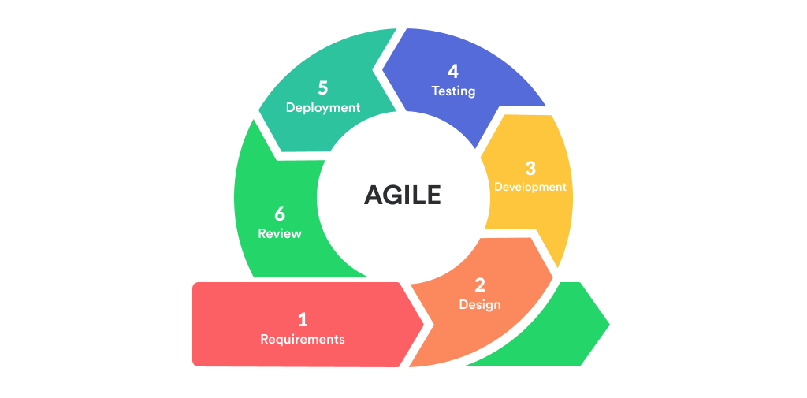

**Figure 2.** shows the Methodology used by the researchers to develop the system. It illustrates the steps that the researchers carried out in iterative model*.*

* *Requirements Phase* – In this phase, the researchers have done interview and observation with the client which is the DSWD and MSWDO office in the Municipality of Sta. Cruz, Laguna to gather information about the process of implementing livelihood programs in order for the researchers to move on the next phase which is the design phase.
* *Design Phase* – In this phase, the researchers used different diagrams like context diagram in order for the researchers to define and clarify the boundaries of the developed system, use case diagram to represent the users’ interaction with the developed system, flowchart to represent the sequence of steps and decisions to perform the process of the developed system, etc. Also, the researchers consulted the client for the layout of the developed system.
* *Development Phase* – In this phase after the researchers have done the different diagrams, the coding and converting the designed diagrams into actual software will take place. The researchers used PHP as programming language, MySQL as the database for all the information gathered. Also, the researchers conducted some suggestions with the adviser and subject specialist for more improvement of the developed system.
* *Testing Phase* – In this phase after the researchers have done developing the functionalities of the system, the software testing will take place. The researchers test the functionalities of the developed system with IT experts through the use of Black Box Testing to ensure that the software is bug-free and the code is clean.
* *Deployment Phase* – In this phase after completing the testing phase, the researchers will deployed the developed system to its working environment. The DSWD and MSWDO Head will be the administrator, the staffs will be the super users, and the participants of the livelihood programs will be the users.
* *Review Phase* – After all the development phases are completed, review phase is performed to review the progress made towards completing the requirements. And if there are any errors found, then the process starts again from the first phase of the Agile methodology. The developed system will be monitored by the developers that there will be no errors.

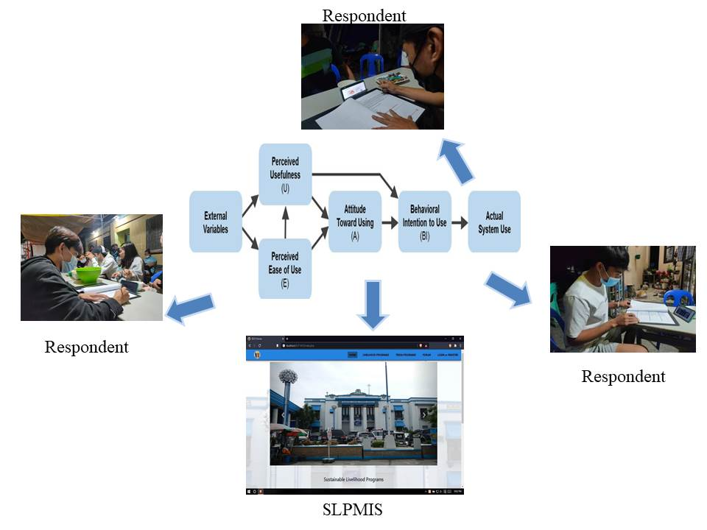**Testing and Evaluation Procedure**

**Figure 3.** This shows the process on how the researchers distribute the questionnaires to the respondents with the use of TAM in terms of Quality Factors, Perceived of Usefulness, Perceived Ease of Use, Attitude Towards Using, Behavioral Intention to Use and Actual Use. The researchers used Technology Acceptance Model (TAM) as survey to gather data form the respondents.

# A study by Durodolu (2016) entitled “Technology acceptance model as a predictor of using information system' to acquire information literacy skills” The TAM is an information system theory that propagates stages to be followed by information seekers or learners in the acceptance, inculcating and utilization of new technology to achieve information literacy skills. This study evaluates the TAM's main variables for Information Literacy acquisition such as: Perceived Usefulness (the intention to use, user training, computer experience, system quality) and Perceived Ease of Use (computer self-efficacy, perception of external control, ease of use, internet self-efficacy, efficacy of library use, computer anxiety, information anxiety, perceived enjoyment and objective usability, behavior and intention).

**Figure 4.** This figure shows software testing method in which the functionalities of software applications are tested

The researchers used black box testing to determine and test the functionalities of the developed system. As mentioned by Jan (2016) in the study entitled “An Innovative Approach to Investigate Various Software Testing Techniques and Strategies” a black box testing is a software testing technique which play an important role in software testing. While performing black box testing, tester don’t have any knowledge of internal design and no access to source code. Testers have only knowledge of system architecture. This technique is to be used to ensure that all inputs needed by the system is accepted in specified manner and provide correct output.

**Testing method**

The researchers disseminated the questionnaires thru an online meet with an IT professional that currently working in the computer industry for an in-depth analysis of the web-based system experience.

# Table 3. Head of DSWD and MSWDO account registration

|  |  |  |
| --- | --- | --- |
| STEP | STEP DETAILS | EXPECTED RESULT |
|
| Admin Home Page | Input Username, Password | Logged In, display Dashboard |
| Accounts | **“Click”** Accounts button | Display all user accounts. |
| Services | **“Click”** Services button | Display all Livelihood Programs. |
| Programs | **“Click”** Programs button | Display all TESDA programs. |
| Create Account | **“Click”** Add Account button | Create account for staff. |
| Manage Account | Select button from Action panel | Can update, edit and delete accounts. |
| View Livelihood Programs | Select Livelihood Program and **“Click”** View Button from Action panel | Views all approved applicants of selected Livelihood program and generate report. |
| View TESDA Programs | Select TESDA Program and **“Click”** View button from Action panel | Views all approved applicants of selected TESDA program and generate report. |
| Manage Account | **“Click”** Manage button | Display and manage own account. |
| Log Out | **“Click”** Log Out button | Log Out |

This shows the testing evaluation for the creation of account for the web-based system.

**Table 4.** Super User 1 and 2 account registration

|  |  |  |
| --- | --- | --- |
| STEP | STEP DETAILS | EXPECTED RESULT |
|
| Admin Home Page | Input Username, Password | Logged In, display Dashboard |
| Services | **“Click”** Services button | Display all Livelihood Programs. |
| Add Livelihood Programs | **“Click”** Add Services button | Insert all information about the new Livelihood Program that are going to be insert into the system |
| View Livelihood Programs | Select Livelihood Program and **“Click”** View button from Action panel | Can view and update information about the selected Livelihood Program |
| View Pending Applicants of Livelihood Programs | Select Livelihood Program and **“Click”** View button from Pending Applicant panel | Can view and approve pending applicants |
| View Approved Applicants of Livelihood Programs | Select Livelihood Program and **“Click”** View button from Approved Applicant panel | Can view, update and generate report about the approved applicants |
| Delete Livelihood Programs | Select Livelihood Program and **“Click** “Delete button from Action panel | Delete selected Livelihood Programs |
| View Programs | **“Click** “Programs Button | Display all TESDA programs. |
| Add TESDA Programs | **“Click”** Add Programs button | Insert all information about the new TESDA Program that are going to be insert into the system |
| View TESDA Programs | Select TESDA Program and **“Click”** View from Action panel | Can view and update information about the selected TESDA Program |
| View Pending Applicants of TESDA Programs | Select TESDA Program and **“Click”** View button from Pending Applicant panel | Can view and approve pending applicants |
| View Approved Applicants of TESDA Programs | Select TESDA Program and **“Click”** View button from Approved Applicant panel | Can view, update and generate report about the approved applicants |
| Delete TESDA Programs | Select TESDA Program and **“Click”** Delete button from Action panel | Delete selected TESDA Programs |
| Manage Account | **“Click”** Manage Button | Display and manage own account. |
| Log Out | **“Click”** Log Out | Log Out |
|  |  |  |

This shows the testing evaluation for the creation of super user 1 and 2 account for the web-based system.

**Table 5.** Applicant account registration

|  |  |  |
| --- | --- | --- |
| STEP | STEP DETAILS | EXPECTED RESULT |
|
| SLP Home Page | View Home page of SLP | Display Home page and information about programs and services |
| Sign up | **“Click”** Signup button | Display signup modal to create personal account |
| Login | **“Click”** Login button | Display login modal to login into the system |
| View Services | **“Click”** Services button | Can view all Livelihood Programs offered of the SLP of Municipality of Santa Cruz, Laguna |
| View Services Description | Select Livelihood Program and **“Click”** Description button | Can view and apply for the selected Livelihood Program |
| View Programs | **“Click”** Programs button | Can view all TESDA Programs offered of the SLP of Municipality of Santa Cruz, Laguna |
| View TESDA Description | Select TESDA Program and **“Click”** Description button | Can view and apply for the selected TESDA Program |
| Contact Us | **“Click”** Contact Us button | Display office hours and address of the Municipality of Santa Cruz, Laguna and people they will find for inquiries. |
| Manage Account | **“Click”** Manage Account button | Can manage personal and account information. |
| My Course | **“Click”** My Course button | Can view pending application or ongoing course. |
| Log Out | **“Click”** Log Out | Log Out |

This shows the testing evaluation for the creation of applicants account for the web-based system*.*

**Table 6.** Testers of Black Box Testing

|  |  |  |
| --- | --- | --- |
| **Tester** | **Names** | **Credentials** |
| Tester 1 | Joelson Arguelles | Mid Programmer |
| Tester 2 | Oliver Aco | Mid Programmer |
| Tester 3  Tester 4 | Eugene Zoleta  Benz Jemver Valenciano | Mid Programmer   Junior Programmer |
| Tester 5 | Gerald Karl Vallez | OIC Municipality Information and Communications Technology Officer |

This table shows the names and credentials of the evaluators for the testing of the system.

**Evaluation Procedure**

In order to attain the evaluation procedure, researchers developed the questionnaire and used the evaluation tool and method for gathering of data and users’ feedback.

**Table 7.** Quality Factors

|  |  |
| --- | --- |
| **Criteria** | |
| 1. **SUITABILITY.**I agree that the developed system has improved the current process of implementing various projects under the Sustainable Livelihood Program (SLP) | ISO/IEC 9126 (2004) |
| 1. **OPERABILITY.**I agree that the developed system contains a user friendly and easy to access interface | ISO/ IEC 9126 (2004) |
| 1. **LEARNABILITY.**I agree that the developed system does not require much effort in terms understanding the flow of the system | ISO/ IEC 9126 (2004) |

This table shows if the developed system has met all the criteria in terms of suitability, operability, and learnability. The written category was based on ISO/IEC 9126. The researchers demonstrated the developed system to the respondents in order for them to recognize if the developed system matches the criteria of quality factors.

**Table 8.** Perceive Ease of Use

|  |  |
| --- | --- |
| **Criteria** | |
| 1. **FUNCTIONALITY.** The developed system can easily organize and sort the data that have been gathered in various programs | ISO/IEC 9126 (2004) |
| 1. **ACCURACY.** The developed system can generate accurate progress tracking reports | ISO/ IEC 9126 (2004) |
| 1. **EFFICIENCY.**I agree that the functionalities of the developed system enhance the way of creating various projects under the Sustainable Livelihood Program | ISO/ IEC 9126 (2004) |

This table shows if the developed system has met all the criteria in terms of functionality, accuracy, and efficiency. The written category was based on ISO/IEC 9126. The researchers demonstrated the developed system to the respondents in order for them to recognize if the developed system matches the criteria of perceive ease of use.

**Table 9.** Experience

|  |  |
| --- | --- |
| **Criteria** | |
| 1. **USER ERROR PROTECTION.**I never experience difficulties something like errors or systems failures while using the system | ISO/IE 25010:2011 |
| 1. **ACCURACY.**I agree that the developed system can generate accurate reports based on the particular programs | ISO/ IEC 9126 (2004) |
| 1. **EFFICIENCY.**I agree that the developed system will make the work easier to its user | ISO/ IEC 9126 (2004) |

This table shows if the developed system has met all the criteria in terms of user error protection, accuracy, and efficiency. The written category was based on ISO/IEC 9126 and ISO/IEC 25010. The researchers demonstrated the developed system to the respondents in order for them to recognize if the developed system matches the criteria of experience.

**Table 10.** Perceive Usefulness

|  |  |
| --- | --- |
| **Criteria** | |
| 1. **ACCESSIBILITY.**I agree that the developed system can be used by the user without technical or software knowledge | ISO/IE 25010:2011 |
| 1. **FUNCTIONALITY.**I agree that the developed system can send notifications regarding the place and time of the implemented program | ISO/ IEC 9126 (2004) |
| 1. **SUITABILITY.**I agree that the developed system allows the user to easily generate reports regarding the Sustainable Livelihood Program | ISO/ IEC 9126 (2004) |

This table shows if the developed system has met all the criteria in terms of accessibility, functionality, and suitability. The written category was based on ISO/IEC 9126 and ISO/IEC 25010. The researchers demonstrated the developed system to the respondents in order for them to recognize if the developed system matches the criteria of perceive usefulness.

**Table 11.** Attitude Towards Using

|  |  |
| --- | --- |
| **Criteria** | |
| 1. **TIME BEHAVIOUR.** The developed system will help the user to save time and effort in terms of getting the needed information in implementing various projects under the Sustainable Livelihood Program | ISO/IE 25010:2011 |
| 1. **TRUST.**I agree that the developed system will be helpful to the participants and also the staff in charge which handles the implementation of the program | Urban, Sultan, and Qualls (2000) |
| 1. **EFFICIENCY.**I agree that the developed system is effective and efficient in terms of implementing various projects under the Sustainable Livelihood Program | ISO/ IEC 9126 (2004) |

This table shows if the developed system has met all the criteria in terms of time behavior, trust, and efficiency. The written category was based on ISO/IEC 9126, ISO/IEC 25010, and Sloan Management review. The researchers demonstrated the developed system to the respondents in order for them to recognize if the developed system matches the criteria of attitude towards using.

**Table 12.** Behavioral Intention to Use

|  |  |
| --- | --- |
| **Criteria** | |
| 1. **CONFIDENTIALITY.**I agree that the developed system is reliable in terms security and getting the overall result of the implemented program | ISO/IE 25010:2011 |
| 1. **ACCURACY.**I agree that the developed system functionalities were accurate to its expected respond | ISO/ IEC 9126 (2004) |
| 1. **FUNCTIONAL APPROPRIATENESS.**I agree that the study satisfies the user in terms of the overall flow of the system | ISO 9241- 110 |

This table shows if the developed system has met all the criteria in terms of confidentiality, accuracy, and functional appropriateness. The written category was based on ISO/IEC 9126, ISO/IEC 25010, and ISO 9241-110. The researchers demonstrated the developed system to the respondents in order for them to recognize if the developed system matches the criteria of behavioral intention to use.

**Table 13.** Actual Use

|  |  |
| --- | --- |
| **Criteria** | |
| 1. **FUCNTIONALITY.** The developed system is very useful in terms implementing various projects under the Sustainable Livelihood Program | ISO/ IEC 9126 (2004) |
| 1. **ACCESIBILITY.**I agree that I can operate the system properly and efficiently | ISO/IEC 25010:2011 |
| 1. **INTEROPERABILITY.** The developed system satisfies and meet the user’s expectation with the system | ISO/ IEC 9126 (2004) |

This table shows if the developed system has met all the criteria in terms of functionality, accessibility, and interoperability. The written category was based on ISO/IEC 9126 and ISO/IEC 25010. The researchers demonstrated the developed system to the respondents in order for them to recognize if the developed system matches the criteria of actual use.

**CHAPTER IV**

**RESULTS AND DISCUSSION**

This chapter presents the objectives of the study. It shows the analysis and interference of results acquired from development, testing and evaluation conducted by the researchers. It also discusses if the study entitled Sustainable Livelihood Program Management Information System with SMS notification has satisfied and meets the needs of the client which is the DSWD and MSWDO office in the Municipality of Sta. Cruz, Laguna.

**Research objective:**

Sustainable Livelihood Program Management Information System with SMS notification aims to evaluate and organize their progress tracking of Sustainable Livelihood Program (SLP) of Municipality of Sta. Cruz, Laguna so that each application can have its own schedule and time for appointment and improvise the checking of validity of each requirement needed. Specifically, it aims to:

**Research Objective No. 1:** To develop and design a system that will create programs for new application that the ways of selecting participants in different programs such as Sustainable Livelihood Programs (SLP) and Technical Education and Skills Development Authority (TESDA) will be applicable for all possible programs in the future.

The researchers used fact finding techniques to know how the current process of implementing different livelihood programs in the Municipality of Sta. Cruz, Laguna. An interview was conducted with Ms. Laarnie last February 11, 2020, during the interview the researchers asked the client about the process of livelihood programs then replied *“Kung pano? yung ginagwa o selection? kami ang kumukuha ng data sa kanila . pangalan, address, anung natapos… iniinterview namin”* then the researchers explained that if the process goes thru online there will be a form to fill up because Ms. Laarnie said that *“wala kaming form.”* And they can register there. They can also view the different programs that they want to avail. February 13, 2020 the researchers returned to the municipality to gather additional information about the process of implementing Sustainable Livelihood Program. The researchers asked Ms. Maribelle if the data of the past livelihood programs are available in order for the researchers to get another information but Ms. Maribelle said that *“Itatanong ko muna dun sa DSWD pdo ko kung pwedeng ibigay sa inyo. Bakit ano bang kailangan nyo bakit kailagan nyong makuha data nila?”,”* *Hindi ko naman pwedeng ibigay sa inyo yung data kasi ano din sila… pero ano ba gusto nyong malaman? Yung data ng 2019 livelihood kasi may livelihood na katulad nun skills training in cosmetology ang hindi palang dyan ay yung mason carpentry kasi ngayong 2020 yan itetraining pero yung apat nay un ay 2019.”*The researchers asked if there are funds used for beneficiaries then Ms. Maribelle said that *“Pondong ginamit yan from DSWD SLP”, “May transpo tapos may allowance for 2 days meron silang narerecieve na starter kit yung pang rebond pang gupit basta project ni DSWD funded yan.kaya nga napakaswerte ng mga beneficiaries na papasok na lang samantalang ang daming nagaaral na gumagastos pa sa TESDA di ba? Ang gusto lang ay yung sigurado ang training ay tatapusin at ipapasa kasi ay sayang at employment kasi napakaganda katulad na lang nung sa welding namin meron na ring nakaabang na employer.”* The researchers asked the process then *“Dadating yung employer orientation meron ding interview yun.kaya nga ang gusto ng DSWD ay yung mga indigent.” “Kasi ganto yan training palang nandito na si employer na inaabangan na sila . ang hinahanp ni employer ay yung NCs nila kung nakapasa.”* There is also a limit for age 18 and above only can participate as stated by Ms. Maribelle. The client also added that *“May mga barangay league meeting lahat ng kapitan edi bumababa ako iaanounce ko para sila may reperal .”* Ms. Maribelle also said that *“Kasi pagka DSWD kasi mahirap hindi mo masasala ang indigent diba? Ang kailangan ng DSWD indigent.”* The researchers suggest that there will be a progress tracking of every participant because based on the researchers’ idea *“Kasi ang idea po naming hindi po sila basta basta pupunta ditto inonotify po sila kasi iveverify nyo pa po kung indigent sila tas makakarecieve po sya ng text na pwede na po sya.”* Ms.Maribelle gladly said that *“Pwede yun.katulda ngayong 2020 ang social preparation namin ay kung ano yung gusto ng tao sa isang barangay na business na hindi sari sara kasi nga sustainable eh kaso mayayare . 2015 pa ang DSWD SLP sa sta. cruz may capital assistance, may hog raising , may organic farming kaya ngayon social preparation kung ano gusto ng tao.”* The researchers asked again if there are forms to be fill up then Ms. Maribelle said that *“Nagkakaroon kasi sila ng form kapag acceptance na tumanggap na sila ng ganto mulas sa DSWD pero kapag registration kumpleto pangalan ,edad laging may datos .”* Through this interview the researchers have known the process and different information that is relevant in developing the system.

**Software Development Model**

The researchers used Agile Methodology for the development of the system. Every phase discussed the results from the gathered information with the client and the outcome of the developed system.

*Requirement phase*

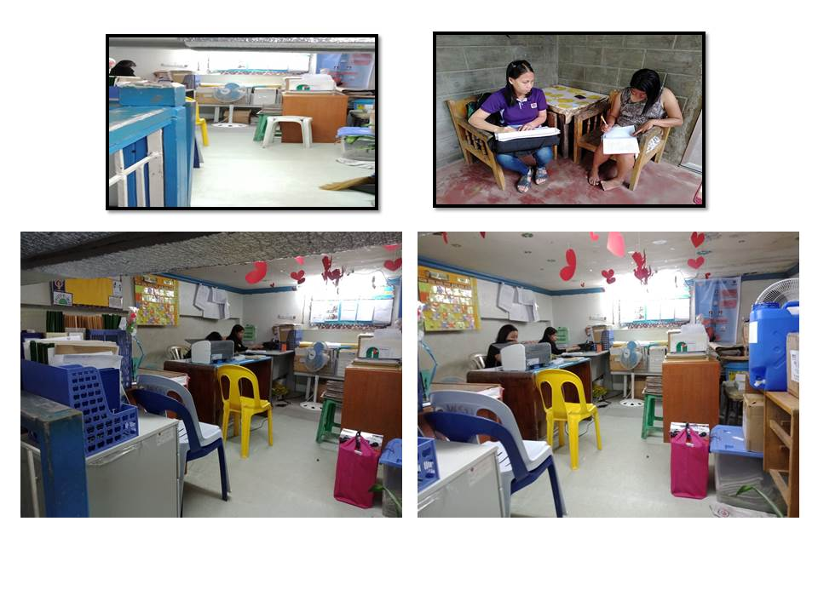 Through the interview and observation, the information gathered will be the basis of the researchers on creating a system that will enhance the manual process of the client in terms of implementing livelihood programs.

**Figure 5.** Gathered information through interview and observation which is one of the processes of the client is door to door interview and through observation, the researchers observed that the data gathered by the client is storing it on cabinets and drawers.

*Design phase*

Through the use of different diagrams the researchers have already formulated a user- friendly interface that would be preferable by the client and the citizens. The overall design will be viewed at the story board created by the researchers that is included in the appendices.

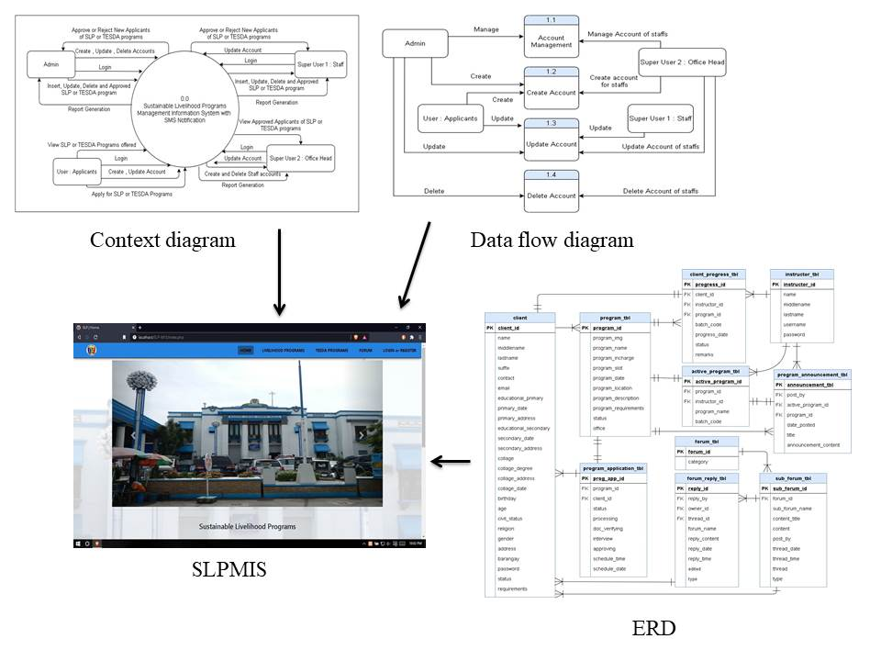

**Figure 6.** The designing process of the Sustainable Livelihood Program Management System with SMS Notification.

*Development phase*

In this phase, the researchers used software tools like PHP as the programming language and MySQL as the database. Also, the conducted consultations with the adviser and subject specialist for additional suggestions to the development of the system.

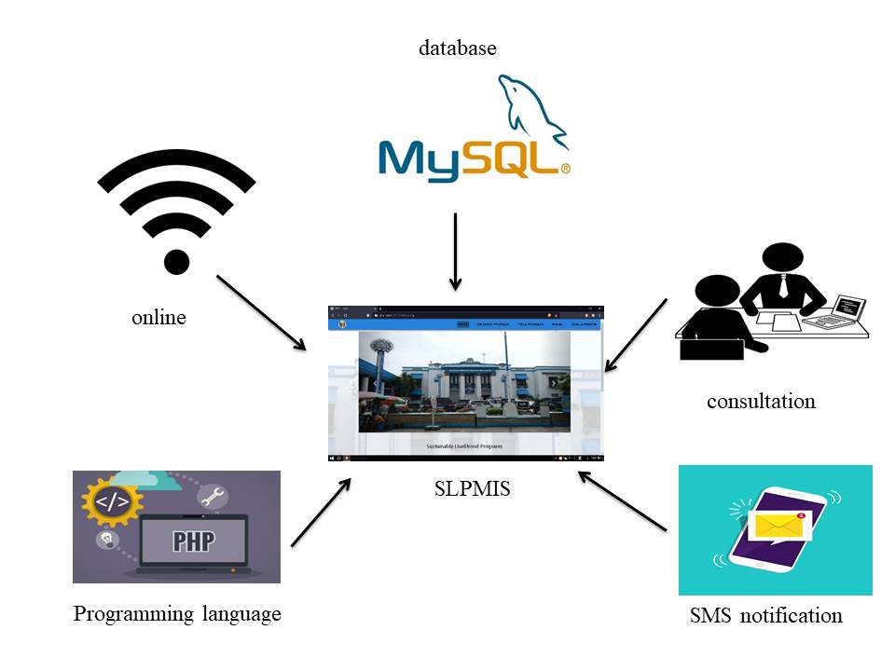

**Figure7.** Software tools used to develop the system and the consultation to get some suggestions regarding the development of the system.

*Testing phase*

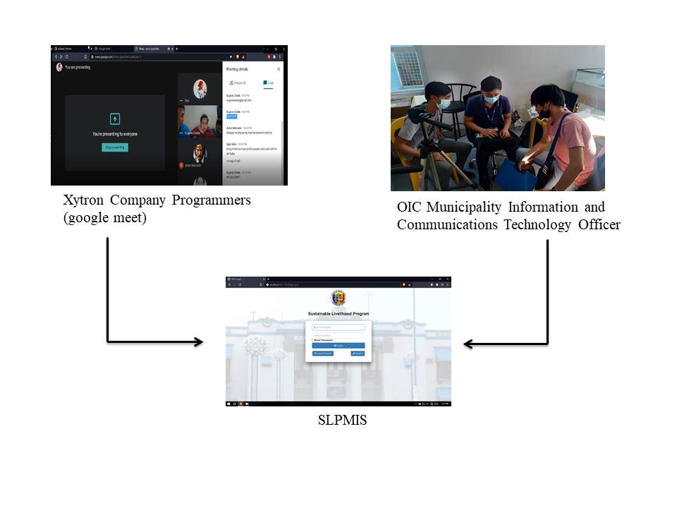 In this phase, the researchers test the functionalities of the developed system with IT experts through the use of Black Box Testing to ensure that all the functions are met.

**Figure8.** Testing of the functionalities of the developed system with different IT experts.

*Deployment phase*

In this phase, the researchers will deploy the developed system to the client in order to be used in its working environment.

*Review phase*

Review phase is performed to review the progress made towards completing the requirements and if there are any errors found. The developers will monitor the developed system to ensure that there will be no errors will occur while the client using it.

**Research Objective No. 2:** To test the functionalities of the organized and developed record management and progress tracking reports and attendance monitoring based on: a) Project Management, b) Online Application and Tracking, c) User Management, d) Document Management, e) Report Generation, f) SMS Notification

The researchers used Black Box Testing as software testing to evaluate the developed system with IT experts to test the functionalities if it meets all the given functions.

**Table 14.** Applicant account registration

|  |  |  |
| --- | --- | --- |
| **Functions** | **STATUS** | |
| **PASS** | **FAIL** |
| SLP Home Page | 5 | 0 |
| Sign up | 5 | 0 |
| Login | 5 | 0 |
| View Services | 5 | 0 |
| View Services Description | 5 | 0 |
| View Programs | 5 | 0 |
| View TESDA Description | 5 | 0 |
| Contact Us | 5 | 0 |
| Manage Account | 5 | 0 |
| My Course | 5 | 0 |
| Log Out | 5 | 0 |

This table shows the result of the testing for applicant account registration with a status of pass and 0 failures.

**Table 15.** Staff of DSWD and MSWDO office account

|  |  |  |
| --- | --- | --- |
| **Functions** | **STATUS** | |
| **PASS** | **FAIL** |
| Admin Home Page | 5 | 0 |
| Services | 5 | 0 |
| Add Livelihood Programs | 5 | 0 |
| View Livelihood Programs | 5 | 0 |
| View Pending Applicants of Livelihood Programs | 5 | 0 |
| View Approved Applicants of Livelihood Programs | 5 | 0 |
| Delete Livelihood Programs | 5 | 0 |
| View Programs | 5 | 0 |
| Add TESDA Programs | 5 | 0 |
| View TESDA Programs | 5 | 0 |
| View Pending Applicants of TESDA Programs | 5 | 0 |
| View Approved Applicants of TESDA Programs | 5 | 0 |
| Delete TESDA Programs | 5 | 0 |
| Manage Account | 5 | 0 |
| Log Out | 5 | 0 |

This table shows the result of the testing for staff of DSWD and MSWDO office account with a status of pass and 0 failures.

**Table 16.** Head of DSWD and MSWDO office account

|  |  |  |
| --- | --- | --- |
| **STEP** | **STATUS** | |
| **PASS** | **FAIL** |
| Admin Home Page | 5 | 0 |
| Accounts | 5 | 0 |
| Services | 5 | 0 |
| Programs | 5 | 0 |
| Create Account | 5 | 0 |
| Manage Account | 5 | 0 |
| View Livelihood Programs | 5 | 0 |
| View TESDA Programs | 5 | 0 |
| Manage Account | 5 | 0 |
| Log Out | 5 | 0 |

This table shows the result of the testing for head of DSWD and MSWDO office account with a status of pass and 0 failures.

All the tables indicated above shows the overall result of the black box testing with five IT experts. All the functionalities given are met. Also, the IT experts give some recommendations on improving the user interface of the developed system and the researchers applied it for improvement.

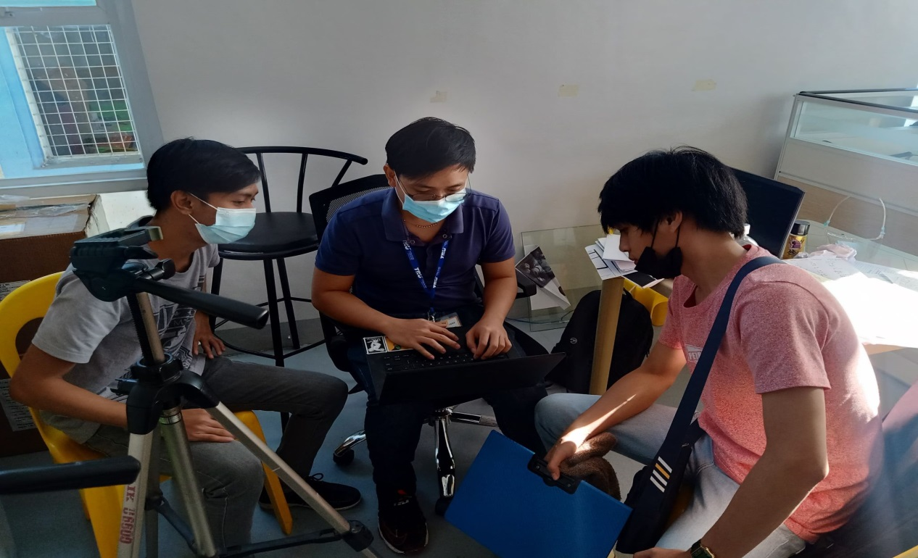**Figure 9.** The researchers test the functionalities of the developed system with the IT expert which has a position of OIC Municipality Information and Communications Technology Officer in the Municipality of Sta. Cruz, Laguna.

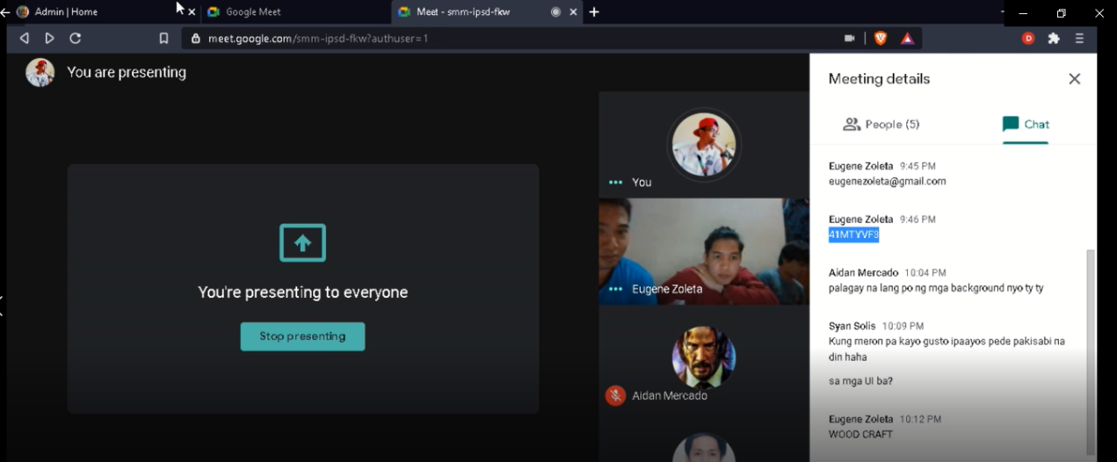  
 **Figure 10.** The researchers conduct an online google meet with 4 programmers of Xytron Company to demonstrate the functionalities of the developed system.

**Research Objective No. 3:** To assessed the developed system in terms of acceptability and behavioral intention upon use of any related to Sustainable Livelihood Program such as: a) Quality Factors, b) Perceived Ease of Use, c) Experience, d) Perceived Usefulness, e) Attitude Towards Using, f) Behavioural Intention to Use, g) Actual Use

The researchers used Technology Acceptance Model with the combination of ISO for evaluation on how the user accepted the technology by giving criteria on the following:

**Table 17.** Quality Factors Result

|  |  |  |  |
| --- | --- | --- | --- |
| **Findings** | **Mean** | **Standard Deviation** | **Interpretation** |
| 1. **SUITABILITY.**I agree that the developed system has improved the current process of implementing various projects under the Sustainable Livelihood Program (SLP) | 4.37 | 0.547 | Highly Acceptable |
| 1. **OPERABILITY.**I agree that the developed system contains a user friendly and easy to access interface | 4.60 | 0.497 | Highly Acceptable |
| 1. **LEARNABILITY.**I agree that the developed system does not require much effort in terms understanding the flow of the system | 4.40 | 0.553 | Highly Acceptable |
| **Weighted Mean** | 4.46 | 0.538 | **Highly** **Acceptable** |

Legend:

**Scale Range Verbal Interpretation**

5 4.20-5.00 Highly Acceptable

4 3.40-4.19 Acceptable

3 2.60-3.39 Moderately Acceptable

2 1.80-2.59 Not Acceptable

1 1.00-1.79 Highly Not Acceptable

Based on the respondents’ perception through using the developed system in terms of quality factors was highly acceptable. The criteria for quality factors in terms of suitability (Mean = 4.37, Standard Deviation = 0.547), operability (Mean = 4.60, Standard Deviation = 0.497), and the respondents does not require much effort in terms understanding the flow of the system through the criteria of learnability (Mean = 4.40, Standard Deviation = 0.553). All of the results of verbal interpretation were highly acceptable with an overall mean of 4.46 and standard deviation of 0.538.

This means that the developed system were able to use by the respondents higher degree. This is done by the criteria of suitability, operability, and learnability that focuses on the developed system entitled Sustainable Livelihood Program Management Information System with SMS Notification.

**Table 18.** Perceived Ease of Use Result

|  |  |  |  |
| --- | --- | --- | --- |
| **Findings** | **Mean** | **Standard Deviation** | **Interpretation** |
| 1. **FUNCTIONALITY.** The developed system can easily organize and sort the data that have been gathered in various programs | 4.29 | 0.572 | Highly Acceptable |
| 1. **ACCURACY.** The developed system can generate accurate progress tracking reports | 4.43 | 0.558 | Highly Acceptable |
| 1. **EFFICIENCY.**I agree that the functionalities of terms of Quality Factors the developed system enhance the way of creating various projects under the Sustainable Livelihood Program | 4.46 | 0.611 | Highly Acceptable |
| **Weighted Mean** | 4.39 | 0.580 | **Highly Acceptable** |

Legend:

**Scale Range Verbal Interpretation**

5 4.20-5.00 Highly Acceptable

4 3.40-4.19 Acceptable

3 2.60-3.39 Moderately Acceptable

2 1.80-2.59 Not Acceptable

1 1.00-1.79 Highly Not Acceptable

Based on the respondents’ perception through using the developed system in terms of perceived ease of use was highly acceptable. The criteria for perceived ease of use in terms of functionality (Mean = 4.29, Standard Deviation = 0.572), accuracy (Mean = 4.43, Standard Deviation = 0.558), and enhancing the way of creating various projects under Sustainable Livelihood Program in efficiency (Mean = 4.46, Standard Deviation = 0.611). All of the results of verbal interpretation were highly acceptable with an overall mean of 4.39 and standard deviation of 0.580.

This means that the developed system were able to use by the respondents at a higher degree. This is done by the criteria of functionality, accuracy, and efficiency that focuses on the developed system entitled Sustainable Livelihood Program Management Information System with SMS Notification.

**Table 19.** Experience Result

|  |  |  |  |
| --- | --- | --- | --- |
| **Findings** | **Mean** | **Standard Deviation** | **Interpretation** |
| 1. **USER ERROR PROTECTION.**I never experience difficulties something like errors or systems failures while using the system | 4.43 | 0.655 | Highly Acceptable |
| 1. **ACCURACY.**I agree that the developed system can generate accurate reports based on the particular programs | 4.51 | 0.562 | Highly Acceptable |
| 1. **EFFICIENCY.**I agree that the developed system will make the work easier to its user Livelihood Program | 4.43 | 0.558 | Highly Acceptable |
| **Weighted Mean** | 4.46 | 0.589 | **Highly Acceptable** |

Legend:

**Scale Range Verbal Interpretation**

5 4.20-5.00 Highly Acceptable

4 3.40-4.19 Acceptable

3 2.60-3.39 Moderately Acceptable

2 1.80-2.59 Not Acceptable

1 1.00-1.79 Highly Not Acceptable

Based on the respondents’ perception through using the developed system in terms of experience was highly acceptable. The criteria for experience in terms of user error protection, the respondents never experience any errors or system failure while using the system (Mean = 4.43, Standard Deviation = 0.655), accurate generating of reports was experience by the respondents in terms of accuracy (Mean = 4.51, Standard Deviation = 0.562), and the respondents experience that the developed system will make the work easier (Mean = 4.43, Standard Deviation = 0.558). All of the results of verbal interpretation were highly acceptable with an overall mean of 4.46 and standard deviation of 0.589.

This means that the developed system were able to use by the respondents at a higher degree. This is done by the criteria of user error protection, accuracy, and efficiency that focuses on the developed system entitled Sustainable Livelihood Program Management Information System with SMS Notification.

**Table 20.** Perceived Usefulness Result

|  |  |  |  |
| --- | --- | --- | --- |
| **Findings** | **Mean** | **Standard Deviation** | **Interpretation** |
| 1. **ACCESSIBILITY.**I agree that the developed system can be used by the user without technical or software knowledge | 4.57 | 0.558 | Highly Acceptable |
| 1. **FUNCTIONALITY.**I agree that the developed system can send notifications regarding the place and time of the implemented program | 4.26 | 0.657 | Highly Acceptable |
| 1. **SUITABILITY.**I agree that the developed system allows the user to easily generate reports regarding the Sustainable Livelihood Program | 4.40 | 0.604 | Highly Acceptable |
| **Weighted Mean** | 4.41 | 0.615 | **Highly Acceptable** |

Legend:

**Scale Range Verbal Interpretation**

5 4.20-5.00 Highly Acceptable

4 3.40-4.19 Acceptable

3 2.60-3.39 Moderately Acceptable

2 1.80-2.59 Not Acceptable

1 1.00-1.79 Highly Not Acceptable

Based on the respondents’ perception through using the developed system in terms of perceived usefulness was highly acceptable. The criteria for perceived usefulness in terms of accessibility, (Mean = 4.57, Standard Deviation = 0.558), the respondents agree that the developed system send notifications regarding the place and time of the implemented program in regards with its’ functionality (Mean = 4.26, Standard Deviation = 0.657), and the respondents agree that the developed system allows the user to easily generate reports regarding the Sustainable Livelihood Program in regards to suitability (Mean = 4.40, Standard Deviation = 0.604). All of the results of verbal interpretation were highly acceptable with an overall mean of 4.41 and standard deviation of 0.615.

This means that the developed system were able to use by the respondents at a higher degree. This is done by the criteria of accessibility, functionality, and suitability that focuses on the developed system entitled Sustainable Livelihood Program Management Information System with SMS Notification.

**Table 21.** Attitude Towards Using Result

|  |  |  |  |
| --- | --- | --- | --- |
| **Findings** | **Mean** | **Standard Deviation** | **Interpretation** |
| 1. **TIME BEHAVIOUR.** The developed system will help the user to save time and effort in terms of getting the needed information in implementing various projects under the Sustainable Livelihood Program | 4.49 | 0.562 | Highly Acceptable |
| 1. **TRUST.**I agree that the developed system will be helpful to the participants and also the staff in charge which handles the implementation of the program | 4.34 | 0.639 | Highly Acceptable |
| 1. **EFFICIENCY.**I agree that the developed system is effective and efficient in terms of implementing various projects under the Sustainable Livelihood Program | 4.43 | 0.502 | Highly Acceptable |
| **Weighted Mean** | 4.42 | 0.568 | **Highly Acceptable** |

Legend:

**Scale Range Verbal Interpretation**

5 4.20-5.00 Highly Acceptable

4 3.40-4.19 Acceptable

3 2.60-3.39 Moderately Acceptable

2 1.80-2.59 Not Acceptable

1 1.00-1.79 Highly Not Acceptable

Based on the respondents’ perception through using the developed system in terms of attitude towards using was highly acceptable. The criteria for attitude towards using in terms of time behavior, the respondents agree that the developed system will help them to save time and effort in getting the needed information in regards to sustainable livelihood program, (Mean = 4.49, Standard Deviation = 0.562), the respondents agree that the developed system will be helpful with both participants and staff/s in regards of its’ trust (Mean = 4.34, Standard Deviation = 0.639), and the respondents agree that the developed system is effective and efficient in regards to the sustainable livelihood program because of its efficiency (Mean = 4.43, Standard Deviation = 0.502). All of the results of verbal interpretation were highly acceptable with an overall mean of 4.42 and standard deviation of 0.568.

This means that the developed system were able to use by the respondents at a higher degree. This is done by the criteria of time behaviour, trust, and efficiency that focuses on the developed system entitled Sustainable Livelihood Program Management Information System with SMS Notification.

**Table 22.** Behavioral Intention to Use Result

|  |  |  |  |
| --- | --- | --- | --- |
| **Findings** | **Mean** | **Standard Deviation** | **Interpretation** |
| 1. **CONFIDENTIALITY.**I agree that the developed system is reliable in terms security and getting the overall result of the implemented program | 4.51 | 0.612 | Highly Acceptable |
| 1. **ACCURACY.**I agree that the developed system functionalities were accurate to its expected respond | 4.26 | 0.780 | Highly Acceptable |
| 1. **FUNCTIONAL APPROPRIATENESS.**I agree that the study satisfies the user in terms of the overall flow of the system | 4.54 | 0.611 | Highly Acceptable |
| **Weighted Mean** | 4.44 | 0.678 | **Highly Acceptable** |

Legend:

**Scale Range Verbal Interpretation**

5 4.20-5.00 Highly Acceptable

4 3.40-4.19 Acceptable

3 2.60-3.39 Moderately Acceptable

2 1.80-2.59 Not Acceptable

1 1.00-1.79 Highly Not Acceptable

Based on the respondents’ perception through using the developed system in terms of behavioral intention to use was highly acceptable. The criteria for behavioral intention to use in terms of confidentiality, the respondents agree that the developed system is reliable in terms of security and getting the overall result of the implemented program, (Mean = 4.51, Standard Deviation = 0.612), the respondents agree that the developed system were accurate to its expected response in regards of its accuracy (Mean = 4.26, Standard Deviation = 0.780), and the respondents agree that the developed system satisfies them in the overall flow of the system in regards on functional appropriateness (Mean = 4.54, Standard Deviation = 0.611). All of the results of verbal interpretation were highly acceptable with an overall mean of 4.44 and standard deviation of 0.678.

This means that the developed system were able to use by the respondents at a higher degree. This is done by the criteria of confidentiality, accuracy and functional appropriateness that focuses on the developed system entitled Sustainable Livelihood Program Management Information System with SMS Notification.

**Table 23.** Actual Use Result

|  |  |  |  |
| --- | --- | --- | --- |
| **Findings** | **Mean** | **Standard Deviation** | **Interpretation** |
| 1. **FUCNTIONALITY.** The developed system is very useful in terms implementing various projects under the Sustainable Livelihood Program | 4.54 | 0.561 | Highly Acceptable |
| 1. **ACCESIBILITY.**I agree that I can operate the system properly and efficiently | 4.49 | 0.562 | Highly Acceptable |
| 1. **INTEROPERABILITY.** The developed system satisfies and meet the user’s expectation with the system | 4.43 | 0.608 | Highly Acceptable |
| **Weighted Mean** | 4.39 | 0.574 | **Highly Acceptable** |

Legend:

**Scale Range Verbal Interpretation**

5 4.20-5.00 Highly Acceptable

4 3.40-4.19 Acceptable

3 2.60-3.39 Moderately Acceptable

2 1.80-2.59 Not Acceptable

1 1.00-1.79 Highly Not Acceptable

Based on the respondents’ perception through using the developed system in terms of actual use was highly acceptable. The criteria for actual use in terms of functionality, the respondents agree that the developed system is useful in implementing various projects under sustainable livelihood program, (Mean = 4.54, Standard Deviation = 0.561), the respondents agree that they operate the system properly and efficiently in regards on accessibility (Mean = 4.49, Standard Deviation = 0.562), and the respondents agree that the developed system satisfies and meet their expectations in regards to interoperability (Mean = 4.43, Standard Deviation = 0.608). All of the results of verbal interpretation were highly acceptable with an overall mean of 4.39 and standard deviation of 0.574.

This means that the developed system were able to use by the respondents at a higher degree. This is done by the criteria of functionality, accessibility and interoperability that focuses on the developed system entitled Sustainable Livelihood Program Management Information System with SMS Notification.

**Table 24.** Overall Results

|  |  |  |
| --- | --- | --- |
| **Findings** | **Mean** | **Interpretation** |
| Quality Factors | 4.46 | Highly Acceptable |
| Perceived Ease of Use | 4.39 | Highly Acceptable |
| Experience | 4.46 | Highly Acceptable |
| Perceived Usefulness | 4.41 | Highly Acceptable |
| Attitude Towards Using | 4.42 | Highly Acceptable |
| Behavioral Intention to Use | 4.46 | Highly Acceptable |
| Actual Use | 4.49 | Highly Acceptable |
| **Overall Mean** | **4.441** | **Highly Acceptable** |

This table shows the overall result of the surveys wherein the quality factors got an overall mean of 4.46, perceived ease of use with an overall mean of 4.39, experience with an overall mean of 4.46, perceived usefulness with an overall mean of 4.41, attitude towards using with an overall mean of 4.42, behavioral intention with an overall mean of 4.46, and actual use with an overall mean of 4.49. The researchers compute all the results of each criteria and the overall result was 4.441 and a verbal interpretation of highly acceptable.

This means that the developed system met all the criteria given in terms of quality factors, perceived ease of use, experience, perceived usefulness, attitude towards using, behavioral intention to use and actual use.

**CHAPTER V**

**SUMMARY, CONCLUSION AND RECOMMENDATION**

This chapter presents the last part of the research that includes the summary and conclusion of the study. Also, it includes all the recommendations that the system needs for further improvements in the future.

**Summary**

Sustainable Livelihood Program Management Information System with SMS notification is a web-based system that focused on organizing and managing all the data of every participant in livelihood programs and TESDA programs. Instead of manual registration, an online platform is developed wherein user registration is online. Through this method it is less hassle and overcrowding at municipal office will be avoided. Also, the system contains SMS notification that notifies participants for schedule of appointment and requirements needed for each program that the participant applied. The system could also generate report about SLP with the help of system database. For the system homepage it contains available programs that the participants can apply.

The “Sustainable Livelihood Program Management Information System with SMS notification” was proposed to technologize the manual process of implementing livelihood programs into an automated process to enhance the services of DSWD and MSWDO office. The researchers used an info graphical conceptual framework in developing the study. The researchers also used the Agile model as a methodology in developing the system. In testing the system, the researchers conduct a simulation testing and give survey questionnaires using TAM with the combination of ISO and Black Box Testing.

The researchers have a profound knowledge in the web-based development system and database system that the researchers extremely need. The researchers used programming and software tools like PHP, MySQL, XAMPP, Jquery, and sublime text.

**Conclusion**

Based on the feedbacks and survey results, it showed that the developed study was ready to use and helpful for the participants especially for DSWD and MSWDO staffs. The researchers proved that the respondents were satisfied and ready to adapt the newly enhance technology for livelihood programs.

1. In order to modernize the current process of implementing different livelihood programs with the client which is the DSWD and MSWDO Office in the Municipality of Sta. Cuz , Laguna, the researchers used fact finding techniques like interview, observation, online research, and consultation to develop the system entitled “ Sustainable Livelihood Program Management Information System with SMS Notification”.
2. The researchers used Black Box Testing to test the functionalities of the developed management information system in terms of function and features with (5) IT experts and Technology Acceptance Model (TAM) to evaluate the user acceptance of the respondents with the developed system.
3. Sustainable Livelihood Program Management Information System with SMS Notification is an automated system that can help the user to make their applying in various programs easier and hassle less because of its functions that is capable of adapting the purpose of the implemented program.

**Recommendations**

Here are some recommendations for the improvement of the developed system entitled” Sustainable Livelihood Program Management Information System with SMS Notification”:

1. To the future researchers, further improvement to the user interface of the developed system is needed.
2. To the future researchers, create a mobile application that is suited for the developed system.
3. To the future researchers, enhance the functionalities of the developed system.

**BIBLIOGRAPHY**

ABBASI, A., SARKER, S., & CHIANG, R. H. (2016). Big data research in information systems: Toward an inclusive research agenda. Journal of the Association for Information Systems, 17(2), 3.

ABU-SHANAB E. A. (2017). E-government familiarity influence on Jordanians’ perceptions. Telematics and Informatics, 34(1), 103-113.

ADAM, A.B., OWEN, J. R., & KEMP, D. (2015). Households, livelihoods and mining-induced displacement and resettlement. The Extractive Industries and Society, 2(3), 581-589.

ADAMS, C., RODRIGUES, S. T., CALMON M., & KUMAR, C. (2016). Impacts of large‐scale forest restoration on socioeconomic status and local livelihoods: what we know and do not know. Biotropica, 48(6), 731-744.

AHETO, D. W., KANKAM, S., OKYERE, I., MENSAH, E., OSMAN, A., JONAH, F. E., & MENSAH, J. C. 2016). Community-based mangrove forest management: implications for local livelihoods and coastal resource conservation along the Volta estuary catchment area of Ghana. Ocean & coastal management, 127, 43-54.

ANTHOPOULOS L, REDDICK C. G. GIANNAKIDOU I, & MAYRIDIS N. (2016). Why e-government projects fail? An analysis of the Healthcare. gov website. Government Information Quarterly, 33(1), 161-173.

BAUCHET, J., MORDUCH, J., & RAVI, S. (2015). Failure vs. displacement: Why an innovative anti-poverty program showed no net impact in South India. *Journal of Development Economics*, *116*, 1-16.

BECHTEL, K. L., & WEINSTEIN R. M. (2016). U.S. Patent No. 9,285,966. Washington, DC: U.S. Patent and Trademark Office.

BORDEN B., & BRAND, R. (2017). U.S. Patent No. 9,678,967. Washington, DC: U.S. Patent and Trademark Office.

CARNEY, D. (2016). Approaches to sustainable livelihoods for the rural poor (p. 32). London: Overseas Development Institute.

CARRE, G., & MUTRICY, A. (2018). U.S. Patent No. 10,127,724. Washington, DC: U.S. Patent and Trademark Office.

CARTER, L., WEERAKKODY, V., PHILLIPS, B., DWIVEDI, Y. K. (2016). Citizen adoption of e-government services: Exploring citizen perceptions of online services in the United States and United Kingdom. Information Systems Management, 33(2), 124-140.

CHANDRA, A., DARGUSCH, P., MCNAMARA, K.E., CASPE, A. M., & DALABIAN, D. (2017). A study of climate-smart farming practices and climate-resiliency field schools in Mindanao, the Philippines. World Development, 98, 214-230.

CHO, Y. ROBALINA, D., & WATSON, S. (2016). Supporting self-employment and small-scale entrepreneurship: potential programs to improve livelihoods for vulnerable workers. IZA Journal of Labor Policy, 5(1), 7.

DASGUPTA, A., GAWANDE, K., & KAPUR, D. (2017). (When) do antipoverty programs reduce violence? India's rural employment guarantee and Maoist conflict. International organization, 605-632.

DE HAAN, L. J. (2016). The livelihood approach: A critical exploration. Erdkunde, 345-357.

DE HAAN, L., & ZOOMERS, A. (2016). Development geography at the crossroads of livelihood and globalization. Tijdschrift voor economize en social geography, 94(3), 350-362.

EKAYANTI, S. M., RIFA A., & IRWAN M. (2018). Determinants effectiveness fixed asset management of district government on the Island of Lombok. International Journal of Business Management and Economic Research (IJBMER), 9(1), 1219-1229.

ELLIS, F. (2015). Rural livelihood diversity in developing countries: evidence and policy implications (Vol. 40, No. 1, pp. 1-10). London: Overseas Development Institute.

ELLIS, F. (2018). Rural livelihood diversity in developing countries: evidence and policy implications (Vol. 40, No. 1, pp. 1-10). London: Overseas Development Institute.

ELLIS, F., & BIGGS, S. (2017). Evolving themes in rural development 1950s‐2000s. Development policy review, 19(4), 437-448.

ELLIS, F., &FREEMAN, H.A. (2015). Rural livelihoods and poverty reduction strategies in four African countries. Journal of development studies, 40(4), 1-30.

FORDAM, A. E., ROBINSOM, G. M., BLACKWELL, B. D., & CLEARY, J. (2018). Contributing to sustainable community livelihoods: corporate social responsibility programmes of resource companies. Rural Society, 27(3), 224-242.

GOLDSHMIDT, K. H., & KUMAR, S. (2016). Humanitarian operations and crisis/disaster management: A retrospective review of the literature and framework for development. International Journal of Disaster Risk Reduction, 20, 1-13.

HARIGUNA, T., LAI, M. T., HUNG, C. W., & CHEN, S. C. (2017). Understanding information system quality on public e-government service intention: an empirical study. International Journal of Innovation and Sustainable Development, 11(2-3), 271-290.

HOSSAIN, M. A., AHEMD, M., OJEA, E., & FERNANDERS, J. A. (2018). Impacts and responses to environmental change in coastal livelihoods of south-west Bangladesh. Science of the total environment, 637, 954-970.

JAZID, A. I. M., IBRAHIM, P., & RASHID, U.K. (2019). Poverty Reduction through Entrepreneurship Programmes. International Journal of Psychosocial Rehabilitation, 23(3).

JOO, Y. J., KIM, N., & KIM, N. H. (2016). Factors predicting online university students’ use of a mobile learning management system (m-LMS). Educational Technology Research and Development, 64(4), 611-630.

JUNG, S. (2018). Evidence on land deals’ impacts on local livelihoods. Current Opinion in Environmental Sustainability, 32, 90-95.

KAPLAN-HALLAM, M., & BENNETT N. J. (2018). Adaptive social impact management for conservation and environmental management. Conservation Biology, 32(2), 304-314.

KOFOHE, M. K., HASSAN, H., & MOHAMAD, R. (2019). Factors affecting successful implementation of government financial management information system (GFMIS) in Jordan public sector: A proposed framework. International Journal of Accounting, Finance and Business (IJAFB), 4(20), 32-44.

LIAO, C., & BROWN, D. G. (2018). Assessments of synergistic outcomes from sustainable intensification of agriculture need to include smallholder livelihoods with food production and ecosystem services. Current Opinion in Environmental Sustainability, 32, 53-59.

LIM, K. (2016). U.S. Patent No. 9,407,662. Washington, DC: U.S. Patent and Trademark Office.

LINNEMAYR, S., HUANG, H., LUOTO, J., KAMBUGU, A., THIRUMURTHY, H, HABERER, J E & MUKASA. (2017). Text messaging for improving antiretroviral therapy adherence: no effects after 1 year in a randomized controlled trial among adolescents and young adults. American journal of public health, 107(12), 1944-1950.

MALAHY, E., SHULLER, D. G., & NEWTON-DUNN, H. O. (2017). U.S. Patent No. 9,615,350. Washington, DC: U.S. Patent and Trademark Office.

MHALANGA, D. & NDHLOVU, E. (2020). Socio-economic implications of the COVID-19 pandemic on smallholder livelihoods in Zimbabwe.

MISTRI, A., & DAS, B. (2020). Foundation of Sustainable Livelihood and Migration. In Environmental Change, Livelihood Issues and Migration (pp. 149-160). Springer, Singapore.

MUDA, I., WARDANI D. Y., E. (2017). THE INFLUENCE OF HUMAN RESOURCES COMPETENCY AND THE USE OF INFORMATION TECHNOLOGY ON THE QUALITY OF LOCAL GOVERNMENT FINANCIAL REPORT WITH REGIONAL ACCOUNTING SYSTEM AS AN INTERVENING. Journal of Theoretical & Applied Information Technology, 95(20).

MUHSIN, B., SULTANOY, E., & QUONG, S. (2020). U.S. Patent No. 10,832,818. Washington, DC: U.S. Patent and Trademark Office.

MULLEN, J. (Ed.). (2019). Rural poverty, empowerment and sustainable livelihoods. Routledge.

MWANGI, P.G., KIARIE, D. M., & KIAI R. M. (2016). Integrated financial management information system, procurement performance and customer satisfaction in the county government of Nyeri.

NASER, S. S. A., & AL SHBAKI, M. J. (2016). The Impact of Management Requirements and Operations of Computerized Management Information Systems to Improve Performance (Practical Study on the employees of the company of Gaza Electricity Distribution).

Osman, M. N., Zain, N. M., Paidi, Z., Sedek, K. A., NajmuddinYusoff, M., & Maghribi, M. (2017). Online Car Rental System using Web-Based and SMS Technology. Computing Research & Innovation, 2, 277-86.

PRISKILA, R., SETYOHADI, D. B., & SANTOSO A. J. (2018, November). An Investigation of Factors Affecting the Success of Regional Financial Management Information System (Case Study of Palangka Raya Government). In 2018 International Seminar on Research of Information Technology and Intelligent Systems (ISRITI) (pp. 253-258). IEEE.

PULLANIKKATIL, D., & SHACKLETON C. M. (2019). Poverty reduction strategies and non-timber forest products. In Poverty Reduction Through Non-Timber Forest Products (pp. 3-13). Springer, Cham.

RAINOHA, R., & LESNIKOVA, P. (2016). Strategic performance management system and corporate sustainability concept-specific parametres in Slovak Enterprises. Journal of Competitiveness.

RANA, N.P., DWIVEDI, Y. K., LAL B., WILLIAMS, M. D., & CLEMENT, M. (2017). Citizens’ adoption of an electronic government system: towards a unified view. Information Systems Frontiers, 19(3), 549-568.

SATI, V. P., & VANGCHHIA, L. (2017). Population and Socio-economic Development. In A Sustainable Livelihood Approach to Poverty Reduction (pp. 35-49). Springer, Cham.

SATI, V.P., & VANGCHHIA, L. (2017). Sustainable livelihood approach to poverty reduction. In A Sustainable Livelihood Approach to Poverty Reduction (pp. 93-100). Springer, Cham.

SCOONES, I. (2015). Sustainable livelihoods and rural development. Practical Action Publishing.

SERRAT, O. (2017). The sustainable livelihoods approach. In Knowledge solutions (pp. 21-26). Springer, Singapore.

SHACKLETON, R. T., SCHACKLETON, C.M. & KULL, C.A. (2019). The role of invasive alien species in shaping local livelihoods and human well-being: A review. Journal of environmental management, 229, 145-157.

SOVACOOL, B. K. (2018). The political economy of energy poverty: A review of key challenges. Energy for Sustainable Development, 16(3), 272-282.

TAHERDOOST, H. (2018). Development of an adoption model to assess user acceptance of e-service technology: E-Service Technology Acceptance Model. Behaviour & Information Technology, 37(2), 173-197.

TONER, A., & FRANKS, T. (2016). Putting livelihoods thinking into practice: implications for development management. Public Administration and Development: The International Journal of Management Research and Practice, 26(1), 81-92.

TRIPATHI, S. S. (2019). Sustainable livelihood models of mobility in an emerging market. In ISPIM Conference Proceedings (pp. 1-11). The International Society for Professional Innovation Management (ISPIM).

VENKATESH, V., THONG J. Y., & XU, X. (2016). Unified theory of acceptance and use of technology: A synthesis and the road ahead. Journal of the association for Information Systems, 17(5), 328-376.

WALLACE, D. J. (2017). U.S. Patent No. 9,773,222. Washington, DC: U.S. Patent and Trademark Office.

WANG, C., & LIU P. (2020, April). Design and Development of Special Equipment Information System Based on J2EE Technology. In 2020 International Conference on Big Data and Informatization Education (ICBDIE) (pp. 362-365). IEEE.

WEBB, G. L. (2016). U.S. Patent No. 9,338,628. Washington, DC: U.S. Patent and Trademark Office.

WEST, A. (2020). U.S. Patent Application No. 16/884,963.

WRIGHT, J.H., HILL N.A., ROE, D., ROWCLIFFE, J. M., KUMPEL, N.F., DAR, M., & MILNER-GULLAND, E. J. (2016). Reframing the concept of alternative livelihoods. Conservation Biology, 30(1), 7-13.

ZHAI, Y., FAN, J., LIANG B., & ZHANG, L. (2019). Evaluation of sustainable livelihoods in the context of disaster vulnerability: A case study of Shenzha county in Tibet, China. Sustainability, 11(10), 2874.

**APPENDICES**

**APPENDIX A**

**Transcribed Interview**

The researchers conducted an interview in the Municipality of Sta. Cruz, Laguna.

The current process is highlighted with color green.

Researcher 1: Gabatbat, Joevic C.

Researcher 2: Solis, Syan Karviy M.

Researcher 3: Mercado, Aidan P.

February 11, 2020

|  |  |
| --- | --- |
| Ms. Laarnie: | Yes, wahat can I hep you? |
| Researcher 1: | kayo po ba yung ano…? |
| Ms. Laarnie: | alin yun? |
| Researcher 1: | yung sa livelihood program? |
| Researcher 2: | about po dun sa mga livelihood programs po. |
| Ms. Laarnie: | ang livelihood! Ako yung tinuro? Ako Laarnie? |
| Researcher 1: | Opo |
| Ms. Laarnie: | Maribel? |
| Researcher 1: | kayo po yung sinulat po eh. |
| Ms. Laarnie: | anong tungkol dito sa livelihood? |
| Researcher 2: | yung sa project po ng mga … halimbawa po yung sa TESDA yung mga ganun ganun po. Ang gusto po namin yung parang process nyo po. |
| Ms. Laarnie: | kung pano? |
| Researcher 2: | opo pano po? |
| Ms. Laarnie: | yung ginagwa o selection? |
| All: | opo parehas po. |
| Ms. Laarnie: | tapos? Tapos ano? |
| Researcher 2: | magpopropose sana po kami ng system po. |
| Ms. Laarnie: | ahh gagawa kayo ng system. |
| Researcher 2: | Opo. |
| Ms. Laarnie: | anong klaseng system? |
| Researcher 2: | online po. Ahmm… parang ano po ahh… nagfifill up po ba sila ng form? |
| Ms. Laarnie: | kami ang kumukuha ng data sa kanila . pangalan, address, anung natapos… |
| Researcher 2: | pwede po kayang ganun? |
| Ms. Laarnie: | wala kaming form. |
| Researcher 2: | kung baga bibigyan na lang po sila ng ano… pupunta nalan po sila dito ganun po. |
| Ms. Laarnie: | iniinterview namin |
| Researcher 2: | isa isa po? |
| Ms. Laarnie: | Oo |
| Researcher 1: | pakita mo yung sa livelihood program |
| Ms. Laarnie: | pagka ito sa ano yan sa baba ito kasi ang sa amin pantawid ng bayan . kapag ang kukunin nyong data ay sa 4P’s nako ano yun … mahirap kumuha ng data kailangan pa ng letter kung san nyo gagamitin. |
| Researcher 2: | eto po may letter naman po kami. |
| Researcher 1: | pero ano po … eto po talaga yung target namin yung pong mga nakasulat dito kung sino pong naghahandle nitong mga ito saka yung … |
| Ms. Laarnie: | ang meron lang kasi kami sa picture na ito … kahit anong TESDA . tapos na to tapos na. |
| Researcher 2: | ah tapos na po? |
| Ms. Laarnie: | Oo |
| Researcher 1: | ahm pwede pong … ah nakarecord na po yun ? |
| Ms. Laarnie: | meron namang panibago kaso dahil wala pa ngang participant namomoroblema pa kami |
| Researcher 1: | pwede po naming maano po yung mga data? |
| Ms. Laarnie: | yung mga data ng mga yun. |
| All: | Opo |
| Ms. Laarnie: | Sige |
| Researcher 2: | para pagka ano po thru online na lang po sila mag aano kunyare po may fifill up an sila dun magreregister sila dun tas parang kayo na lang po ang magaaprove. |
| Ms. Laarnie: | kung online yun mahirap pag walang internet … |
| Researcher 1: | Po? |
| Ms. Laarnie: | di ba online kayo ? di ba kayo makakagawa ng offline? |
| Researcher 2: | kasi kapag offline po kailangan pa nilang maacess yun. Para po kung sakali kung nasan man po sila pupunta na lang po sila dito para sa approval niyo . |
| Ms. Laarnie: | ano ba talagang kailangan nyo information? |
| Researcher 2: | yung mga sumali po sa TESDA mga ganun po |
| Ms. Laarnie: | ano bang mga information ang kailangan nyo? |
| Researcher 1: | kung ano po yung kinukuha nyong information sa kanila |
| All: | Opo opo |
| Ms. Laarnie: | gagawa kayo ng google form ? |
| Researcher 1: | opo kasi po titignan po namin … kasi kayo po yung sa TESDA kasi sabi nyo po yung iba po nasa baba kakausapin din po namin sila kung pano namin maayos yung ganun kailangan po may basehan po. |
| Ms. Laarnie: | pero yung ano yung gusto nyong kunin ? |
| Researcher 1: | kasi po yung pinopropose po namin yung sakupin po lahat ng livelihood program isang site na lang po dun na lang po sya titingin ng lahat tas kung gusto nyang mag avail nung mga program na yun kasi po di ba magkahiwalay dun na lang po sya ano … |
| Researcher 2: | hahanapin na lang po nila dun kung ano yung gusto nilang program. |
| Ms. Laarnie: | tapos may form na ififill up dun? |
| All: | Opo. |
| Researcher 2: | pero yung form po base po sa inyo yun. |
| Ms. Laarnie: | bukas na lang to ng umaga |
| Researcher 1: | mga anong oras po? |
| Ms. Laarnie: | punta kayo dito ng mga 8:30 or 9 . kaso lang kasi kung forms ang paguusapan … |
| Researcher 2: | maam kung saka sakali man pong may gusto kayong idagdag pwede nyo pong idagdag dun. |
| Ms. Laarnie: | pero ang ongoing namin ngayon ay isa lng kasi yung iba ay tapos na talga yung iba talaga na nandyan sa picture tapos na talaga. Kasi ang sa amin ang ongoing ngayon sa dswd 4a ay carpentry na naghahanap pa kami ng participants. |
| Researcher 1: | sino po yung naghahandle ng iba po yung nasa baba pwedeng palista po ng pangalan po? |
| Ms. Laarnie: | basta meron pong part dyan na sa amin at meron pong binibigay yung region 4a yun po yung sa pantawid pero pag di kami nakatarget ng for pantawid kumukuha kami ng non pantawid pero hindi lahat ng nakalagay dyan ay sa dswd so merong livelihood projects ang LGU mismo eto yung naghahandle doon ang alam ko nasa admin office din yun . pinareceive nyo lang to? Di nyo pa nakakausap si sir? |
| All: | Di pa po. |
| Ms. Laarnie: | kasi ang alam ko sya rin ang naghahawak ng livelihood . I confirm nyo dito sa baba kung sino ang naghahandle ng lgu kasi si ate maribelle … ilista natin ha? |
| All: | Opo. |
| Ms. Laarnie: | baka kasi meron pa … yung sa LGU naman … eto po yung sa DSWD 4a di ko lang po alam kung sino yung sa LGU po namin. |
| Researcher 2: | dito lang din po sa munisipyo yun? |
| Ms. Laarnie: | kasi si ate belle sa livelihood din sya ng DSWD hindi sya sa LGU so kung sino yung naghahandle ng sa LGU … |
| Researcher 1: | yun po yung lalapitan namin … |
| Ms. Laarnie: | para dun sa ibang livelihood projects . kasi ang sa amin ay may tatlo na kaming projects ay parang apat lang tapos na pero ang ongoing nga ngayon ay yung sa carpentry . |
| Researcher 1: | so ang makukuha lang po namin ay yung sa apat lang po? |
| Ms. Laarnie: | opo . ang itatanong nyo lang ay kung sino yung humahawak ng LGU livelihood . tanong mo din dito kay maam lucie . |
| Researcher 1: | natanong ko na po dito po kami itinuro sa taas sabi rumekta daw po kami dito |
| Researcher 2: | iba iba po ba to ? iba iba ang humahandle? |
| Ms. Laarnie: | Opo. |
| Researcher 2: | pagka po thurday ? kasi may pasok po kami bukas |
| Ms. Laarnie: | ahh may pasok kayo bukas |
| Researcher 2: | opo sakto po 8 po |
| Ms. Laarnie: | ano ba ang Thursday? |
| All: | 13 po. |
| Ms. Laarnie: | Mga 8. |
| Researcher 2: | ayun po mga 8 po |
| Ms. Laarnie: | Thursday na lang kayo babalik ha. |
| All: | opo thank you po. |

February 13, 2020

|  |  |
| --- | --- |
| Ms. Mogro : | Anong mapaglilingkod ko sa inyo? |
| Researcher 2: | yung data po sana nung last last Livelihood program. |
| Ms. Mogro : | data ng last year? |
| Researcher 2: | yung mga project nyo po sa livelihood para sa tao. |
| Ms. Mogro : | Ang TESDA lang naming last year ay yung sa welding. |
| Researcher 2: | Okay po. |
| Ms. Mogro : | Yun lang oh sige. |
| Researcher 2: | Sa mga nag livelihood po sa inyo may data rin po ba kayo ng tao? |
| Ms. Mogro : | Meron naman lahat naman sila may data so teaka lang ha? Itatanong ko muna dun sa DSWD pdo ko kung pwedeng ibigay sa inyo. Bakit ano bang kailangan nyo bakit kailagan nyong makuha data nila? |
| Researcher 2: | Para may basehan po kami … |
| Ms. Mogro : | Basehan para? |
| Researcher 2: | Parang kailagan po namin ng data na gagamitin sa system na gagawin po namin parang naka include na po yun. |
| Ms. Mogro : | Naka include? Oh sige. By the way goodmorning sa inyo ako si ate Maribelle Mogro syempre kayo ay? Ikaw? |
| Researcher 2: | Syan Solis po. |
| Ms. Mogro : | Syan solis taga saang barangay? |
| Researcher 2: | Taga Majayjay po. |
| Ms. Mogro : | Layo. Ikaw po? |
| Researcher 3: | Aidan Mercado po taga Bagumbayan po. |
| Researcher 1: | Joevic Gabatbat po taga Magdalena. |
| Researcher 2: | Maam may tanong rin po sana ako diba po may 4Ps din po kayo yung mga tao po ba dun beneficiaries din po ba? |
| Ms. Mogro : | Ano daw po bang gagawin nyo ba? Kasi magleletter pa po kayo. Nakapagletter na ba kayo? |
| All : | Di pa po. |
| Ms. Mogro : | Usually ang mga datos kasi pangalan , birthday, edad…ganun? |
| All : | Opo. |
| Ms. Mogro : | Ano bang gagawin nyo talaga? |
| Researcher 2: | Isasama po naming sa database. |
| Ms. Mogro : | Sasama nyo sa database tapos? |
| All : | Opo. |
| Ms. Mogro : | Kung baga nandun lang sila parang I uUSB nyo lang? yung ganun? |
| All : | Ayy hindi po. |
| Researcher 2: | Nandun lang po yung pangalan nila. |
| Ms. Mogro : | Kasi baka mamaya di pa kumpleto information nila contact number ganun kaya kailangan nyo din magletter kayo. |
| All : | Okay po. |
| Ms. Mogro : | Hindi ko naman pwedeng ibigay sa inyo yung data kasi ano din sila… pero ano ba gusto nyong malaman? Yung data ng 2019 livelihood kasi may livelihood na katulad nun skills training in cosmetology ang hindi palang dyan ay yung mason carpentry kasi ngayong 2020 yan itetraining pero yung apat nay un ay 2019. |
| Researcher 2: | Tapos na po yun? |
| Ms. Mogro : | Yung welding ko na lang ang maggagraduation ngayong February. |
| Researcher 1: | Eto po yung ginamit nyong pondo sa kanila? |
| Ms. Mogro : | Pondong ginamit yan from DSWD SLP |
| Researcher 2: | Ahh pinopondohan nyo po sila? |
| Ms. Mogro : | oo. yan ay project ng 2017 pero naimplement lang ng 2019. |
| Researcher 1: | Pano po yun yung kada member may allowance po ba silang natatangap? |
| Ms. Mogro : | May transpo tapos may allowance for 2 days meron silang narerecieve na starter kit yung pang rebond pang gupit basta project ni DSWD funded yan.kaya nga napakaswerte ng mga beneficiaries na papasok na lang samantalang ang daming nagaaral na gumagastos pa sa TESDA di ba? Ang gusto lang ay yung sigurado ang training ay tatapusin at ipapasa kasi ay sayang at employment kasi napakaganda katulad na lang nung sa welding namin meron na ring nakaabang na employer. |
| Researcher 1: | Yung sa employment po nila kayo rin po ba ang nagaasikaso? |
| Ms. Mogro : | Dadating yung employer orientation meron ding interview yun.kaya nga ang gusto ng DSWD ay yung mga indigent. |
| Researcher 1: | Ano po yun kusa po silang pumupunta o nirerepair nyo po sila? |
| Ms. Mogro : | Kasi ganto yan training palang nandito na si employer na inaabangan na sila . ang hinahanp ni employer ay yung NCs nila kung nakapasa. |
| Researcher 1: | May mas mababa pa po bas a 18? |
| Ms. Mogro : | Ah hindi. Hindi pinapayagan dapat 18 to physically fit kunyare mga 45 ganun. |
| Researcher 3: | Maam may tanong po ako may limit po ba yung mga pwedeng mag participate sa program nay un? |
| Ms. Mogro : | May limit. |
| Researcher 2: | Pumupunta po ba sila dito? |
| Ms. Mogro : | May mga barangay league meeting lahat ng kapitan edi bumababa ako iaanounce ko para sila may reperal . |
| Researcher 2: | Mas maganda po kasi kung through internet na lang po sila |
| Ms. Mogro : | Kasi pagka DSWD kasi mahirap hindi mo masasala ang indigent diba? Ang kailangan ng DSWD indigent. |
| Researcher 2: | Maglalagay na lang po kami ng progress tracking na katulad ng sinasabi nyo po. |
| Researcher 1: | Kasi ang idea po naming hindi po sila basta basta pupunta ditto inonotify po sila kasi iveverify nyo pa po kung indigent sila tas makakarecieve po sya ng text na pwede na po sya. |
| Ms. Mogro : | Pwede yun.katulda ngayong 2020 ang social preparation namin ay kung ano yung gusto ng tao sa isang barangay na business na hindi sari sara kasi nga sustainable eh kaso mayayare . 2015 pa ang DSWD SLP sa sta. cruz may capital assistance, may hog raising , may organic farming kaya ngayon social preparation kung ano gusto ng tao. |
| Researcher 2: | Nagbibigay po ba kayo ng form sa kanila? |
| Ms. Mogro : | Kasi usually naman iinterviehin ko lang sila . |
| Researcher 2: | Meron din po ba silang finifillupan? |
| Ms. Mogro : | Para? |
| Researcher 2: | Para po maibigay sa inyo. |
| Ms. Mogro : | Nagkakaroon kasi sila ng form kapag acceptance na tumanggap na sila ng ganto mulas sa DSWD pero kapag registration kumpleto pangalan ,edad laging may datos . |
| All : | Salamat po maam. |
| Ms. Mogro : | Okay sige . |

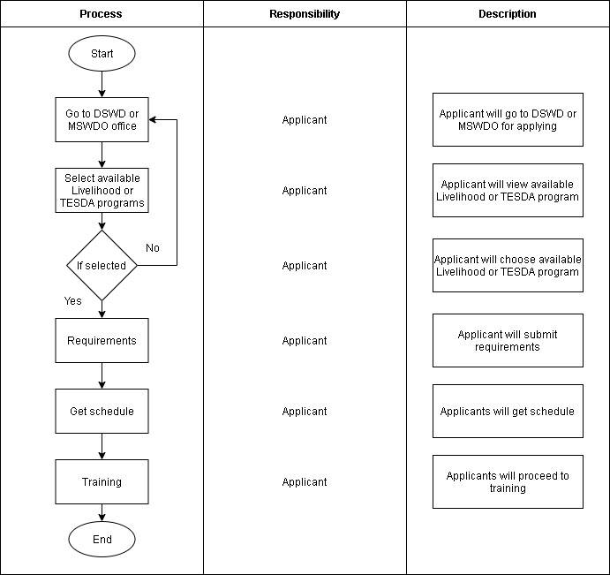**Current Process Flow**

**Figure 8.** The current process of the SLP applicant/s in terms of selecting various programs that implement by the client which is the DSWD and MSWDO office in the Municipality of Sta. Cruz, Laguna.

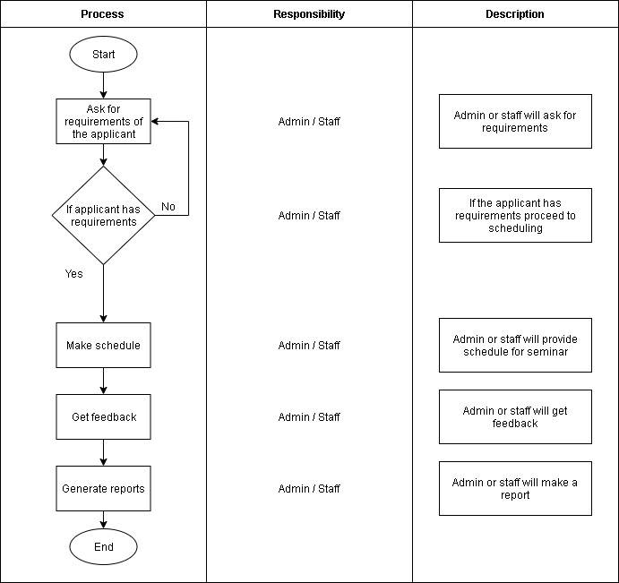

**Figure 9.** The current process of the client which is the DSWD and MSWDO office in the Municipality of Sta. Cruz, Laguna in terms of implementing program under SLP that will take by the applicants.

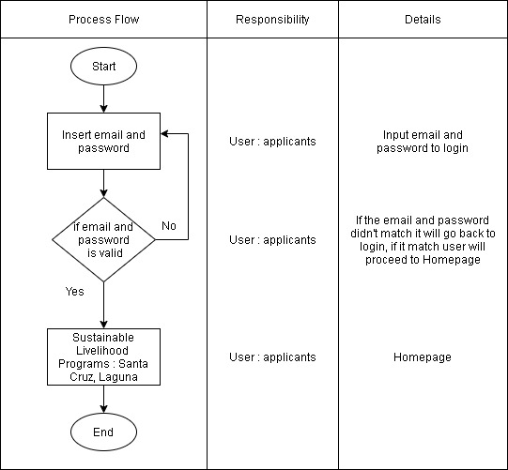**Proposed Process Flow**

**Figure 11.** The proposed process for the user login of the developed system entitled Sustainable Livelihood Program Management Information System with SMS Notification

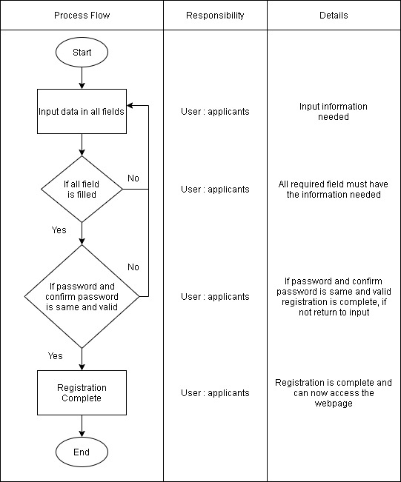

**Figure 12.** The proposed process of the user registration of the developed system in order to register the accounts to be used.

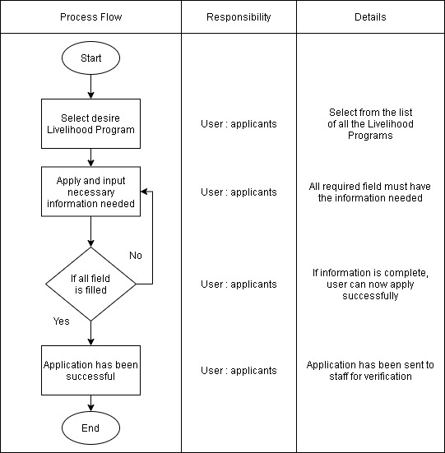

**Figure 13.** The proposed process of the user’s application for livelihood program in order for the applicants to apply on the preferable program they choose.

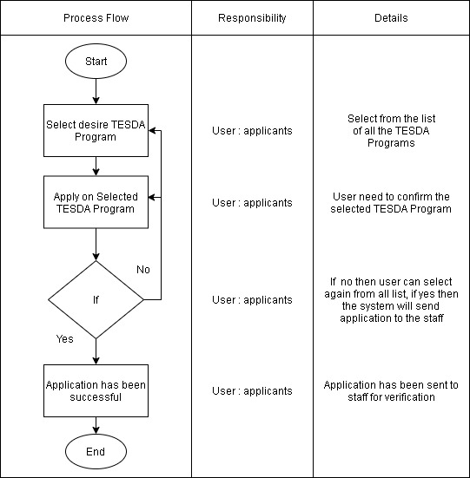

**Figure 14.** The proposed process of the user’s application for TESDA programs in order for the applicants to apply on the preferable program they choose.

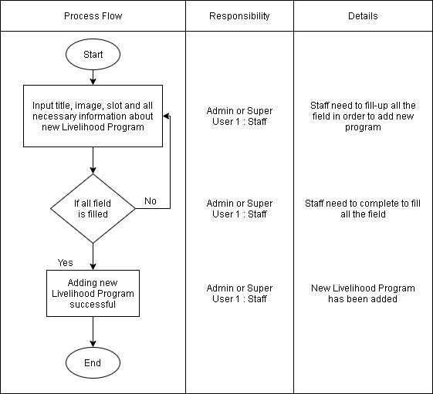 **Figure 15.** The proposed process of the admin or super user 1 in terms of adding new livelihood programs in the developed system in order for the applicants to choose the preferable program they will apply for.

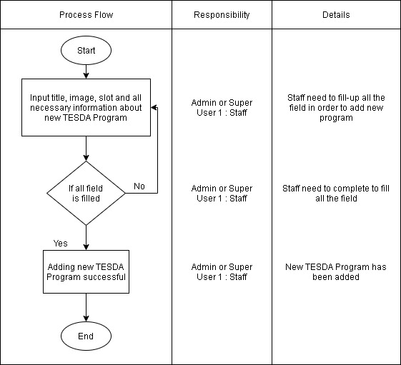

**Figure 16.** The proposed process of the admin or super user 1 in terms of adding new TESDA programs in the developed system in order for the applicants to choose the preferable program they will apply for.

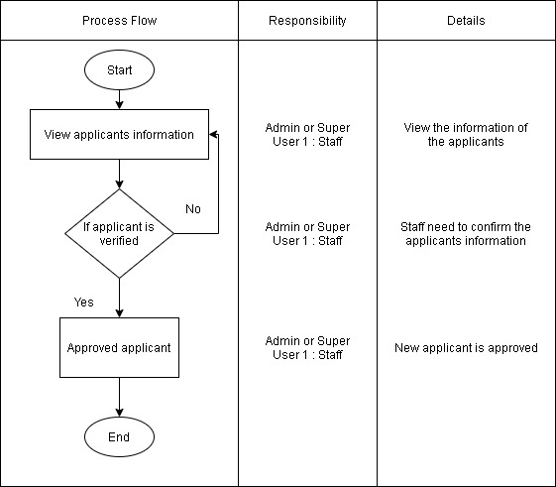

**Figure 17.** The proposed process of the admin or super user 1 in terms of verifying new applicant of livelihood program in the developed system.

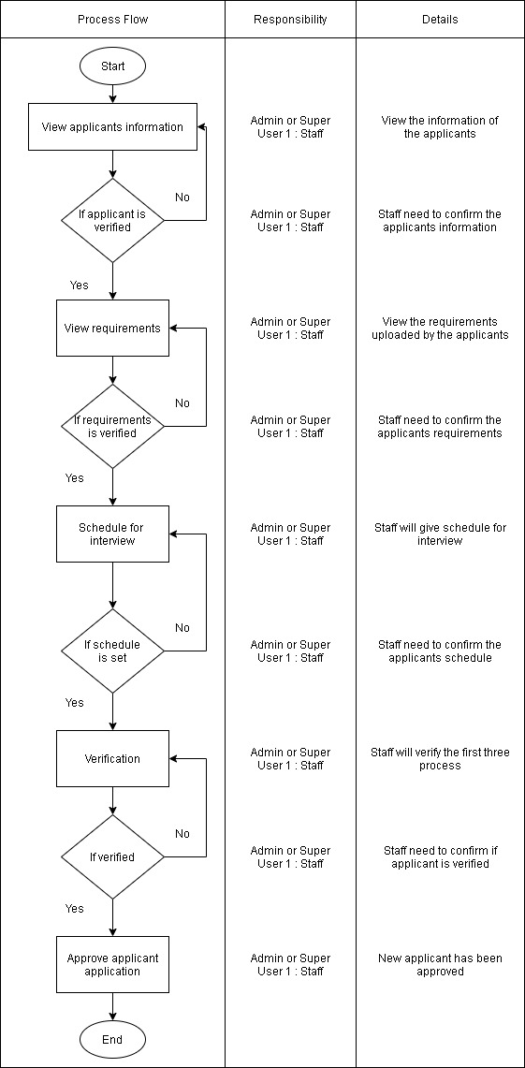

**Figure 18.** The proposed process of the admin or super user 1 in terms of verifying new applicant of TESDA program in the developed system.

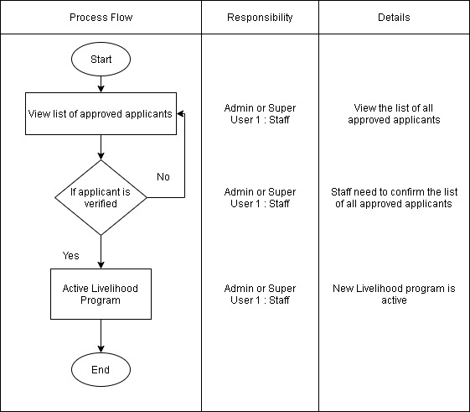

**Figure 19.** The proposed process of the admin or super user 1 in terms of activating new livelihood program in the developed system.

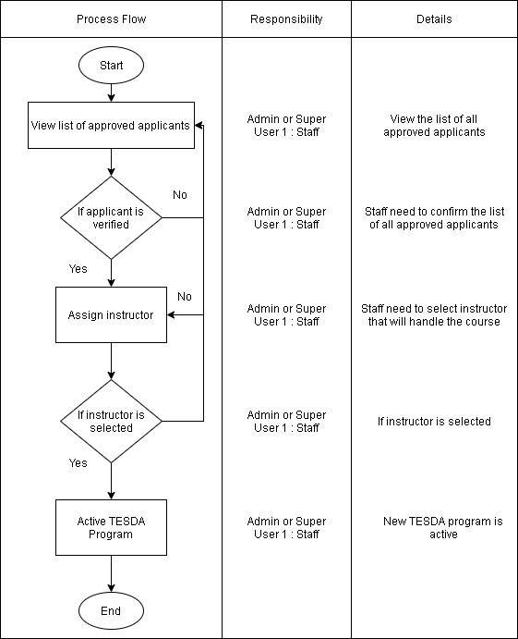

**Figure 20.** The proposed process of the admin or super user 1 in terms of activating new TESDA program in the developed system.

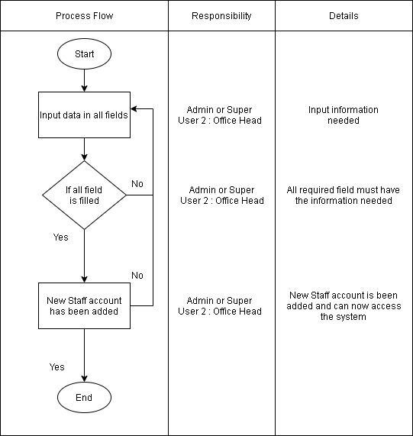

**Figure 21.** The proposed process of the admin or super user 1 in terms of adding new staff account in the developed system.

**Use Case Diagram**

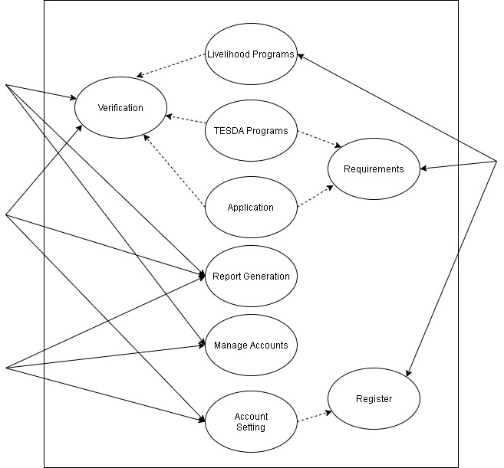

Admin

Super User 2:

Office Head

Super User 1:

Staff

User: Applicant

**Figure 22.** The illustration of the full access of every user in the developed system Sustainable Livelihood Program Management Information System with SMS Notification.

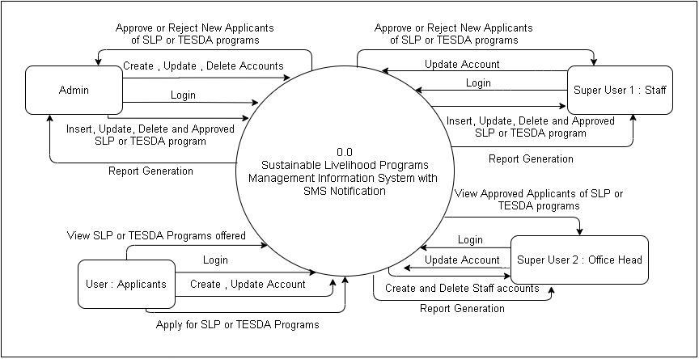**System Context Diagram**

**Figure 23.** The connection of every user to the developed system and shows differentattributes that the users are giving and the developed system.

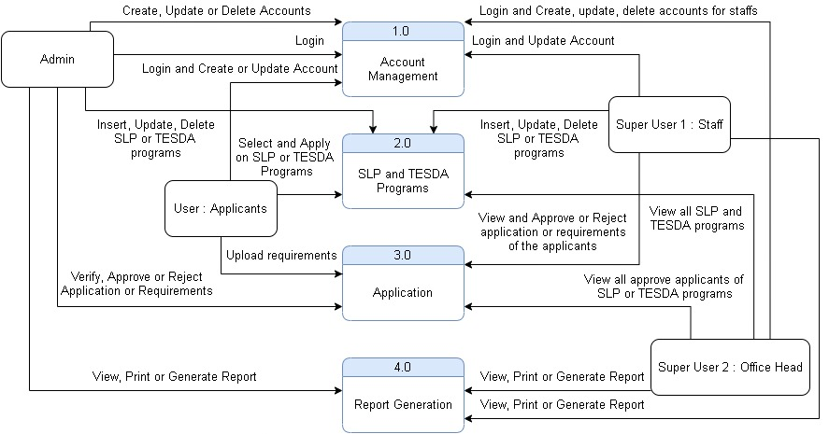**Data Flow Diagram**

**Figure 24.** The level 0 of data flow diagram in terms of account management, SLP and TESDA programs, application for requirements, and report generations of the gathered data of the applicants.

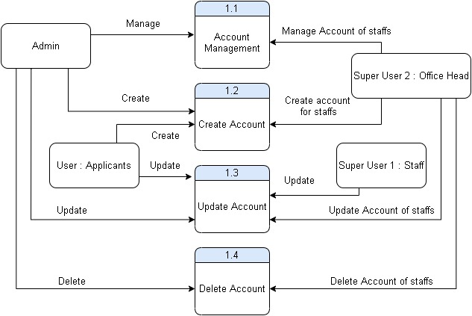

**Figure 25.** The level 1 of data flow diagram in terms of account management, creating accounts, updating accounts, and deleting accounts.

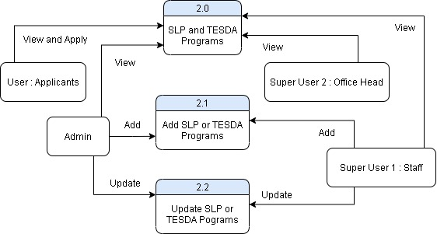

**Figure 26.** The level 2 of data flow diagram in terms of viewing SLP and TESDA programs, adding SLP or TESDA programs, and updating SLP or TESDA programs.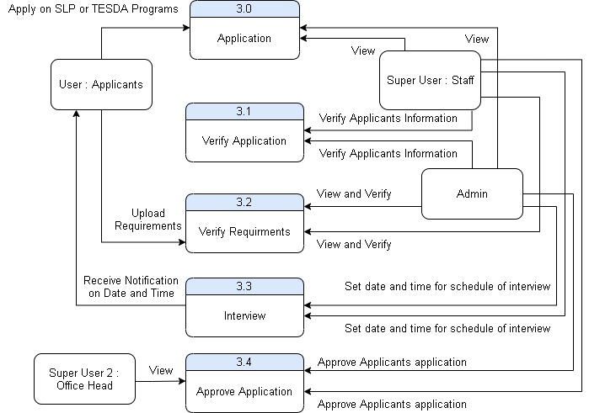

**Figure 27.** The level 3 of data flow diagram in terms of applying on SLP and TESDA program, verifying the applicants’ information, verifying the uploaded requirements, receiving notification on date and time for interview, and approving applicants’ application.

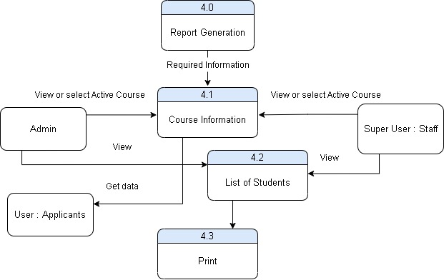

**Figure 28.** The level 4 of data flow diagram in terms of report generations for the required information, viewing course information, viewing the list of applicants, and the printing of reports.

**Data Dictionary**

**Table 22.** Accounts

|  |  |  |  |  |  |
| --- | --- | --- | --- | --- | --- |
| **Items** | **Data type** | **Length** | **Category** | **Not null** | **Auto Increment** |
| user_id | int | 11 | Primary Key | No | Yes |
| username | varchar | 20 |  | No | No |
| password | varchar | 20 |  | No | No |
| usertype | varchar | 10 |  | No | No |
| name | varchar | 50 |  | No | No |
| middlename | varchar | 50 |  | No | No |
| lastname | varchar | 50 |  | No | No |

This table shows the data table for the users’ profile. It includes the information which is the user_id, username, password, usertype, name, middlename, and lastname.

**Table 23.** active_program_tbl

|  |  |  |  |  |  |
| --- | --- | --- | --- | --- | --- |
| **Items** | **Data type** | **Length** | **Category** | **Not null** | **Auto Increment** |
| active_program_id | int | 11 | Primary Key | No | Yes |
| program_id | int | 11 |  | No | No |
| program_name | varchar | 100 |  | No | No |
| instructor_id | int | 11 |  | No | No |
| batch_code | varchar | 10 |  | No | No |

This table shows the data table for active program. It includes the needed information which is the active_program_id, program_id, program_name, instructor_id, and batch_code.

**Table 24.** active_service_tbl

|  |  |  |  |  |  |
| --- | --- | --- | --- | --- | --- |
| **Items** | **Data type** | **Length** | **Category** | **Not null** | **Auto Increment** |
| active_service_id | int | 11 | Primary Key | No | Yes |
| service_id | int | 11 | Foreign Key | No | No |
| service_name | varchar | 200 |  | No | No |
| service_code | varchar | 100 |  | No | No |
| service_status | varchar | 10 |  | No | No |

This table shows the data table for active service. It includes the needed information which is the active_service_id, service_id, service_name, service_code, and server status.

**Table 25.** application_tbl

|  |  |  |  |  |  |
| --- | --- | --- | --- | --- | --- |
| **Items** | **Data type** | **Length** | **Category** | **Not null** | **Auto Increment** |
| application_id | int | 11 | Primary Key | No | Yes |
| client_id | int | 100 | Foreign Key | No | No |
| service_id | int | 100 | Foreign Key | No | No |
| firstname | varchar | 20 |  | No | No |
| middlename | varchar | 20 |  | No | No |
| lastname | varchar | 20 |  | No | No |
| contact | varchar | 13 |  | No | No |
| birthday | varchar | 20 |  | No | No |
| age | int | 13 |  | No | No |
| address | varchar | 100 |  | No | No |
| status | varchar | 10 |  | No | No |

This table shows the data table for application. It includes the needed information which is the application_id, client_id, service_id, firrstname, middlename, lastname, contact, birthday, age, address, and status.

**Table 26.** Client

|  |  |  |  |  |  |
| --- | --- | --- | --- | --- | --- |
| **Items** | **Data type** | **Length** | **Category** | **Not null** | **Auto Increment** |
| client_id | int | 11 | Primary Key | No | Yes |
| name | varchar | 50 |  | No | No |
| middlename | varchar | 50 |  | No | No |
| lastname | varchar | 50 |  | No | No |
| suffix | varchar | 50 |  | Yes | No |
| contact | varchar | 13 |  | No | No |
| email | varchar | 50 |  | No | No |
| educational_primary | varchar | 50 |  | No | No |
| primary_date | varchar | 20 |  | No | No |
| primary_address | varchar | 100 |  | No | No |
| educational_secondary | varchar | 50 |  | No | No |
| secondary_date | varchar | 20 |  | No | No |
| secondary_address | varchar | 100 |  | No | No |
| collage | varchar | 50 |  | Yes | No |
| collage_degree | varchar | 50 |  | Yes | No |
| collage_date | varchar | 20 |  | Yes | No |
| collage_address | varchar | 100 |  | Yes | No |
| birthday | varchar | 20 |  | No | No |
| age | int | 2 |  | No | No |
| civil_status | varchar | 20 |  | No | No |
| religion | varchar | 20 |  | No | No |
| gender | varchar | 10 |  | No | No |
| address | varchar | 100 |  | No | No |
| barangay | varchar | 20 |  | No | No |
| password | varchar | 50 |  | No | No |
| status | varchar | 20 |  | No | No |
| requirements | varchar | 100 |  | No | No |

This table shows the data table of client. It includes the needed information in applying the program and the requirements needed.

**Table 27.** client_progress_tbl

|  |  |  |  |  |  |
| --- | --- | --- | --- | --- | --- |
| **Items** | **Data type** | **Length** | **Category** | **Not null** | **Auto Increment** |
| progress_id | int | 11 | Primary Key | No | Yes |
| client_id | int | 11 | Foreign Key | No | No |
| instructor_id | int | 11 | Foreign Key | No | No |
| program_id | int | 11 | Foreign Key | No | No |
| batch_code | varchar | 20 |  | No | No |
| progress_date | varchar | 10 |  | No | No |
| status | varchar | 10 |  | No | No |
| remarks | varchar | 100 |  | No | No |

This table shows the data table for client progress. It includes the needed information which is the progress_id, client_id, instructor_id, program_id, batch_code, progress_date, status, and remarks.

**Table 28.** forum_reply_tbl

|  |  |  |  |  |  |
| --- | --- | --- | --- | --- | --- |
| **Items** | **Data type** | **Length** | **Category** | **Not null** | **Auto Increment** |
| reply_id | int | 11 | Primary Key | No | Yes |
| reply_by | int | 11 | Foreign Key | No | No |
| owner_id | int | 11 | Foreign Key | No | No |
| forum_name | varchar | 100 |  | No | No |
| thread_id | int | 11 | Foreign Key | No | No |
| reply_content | varchar | 1000 |  | No | No |
| reply_date | varchar | 20 |  | No | No |
| reply_time | varchar | 20 |  | No | No |
| edited | varchar | 10 |  | No | No |
| type | varchar | 10 |  | No | No |

This table shows the data table of forum. It includes the needed information in editing the forum information.

**Table 29.** forum_tbl

|  |  |  |  |  |  |
| --- | --- | --- | --- | --- | --- |
| **Items** | **Data type** | **Length** | **Category** | **Not null** | **Auto Increment** |
| forum_id | int | 11 | Primary Key | No | Yes |
| category | varchar | 20 |  | No | No |

This table shows the data table of forum. It includes the needed information in creating the category in the forum page.

**Table 30.** instructor_tbl

|  |  |  |  |  |  |
| --- | --- | --- | --- | --- | --- |
| **Items** | **Data type** | **Length** | **Category** | **Not null** | **Auto Increment** |
| instructor_id | int | 11 | Primary Key | No | Yes |
| name | varchar | 20 |  | No | No |
| middlename | varchar | 20 |  | No | No |
| lastname | varchar | 20 |  | No | No |
| username | varchar | 16 |  | No | No |
| password | varchar | 16 |  | No | No |

This table shows the data table of instructor. It includes the needed information in creating the account of the instructor.

**Table 31.** program_announcement_tbl

|  |  |  |  |  |  |
| --- | --- | --- | --- | --- | --- |
| **Items** | **Data type** | **Length** | **Category** | **Not null** | **Auto Increment** |
| announcement_id | int | 11 | Primary Key | No | Yes |
| posted_by | int | 11 | Foreign Key | No | No |
| date_posted | varchar | 20 |  | No | No |
| title | varchar | 100 |  | No | No |
| announcement_content | varchar | 1000 |  | No | No |
| active_program_id | int | 11 | Foreign Key | No | No |
| program_id | int | 11 | Foreign Key | No | No |

This table shows the data table of program announcement. It includes the needed information in updating the announcement page.

**Table 32.** program_application_tbl

|  |  |  |  |  |  |
| --- | --- | --- | --- | --- | --- |
| **Items** | **Data type** | **Length** | **Category** | **Not null** | **Auto Increment** |
| prog_app_id | int | 11 | Primary Key | No | Yes |
| program_id | int | 11 | Foreign Key | No | No |
| client_id | int | 11 | Foreign Key | No | No |
| status | varchar | 20 |  | No | No |
| processing | varchar | 11 |  | No | No |
| doc_verifying | varchar | 11 |  | No | No |
| interview | varchar | 11 |  | No | No |
| approving | varchar | 20 |  | No | No |
| schedule_time | varchar | 20 |  | No | No |
| schedule_time | varchar | 20 |  | No | No |

This table shows the data table of program application. It includes the needed information in approving and verifying the program.

**Table 33.** program_tbl

|  |  |  |  |  |  |
| --- | --- | --- | --- | --- | --- |
| **Items** | **Data type** | **Length** | **Category** | **Not null** | **Auto Increment** |
| program_id | int | 11 | Primary Key | No | Yes |
| program_img | varchar | 100 |  | No | No |
| program_name | varchar | 50 |  | No | No |
| program_incharge | varchar | 50 |  | No | No |
| program_slot | int | 11 |  | No | No |
| program_date | varchar | 20 |  | No | No |
| program_location | varchar | 100 |  | No | No |
| program_description | varchar | 1000 |  | No | No |
| program_requirements | varchar | 1000 |  | No | No |
| status | varchar | 11 |  | No | No |
| office | varchar | 20 |  | No | No |

This table shows the data table of program. It includes the needed information in applying the program and the requirements needed.

**Table 34.** service_application_tbl

|  |  |  |  |  |  |
| --- | --- | --- | --- | --- | --- |
| **Items** | **Data type** | **Length** | **Category** | **Not null** | **Auto Increment** |
| ser_app_id | int | 11 | Primary Key | No | Yes |
| service_id | int | 11 | Foreign Key | No | No |
| name | varchar | 20 |  | No | No |
| middlename | varchar | 20 |  | No | No |
| lastname | varchar | 20 |  | No | No |
| contact | varchar | 11 |  | No | No |
| birthday | varchar | 20 |  | No | No |
| age | int | 2 |  | No | No |
| sex | varchar | 10 |  | No | No |
| address | varchar | 100 |  | No | No |
| barangay | varchar | 20 |  | No | No |
| status | varchar | 20 |  | No | No |

This table shows the data table of service application. It includes the needed information of the applicant.

**Table 35.** service_tbl

|  |  |  |  |  |  |
| --- | --- | --- | --- | --- | --- |
| **Items** | **Data type** | **Length** | **Category** | **Not null** | **Auto Increment** |
| service_id | int | 11 | Primary Key | No | Yes |
| img_name | varchar | 1000 |  | No | No |
| service_name | varchar | 100 |  | No | No |
| service_incharge | varchar | 100 |  | No | No |
| service_slot | int | 100 |  | No | No |
| service_date | varchar | 100 |  | No | No |
| service_location | varchar | 100 |  | No | No |
| service_description | varchar | 1000 |  | No | No |
| status | varchar | 20 |  | No | No |
| office | varchar | 20 |  | No | No |

This table shows the data table of service. It includes the needed information in the service provided.

**Table 36.** sub_forum_tbl

|  |  |  |  |  |  |
| --- | --- | --- | --- | --- | --- |
| **Items** | **Data type** | **Length** | **Category** | **Not null** | **Auto Increment** |
| sub_forum_id | int | 11 | Primary Key | No | Yes |
| forum_id | int | 11 | Foreign Key | No | No |
| sub_forum_name | int | 100 |  | No | No |
| content_title | varchar | 100 |  | No | No |
| content | int | 1000 |  | No | No |
| post_by | varchar | 11 | Foreign Key | No | No |
| thread_date | varchar | 10 |  | No | No |
| thread_time | varchar | 10 |  | No | No |
| edited | varchar | 10 |  | No | No |
| type | varchar | 10 |  | No | No |

This table shows the data table of sub forum. It includes the needed information in editing the sub forum information.

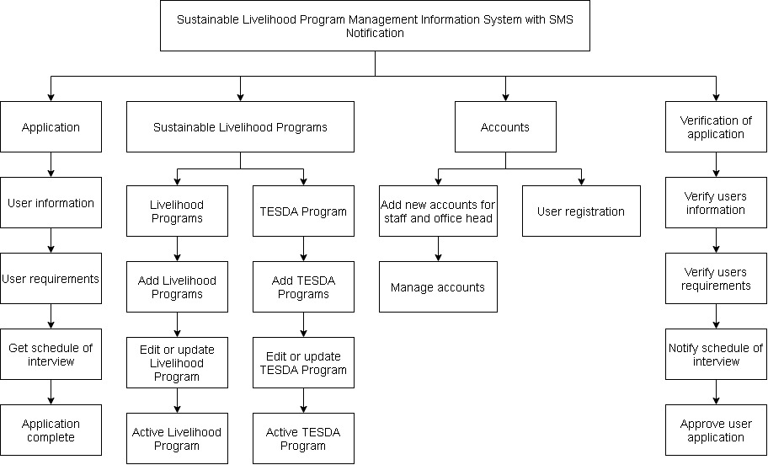**HIPO Model**

**Figure 29.** Illustration of module of the system hierarchy that show the system design of the develop system.

**Table 37.** Project Schedule

|  |  |  |  |  |  |  |  |  |  |  |  |  |  |
| --- | --- | --- | --- | --- | --- | --- | --- | --- | --- | --- | --- | --- | --- |
|  | | 2020 | | | | | | | | | | | |
| Id | Task Name | January | | | | February | | | | March | | | |
|  |  | 1 | 2 | 3 | 4 | 1 | 2 | 3 | 4 | 1 | 2 | 3 | 4 |
| 1 | Look for a client |  |  |  |  |  |  |  |  |  |  |  |  |
| 2 | Data Gathering |  |  |  |  |  |  |  |  |  |  |  |  |
| 3 | Title Approved |  |  |  |  |  |  |  |  |  |  |  |  |
| 4 | Look for thesis adviser and panel members for nomination |  |  |  |  |  |  |  |  |  |  |  |  |
| 5 | Chapter I (Project context, Research Objectives, & Conceptual Framework) |  |  |  |  |  |  |  |  |  |  |  |  |
| 6 | Chapter II (Tech-gap analysis and RRL matrix) |  |  |  |  |  |  |  |  |  |  |  |  |
| 7 | Appendices |  |  |  |  |  |  |  |  |  |  |  |  |
| 8 | Chapter III |  |  |  |  |  |  |  |  |  |  |  |  |

This table shows the time estimated duration of the work schedule. The task name accompanied from the start up to chapter III.

**Hardware and Software Resources**

**Table 38.** Hardware resources

|  |  |
| --- | --- |
| **Hardware Requirements** | **Description** |
| 1. Computer Unit | * Processor (dual core 2.4 GHz, i3 series Intel Processor * RAM at least 2GB * Hard Drive 256 GB or larger solid-state hard drive * Graphics Card – any with DisplayPort/ HDMI or DVI support |
| 1. Input Devices | * Mouse * Keyboard |
| 1. Output Devices | * Monitor * Printer |

This table shows the hardware requirements used in developing the system entitled Sustainable Livelihood Program Management Information System with SMS Notification.

**Table 39.** Software resources

|  |  |
| --- | --- |
| **Software Requirements** | **Description** |
| 1. Operating System | * Windows 7 Home or Professional or higher specs |
| 1. Browser | * Google Chrome (Recommended) * Or any kind of browser |
| 1. Programming Language | * PHP * JavaScript |
| 1. Database | * MySQL |
| 1. Other Application | * XAMPP * Sublime * SQLyog |

This table shows the software requirements used in developing the system entitled Sustainable Livelihood Program Management Information System with SMS Notification.

**Input, Output, Reports Screenshots**

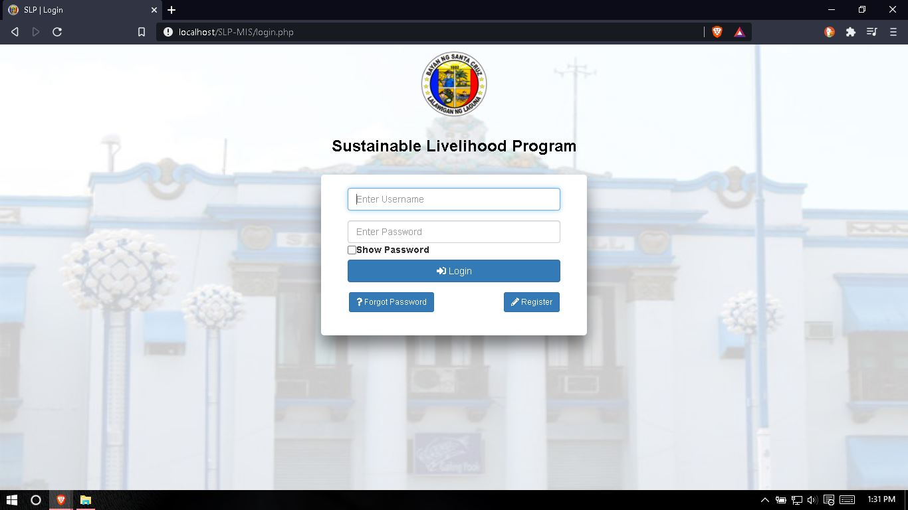

**Figure 30.** This shows the login page for users in order to login into the system.

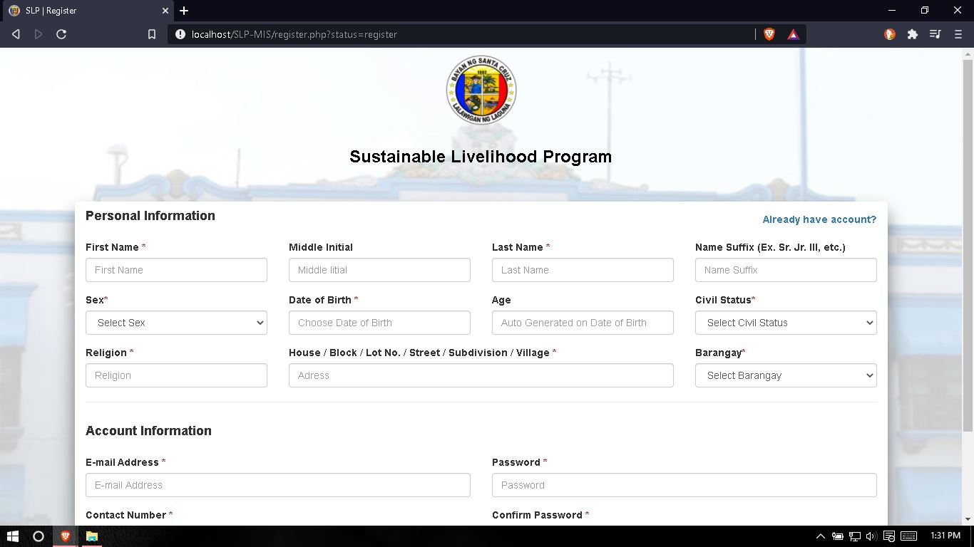

**Figure 31.** This shows the registration page where the user need to fill up all fields needed for them to have an account that will be used to login into the system.

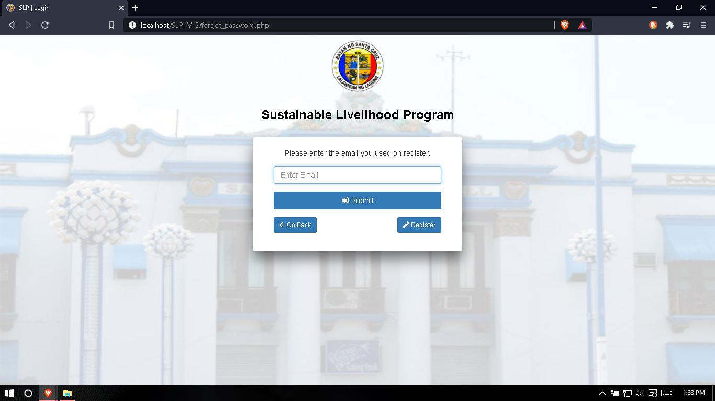

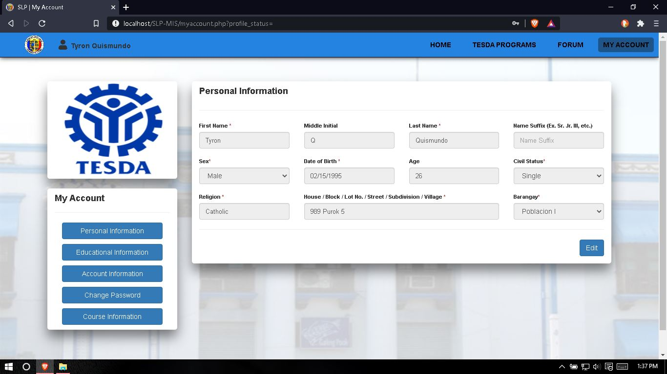**Figure 32.** This shows the page for user if they forget their password, they just need to input their email address that they used on registration and they will receive an email for their password retrieval.

**Figure 33.** This page shows the profile of the user, they can also edit or update their profile in this page.

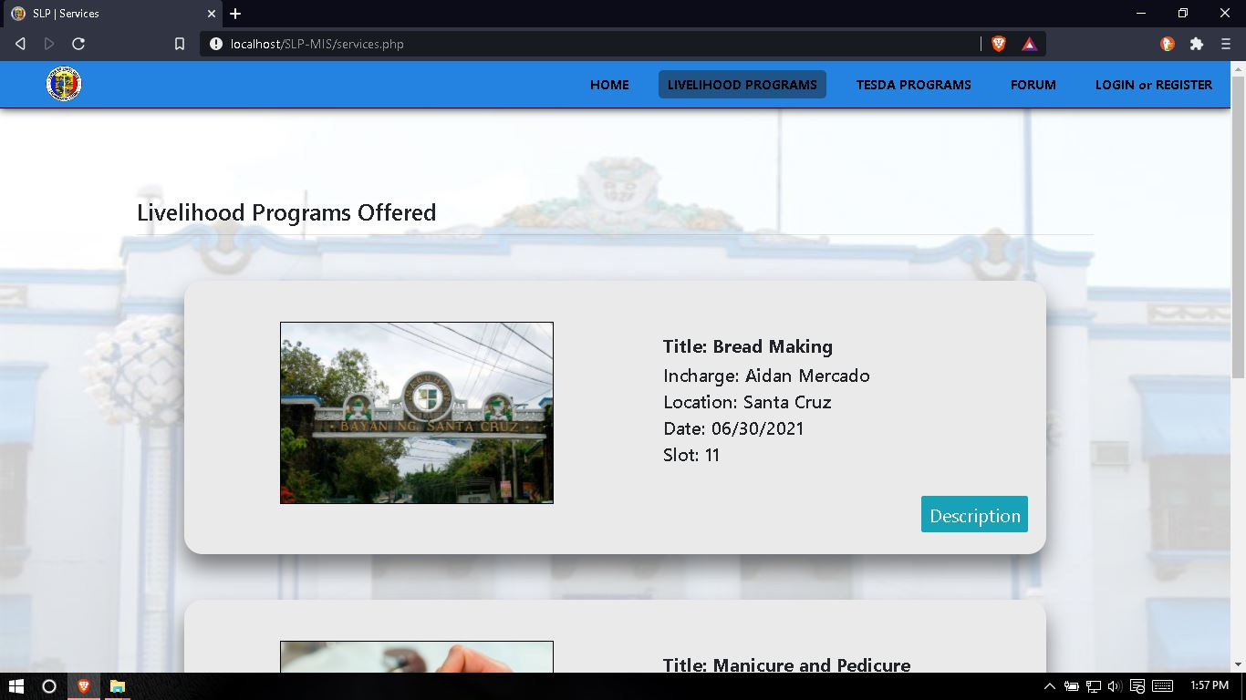

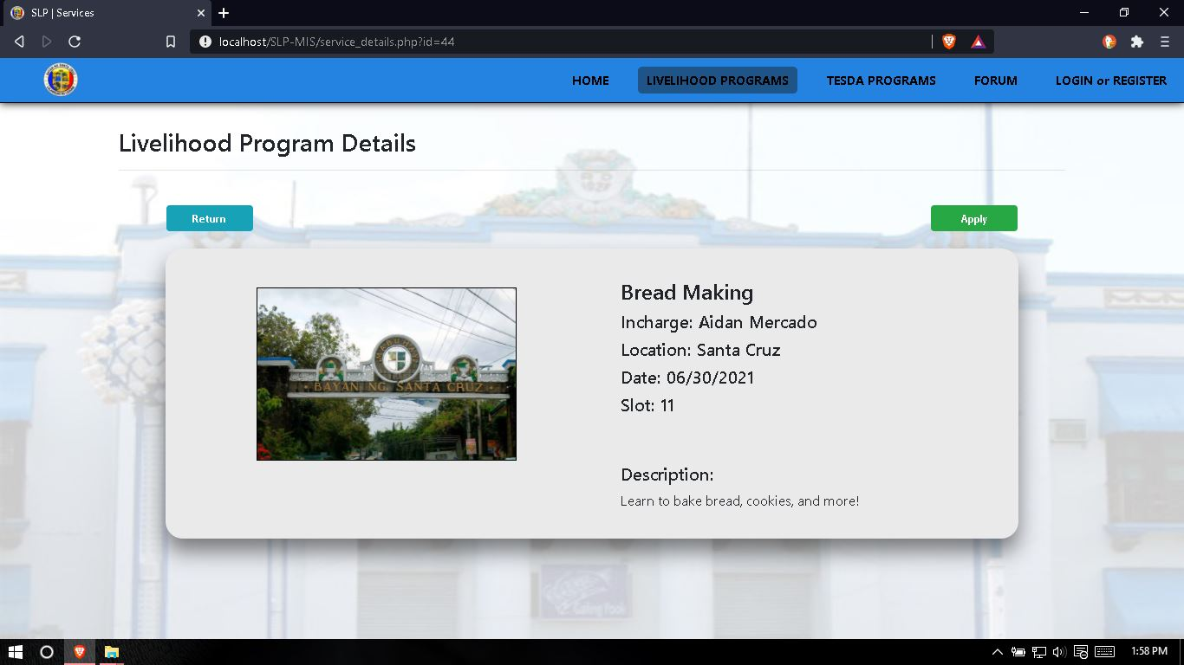**Figure 34.** This page shows all the Livelihood Programs offered by the Municipality of Santa Cruz, Laguna.

**Figure 35.** This page shows the description and information on the selected Livelihood Programs and they can apply on it without an account.

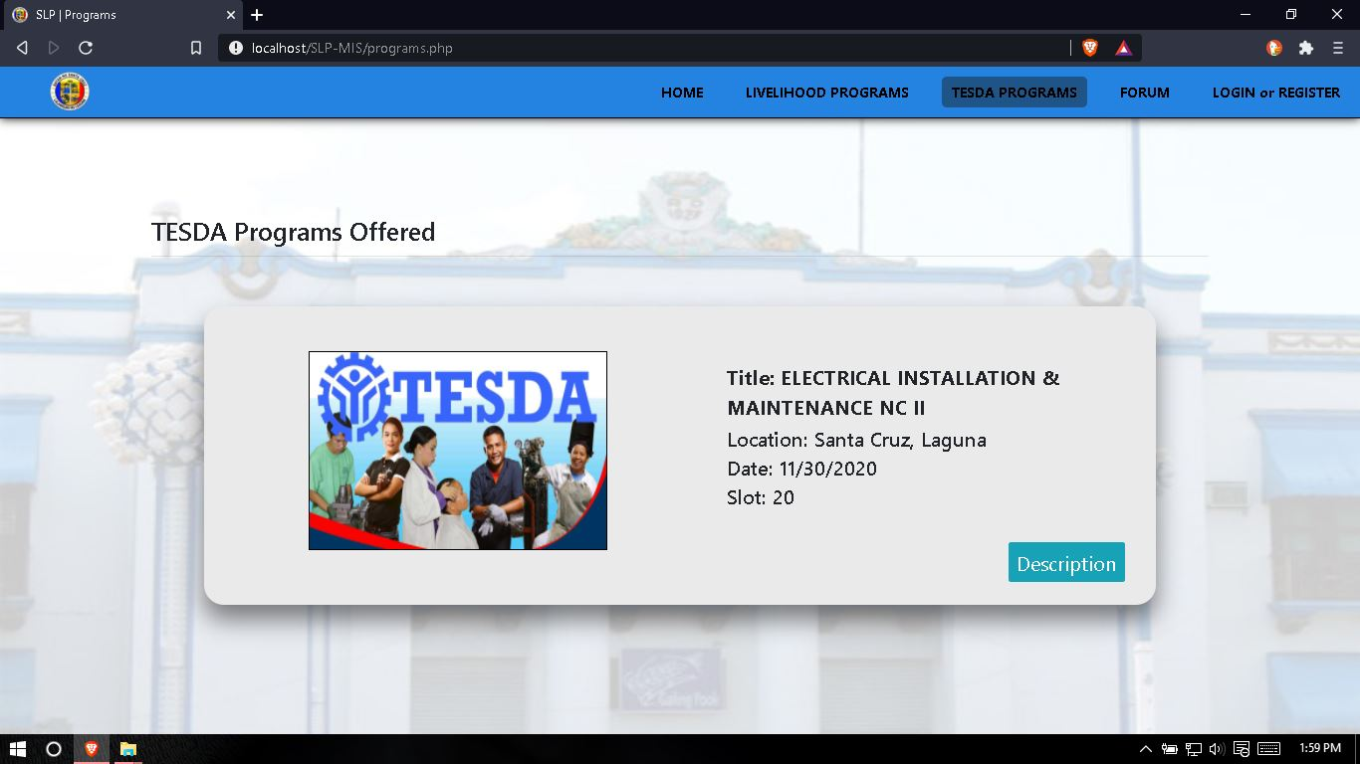

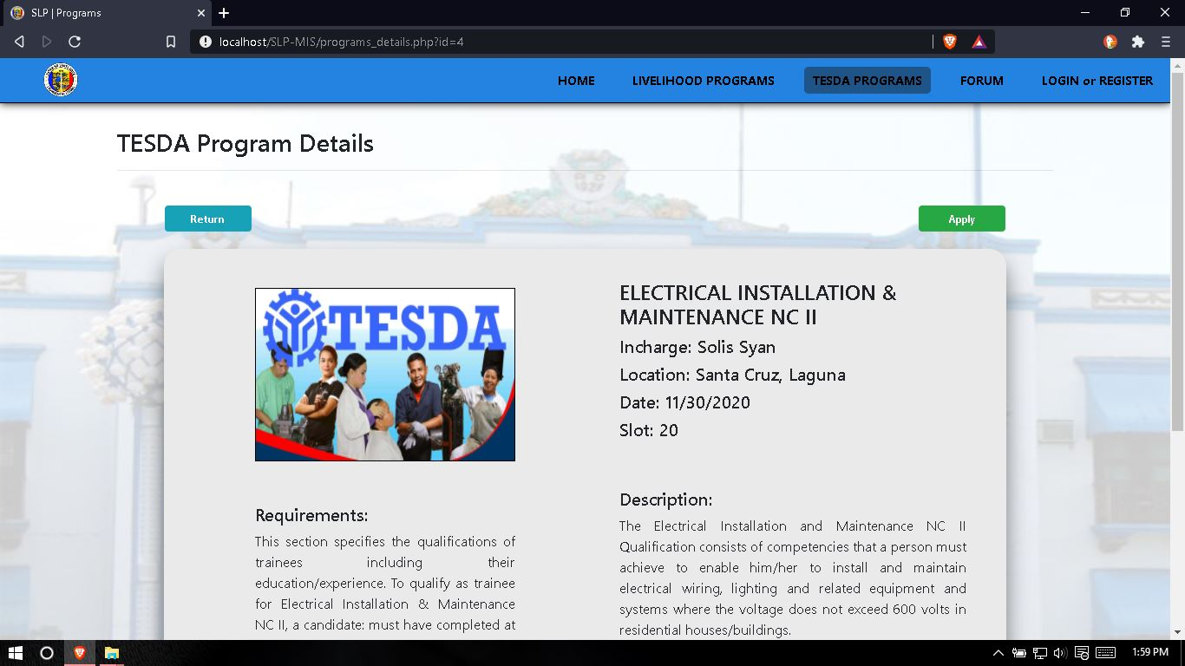**Figure 36.** This page shows all the TESDA programs offered by the Municipality of Santa Cruz, Laguna.

**Figure 37.** This page shows the description and information on the selected TESDA program, this page also shows the requirements needed in order for the user to apply and this application can only be access by login in an account.

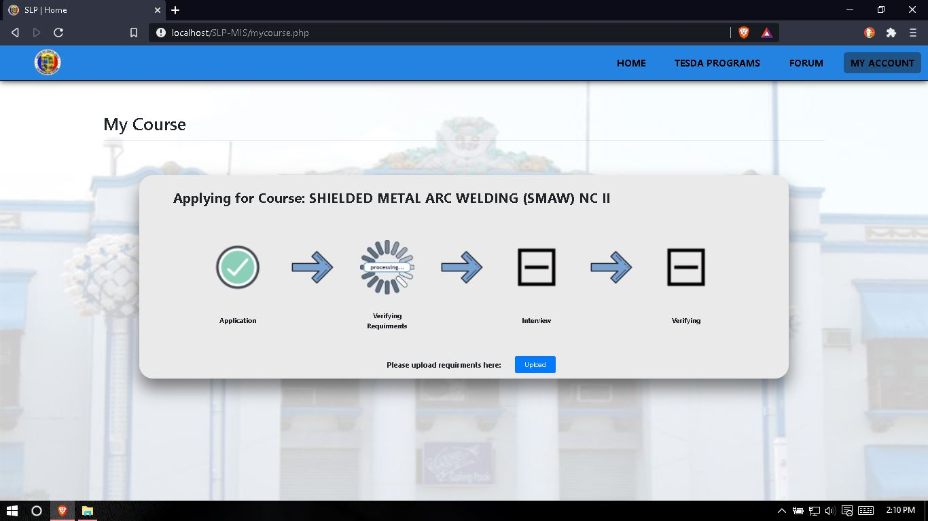

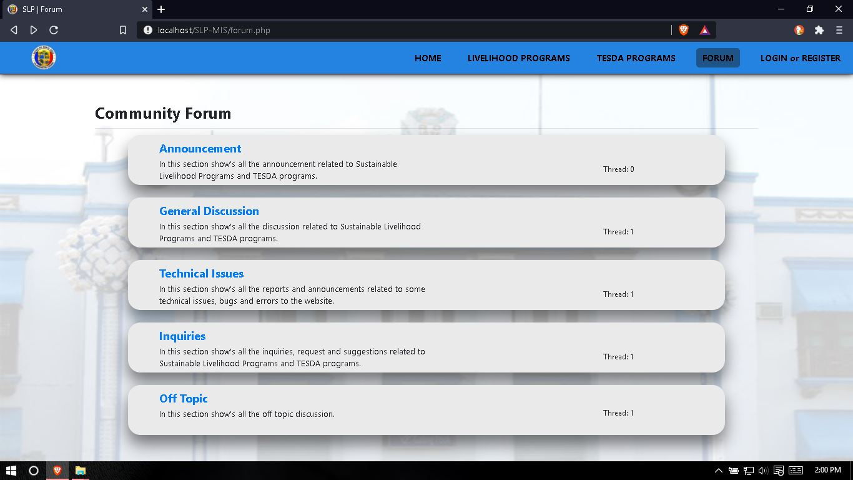**Figure 38.** This page shows the progress of the user’s application, in this page the user can also upload the requirements needed by the selected TESDA program they apply on.

**Figure 39.** This page shows the community forum of the system, this page can also allow the user to view announcement and can make discussions and ask questions.

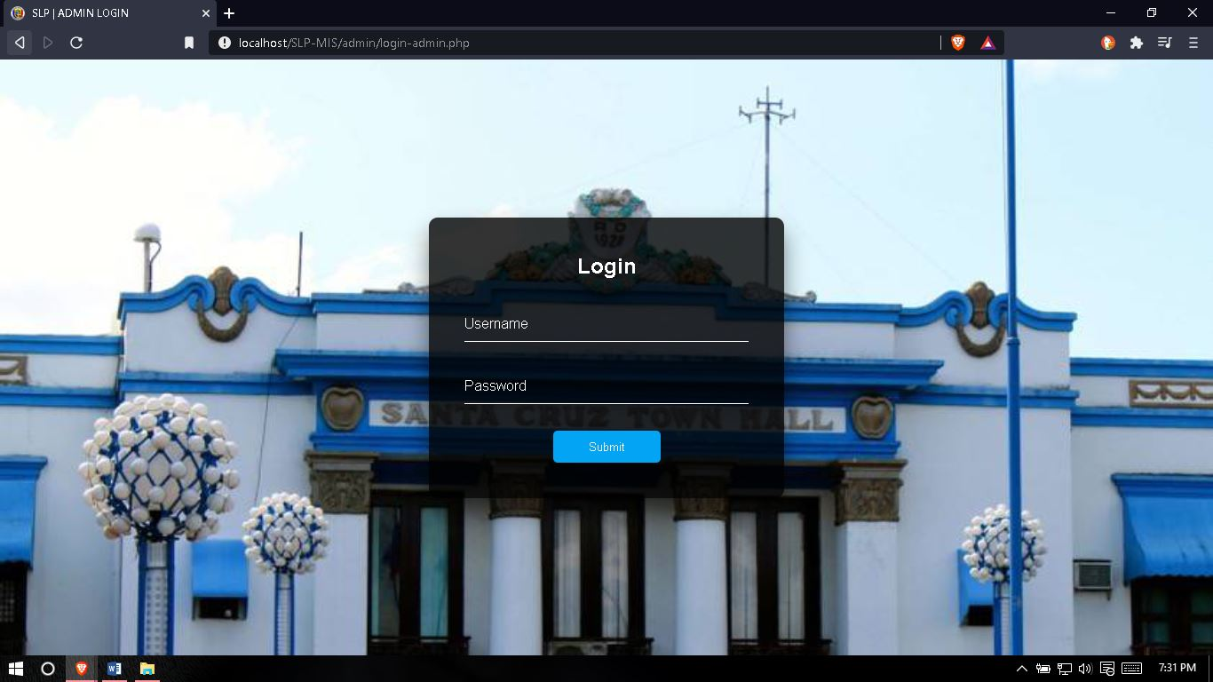

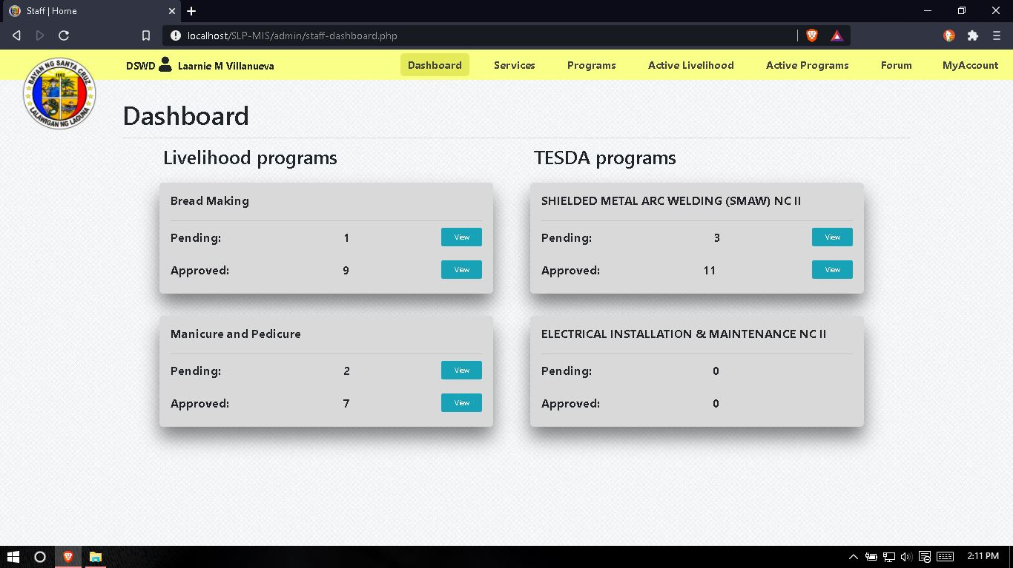**Figure 40.** This page shows the login page for admin, staff, office head and instructor, in order for them to login into the system.

**Figure 41.** This page show the dashboard for staff, this page shows all pending and approved counts of every Livelihood and TESDA program.

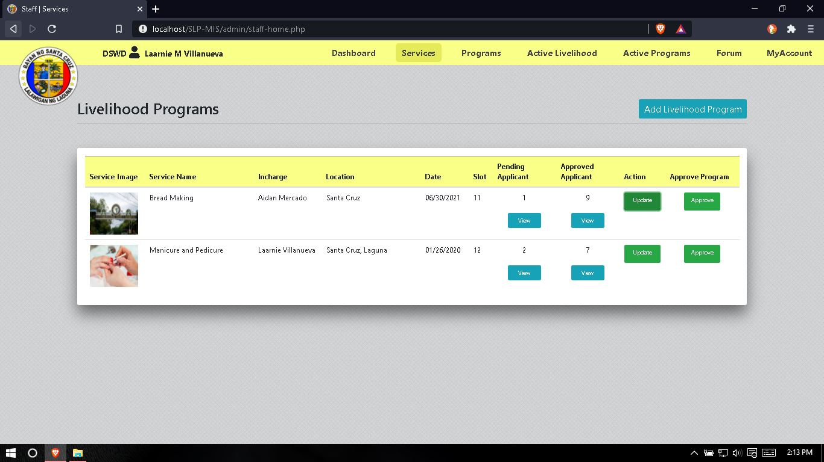

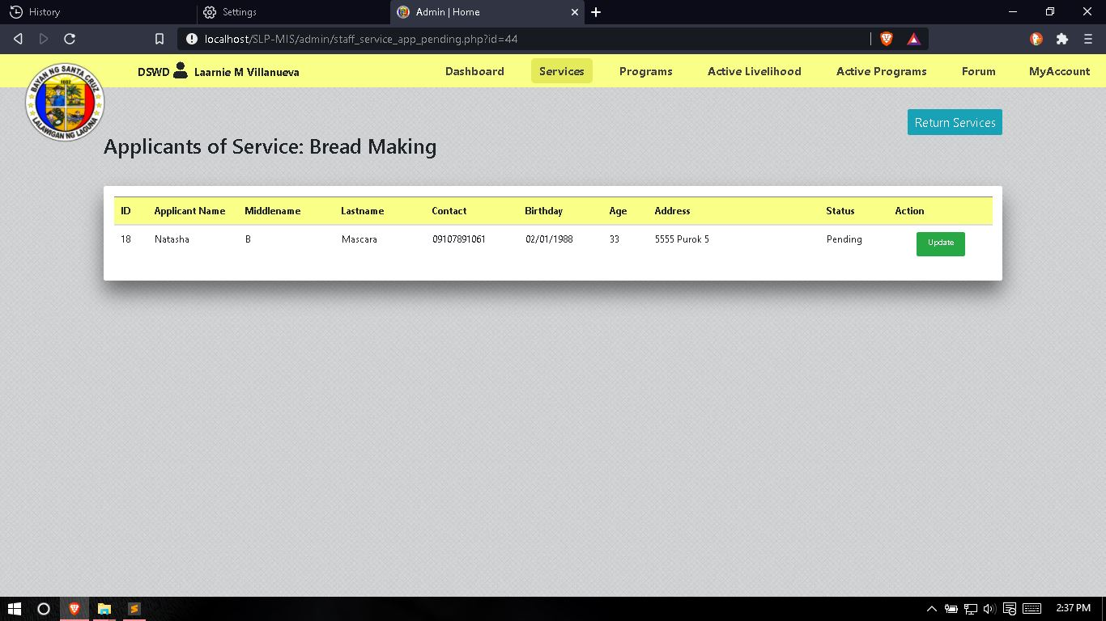**Figure 42.** This page shows all the Livelihood programs, the staff can view pending and approved applicants and can add or edit / update Livelihood programs.

**Figure 43.** This page shows the information of the applicants on the selected Livelihood program and approved it.

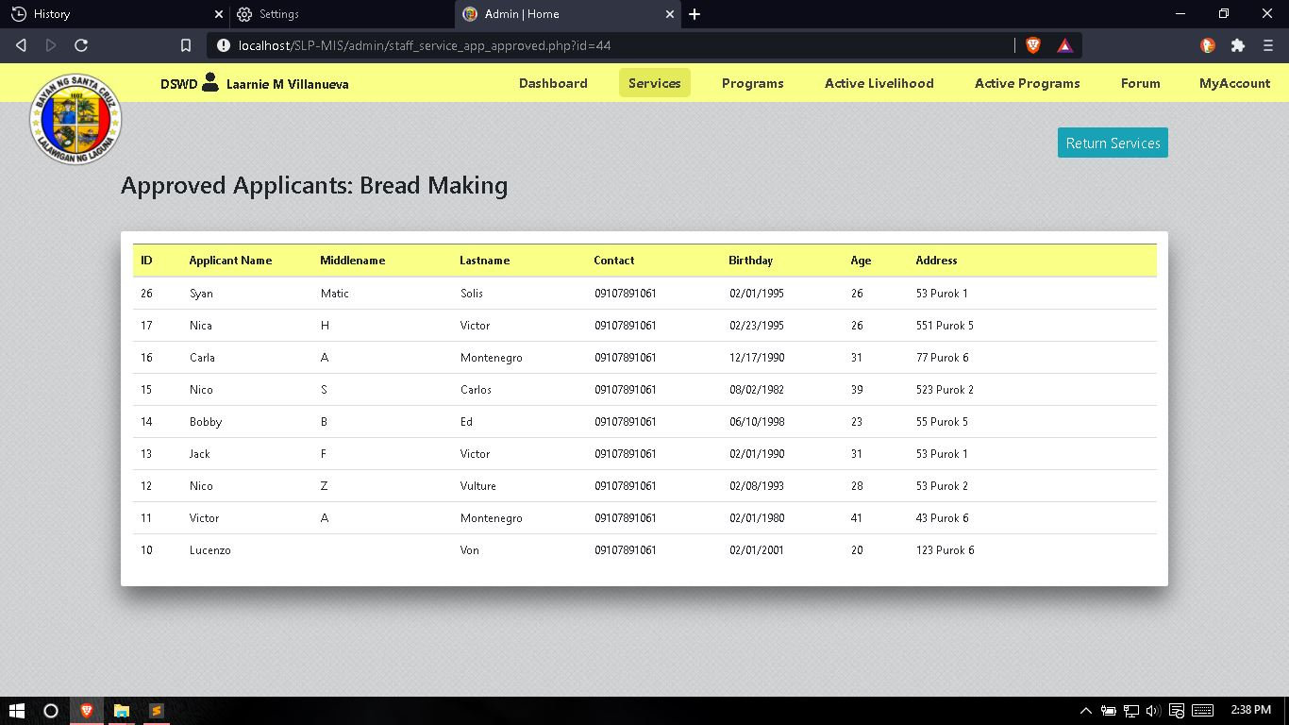

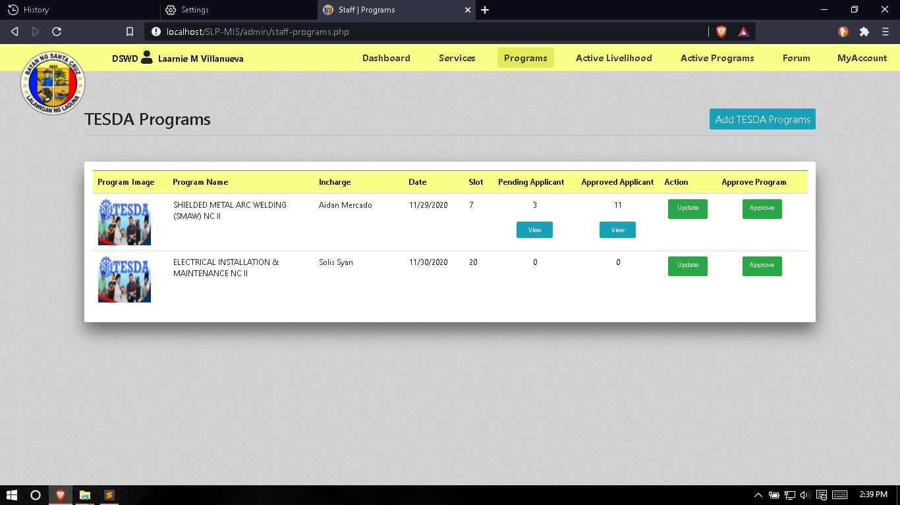**Figure 44.** This page shows all the information about the approved applicants of the selected Livelihood programs.

**Figure 45.** This page shows all the TESDA programs, the staff can view pending and approved applicants and can add or edit / update TESDA programs.

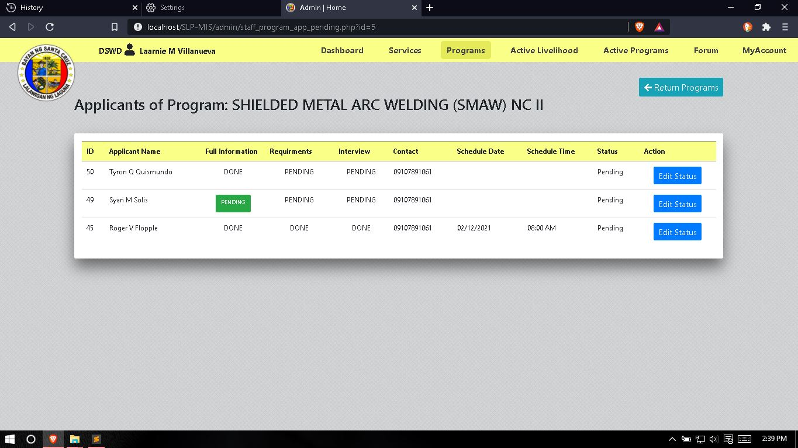

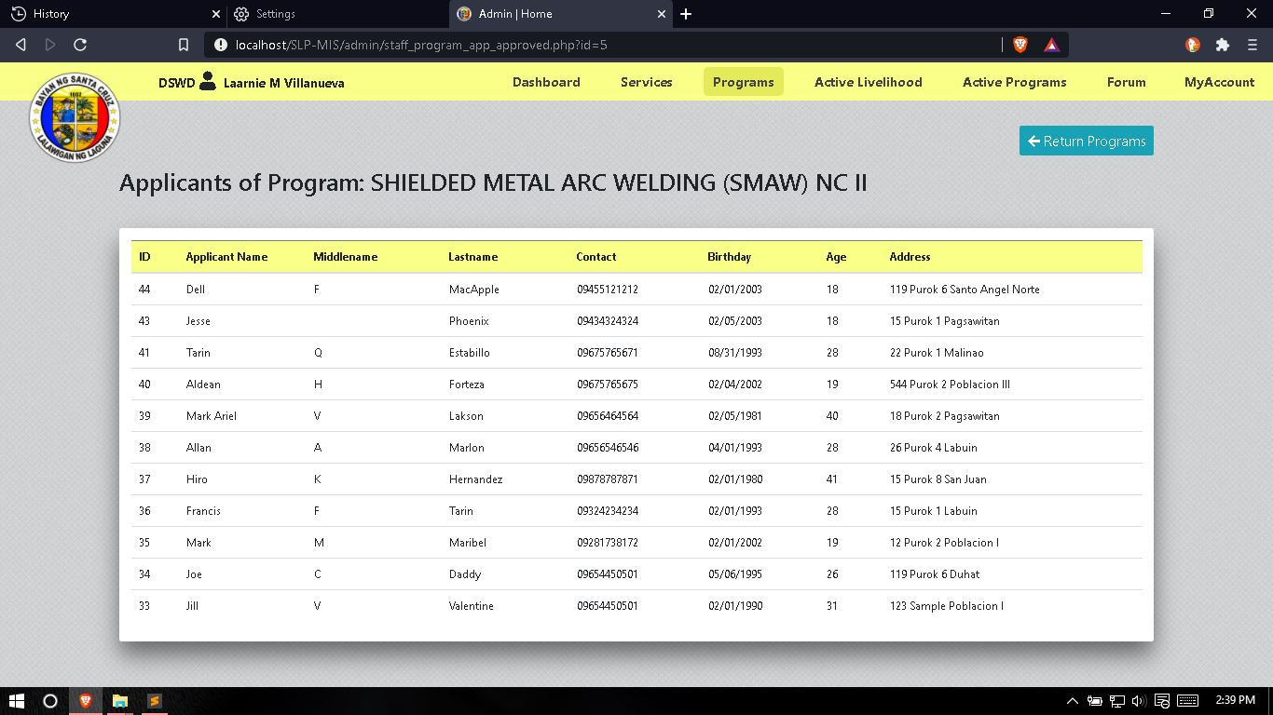**Figure 46.** This page shows the information of the applicants on the selected TESDA program. This page can also view the full information of the applicants, download requirements of the applicants, make schedule for the interview of the applicants and approved the application of the applicants if all the requirements is meet.

**Figure 47.** This page shows all the information about the approved applicants of the selected TESDA programs.

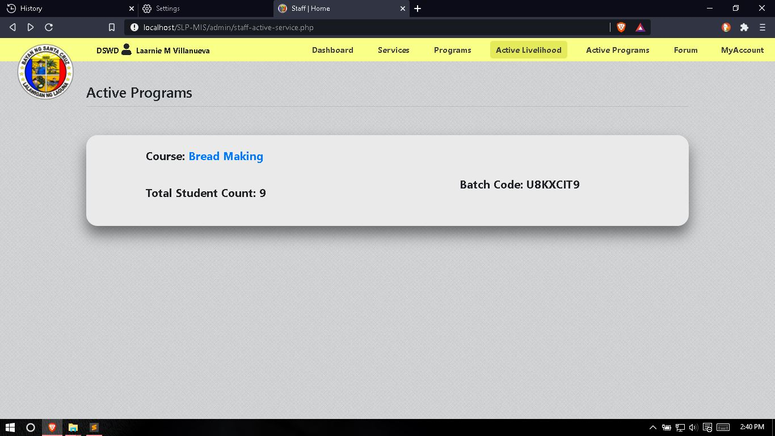

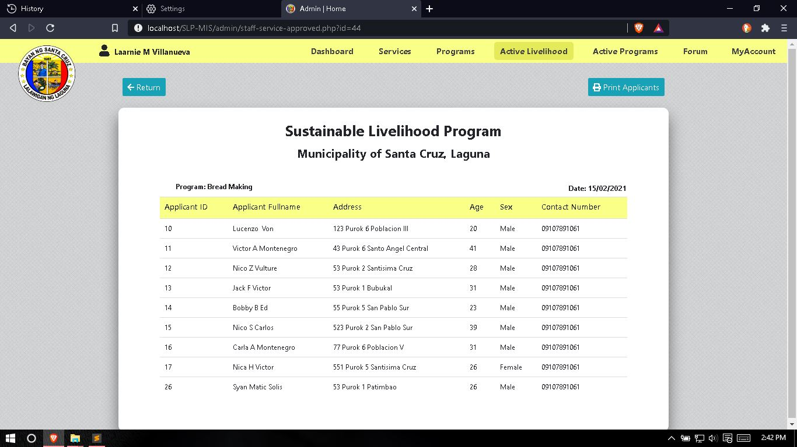**Figure 48.** This page shows all the active Livelihood programs alongside is the student count and batch code of each Livelihood programs.

**Figure 49.** This page shows all the list and information about the approved applicants of the selected Livelihood programs and can generate report.

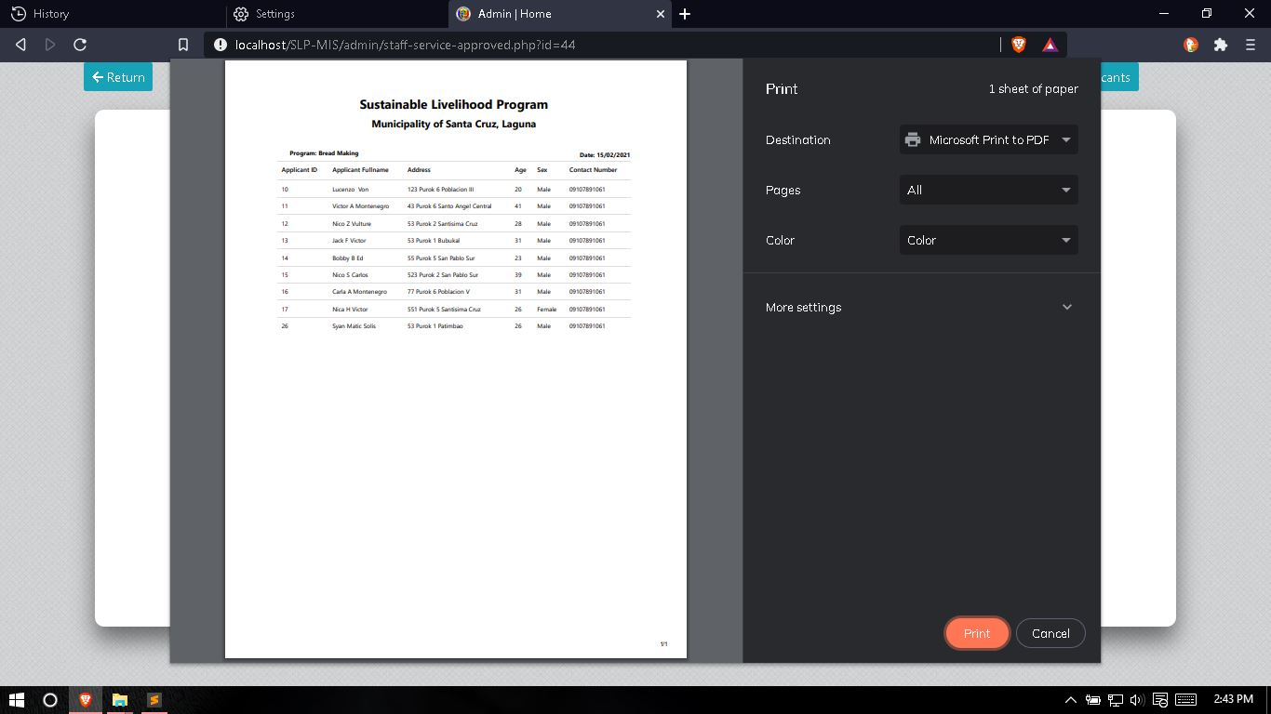

**Figure 50.** This page shows the report that will be generated on the selected active Livelihood program.

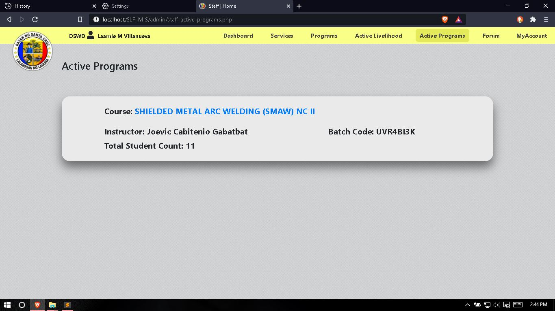

**Figure 51.** This page shows all the active TESDA programs alongside is the student count, assigned instructor and batch code of each TESDA programs.

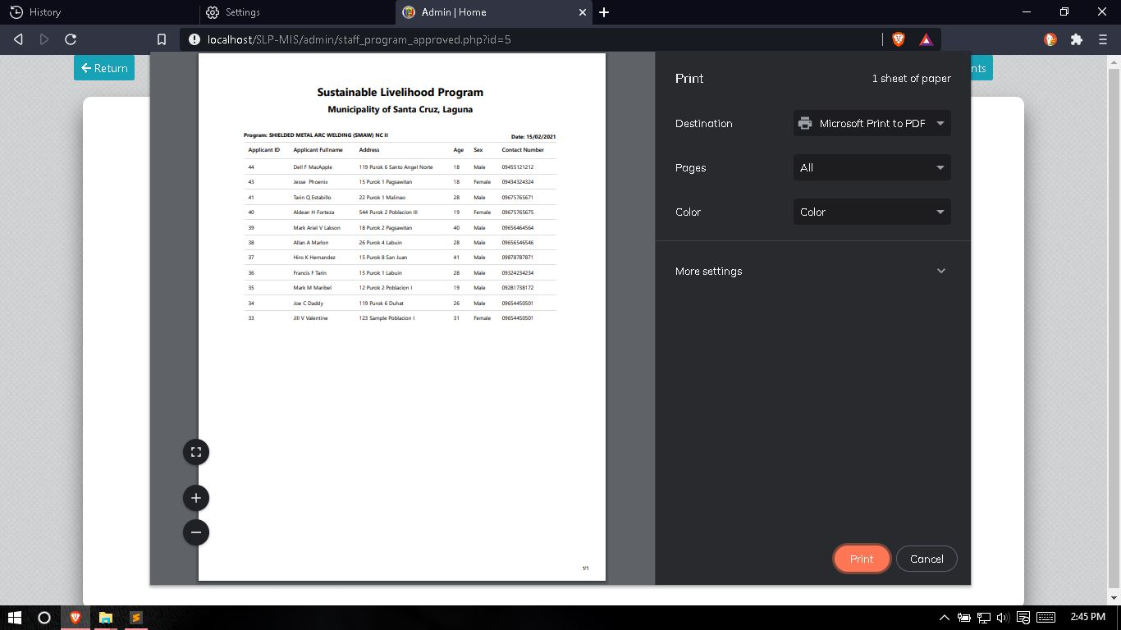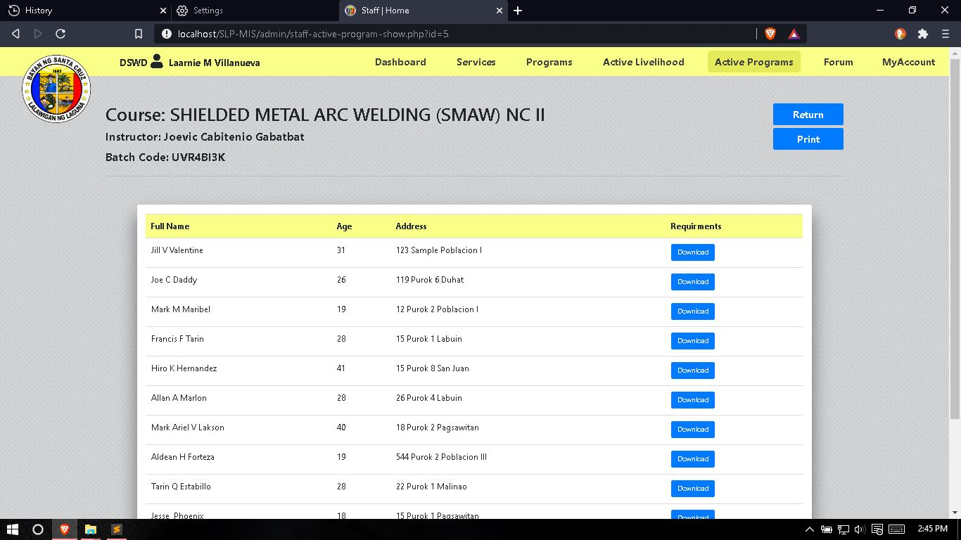  
**Figure 52.** This page shows all the list and information about the approved applicants of the selected TESDA programs, this page also shows the assigned instructor and batch code of the selected TESDA programs.

**Figure 53.** This page shows the report that will be generated on the selected active TESDA program.

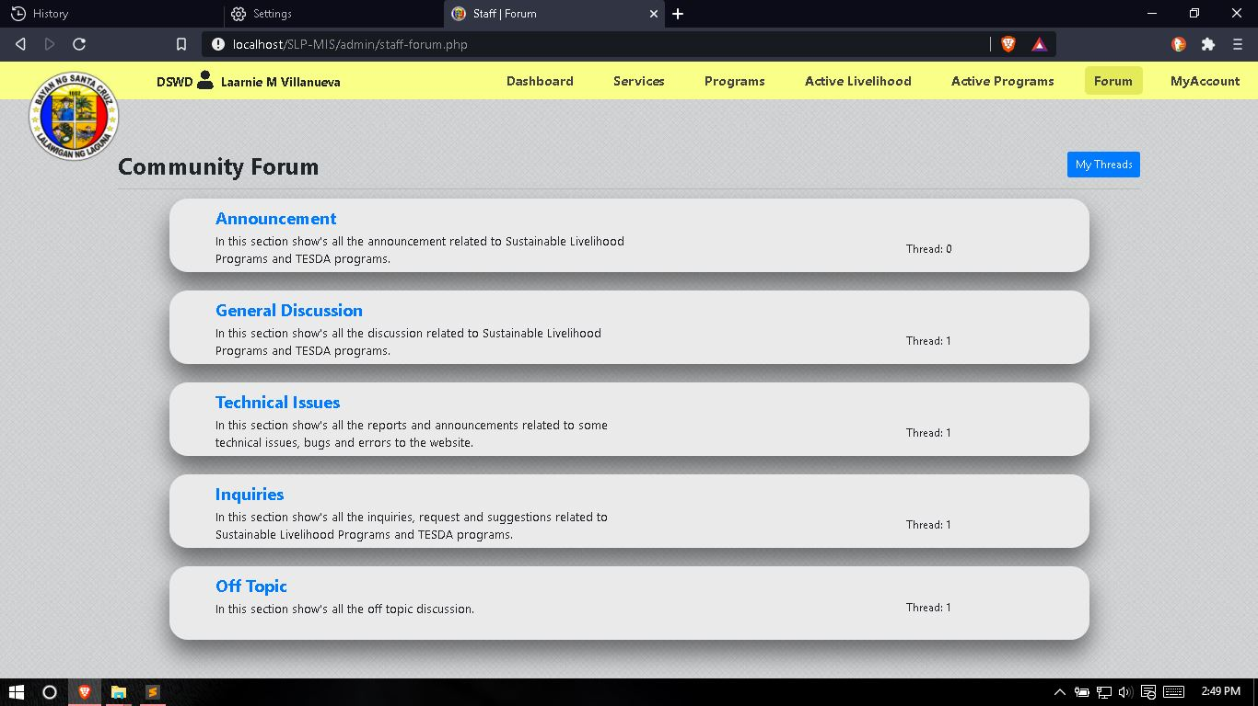

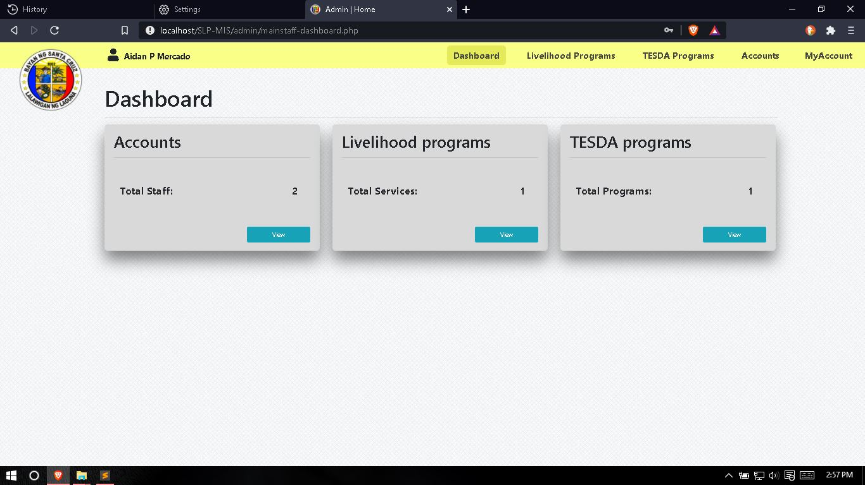**Figure 54.** This page shows the forum for the staff in order for them to view the user’s questions, inquiries, reports and off topic questions. In this page the staff can also post announcements related to the Sustainable Livelihood Programs for the users.

**Figure 55.** This page shows the dashboard for the office head, this page display the total counts of all the staff accounts and active Livelihood and TESDA programs.

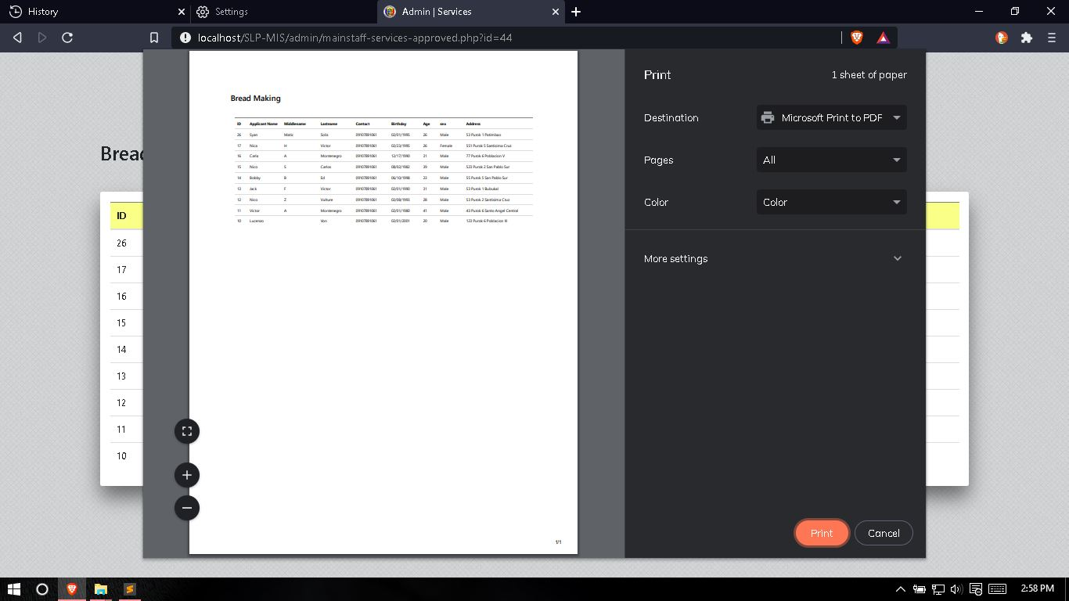

**Figure 56.** This page shows the report that will be generated on the selected active Livelihood program by the office head.

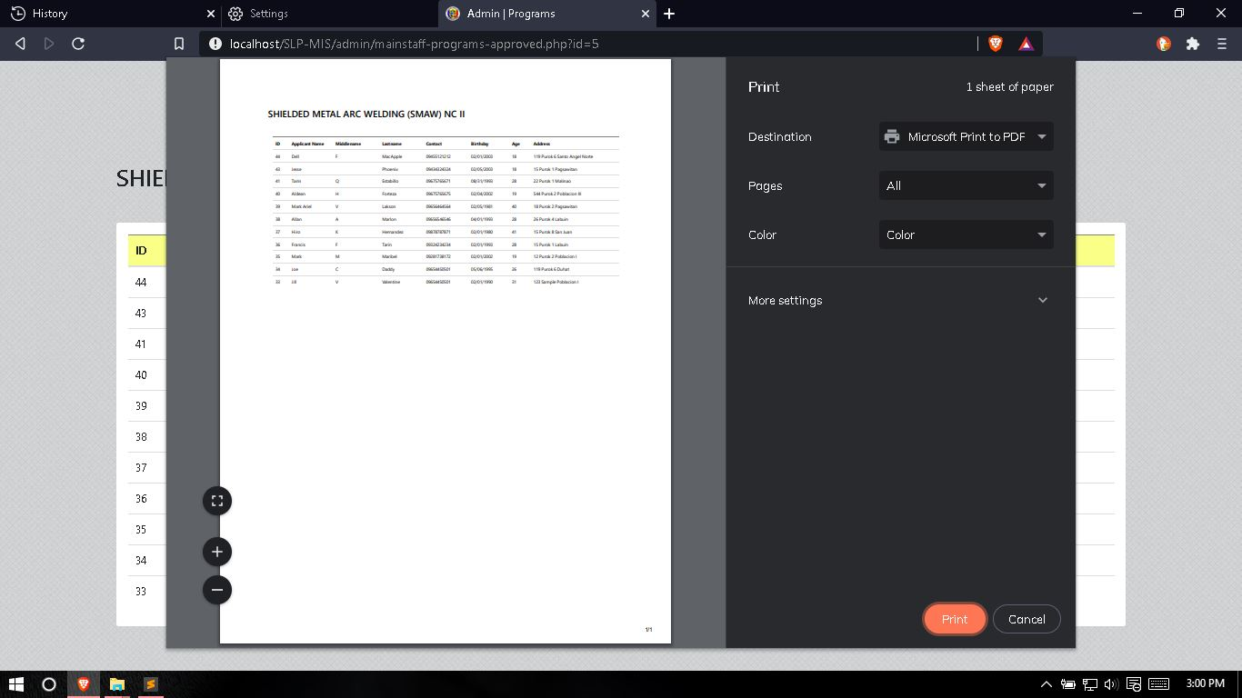

**Figure 57.** This page shows the report that will be generated on the selected active TESDA program by the office head.

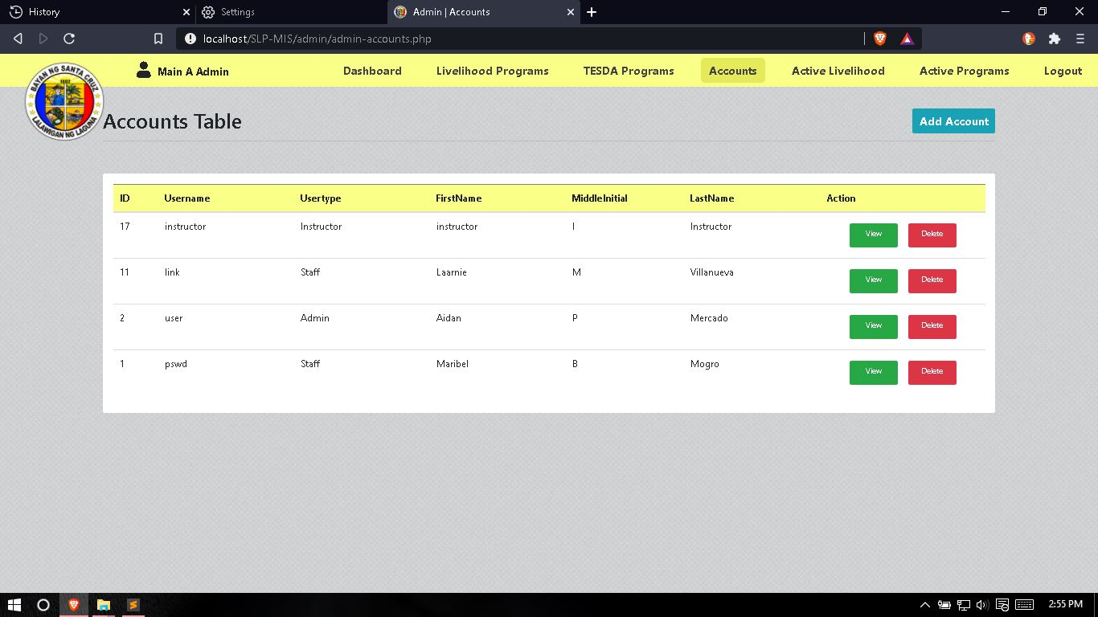

**Figure 58.** This page shows all the accounts of the staff and can add, edit / update or delete by the admin or the office head.

**Testing and Evaluation Instruction**

**TAM QUESTIONNAIRE**

**The College of Computer Studies**

Name: _____________________ Date: _______________

Position: __________________

The researchers are currently developing on their Capstone Project entitled “Sustainable Livelihood Program Management Information System with SMS Notification”. This questionnaire is a part of the researcher’s data collection method. Through your participation the researchers will be able to know the acceptability of their system.

**Direction:** Kindly put CHECK (  ) on the corresponding scale to indicate your level of perception relative to each question.

(5) Strongly Agree (4) Agree (3) Neutral (2) Disagree (1) Strongly Disagree

|  |  |  |  |  |  |  |
| --- | --- | --- | --- | --- | --- | --- |
| 1. **QUALITY FACTORS** | **Source** | **5** | **4** | **3** | **2** | **1** |
| 1. **SUITABILITY.**I agree that the developed system has improved the current process of implementing various projects under the Sustainable Livelihood Program (SLP) | ISO/IEC 9126  (2004) |  |  |  |  |  |
| 1. **OPERABILITY.**I agree that the developed system contains a user friendly and easy to access interface | ISO/IEC 9126  (2004) |  |  |  |  |  |
| 1. **LEARNABILITY.**I agree that the developed system does not require much effort in terms understanding the flow of the system | ISO/IEC 9126  (2004) |  |  |  |  |  |
| 1. **PERCEIVE EASE OF USE** |  | **5** | **4** | **3** | **2** | **1** |
| 1. **FUNCTIONALITY.** The developed system can easily organize and sort the data that have been gathered in various programs | ISO/IEC 9126  (2004) |  |  |  |  |  |
| 1. **ACCURACY.** The developed system can generate accurate progress tracking reports | ISO/IEC 9126  (2004) |  |  |  |  |  |
| 1. **EFFICIENCY.**I agree that the functionalities of the developed system enhance the way of creating various projects under the Sustainable Livelihood Program | ISO/IEC 9126  (2004) |  |  |  |  |  |
| 1. **EXPERIENCE** |  | **5** | **4** | **3** | **2** | **1** |
| 1. **USER ERROR PROTECTION.**I never experience difficulties something like errors or systems failures while using the system | ISO/IEC 25010:2011 |  |  |  |  |  |
| 1. **ACCURACY.**I agree that the developed system can generate accurate reports based on the particular programs | ISO/IEC 9126  (2004) |  |  |  |  |  |
| 1. **EFFICIENCY.**I agree that the developed system will make the work easier to its user | ISO/IEC 9126  (2004) |  |  |  |  |  |
| 1. **PERCEIVED USEFULNESS** |  | **5** | **4** | **3** | **2** | **1** |
| 1. **ACCESSIBILITY.**I agree that the developed system can be used by the user without technical or software knowledge | ISO/IEC 25010:2011 |  |  |  |  |  |
| 1. **FUNCTIONALITY.**I agree that the developed system can send notifications regarding the place and time of the implemented program | ISO/IEC 9126  (2004) |  |  |  |  |  |
| 1. **SUITABILITY.**I agree that the developed system allows the user to easily generate reports regarding the Sustainable Livelihood Program | ISO/IEC 9126  (2004) |  |  |  |  |  |
| 1. **ATTITUDE TOWARDS USING** |  | **5** | **4** | **3** | **2** | **1** |
| 1. **TIME BEHAVIOUR.** The developed system will help the user to save time and effort in terms of getting the needed information in implementing various projects under the Sustainable Livelihood Program | ISO/IEC 25010:2011 |  |  |  |  |  |
| 1. **TRUST.**I agree that the developed system will be helpful to the participants and also the staff in charge which handles the implementation of the program | Urban, Sultan, and Qualls (2000) |  |  |  |  |  |
| 1. **EFFICIENCY.**I agree that the developed system is effective and efficient in terms of implementing various projects under the Sustainable Livelihood Program | ISO/IEC 9126  (2004) |  |  |  |  |  |
| 1. **BEHAVIORAL INTENTION TO USE** |  | **5** | **4** | **3** | **2** | **1** |
| 1. **CONFIDENTIALITY.**I agree that the developed system is reliable in terms security and getting the overall result of the implemented program | ISO/IEC 25010:2011 |  |  |  |  |  |
| 1. **ACCURACY.**I agree that the developed system functionalities were accurate to its expected respond | ISO/IEC 9126  (2004) |  |  |  |  |  |
| 1. **FUNCTIONAL APPROPRIATENESS.**I agree that the study satisfies the user in terms of the overall flow of the system | ISO 9241- 110 |  |  |  |  |  |
| 1. **ACTUAL USE** |  | **5** | **4** | **3** | **2** | **1** |
| 1. **FUCNTIONALITY.** The developed system is very useful in terms implementing various projects under the Sustainable Livelihood Program | ISO/IEC 9126  (2004) |  |  |  |  |  |
| 1. **ACCESIBILITY.**I agree that I can operate the system properly and efficiently | ISO/IEC 25010:2011 |  |  |  |  |  |
| 1. **INTEROPERABILITY.** The developed system satisfies and meet the user’s expectation with the system | ISO/IEC 9126  (2004) |  |  |  |  |  |

**Feel free to write a comment if you have any suggestions at the back**

Validated by:  
 Dr. Mia V. Villarica, DIT  
 Research Adviser Signature

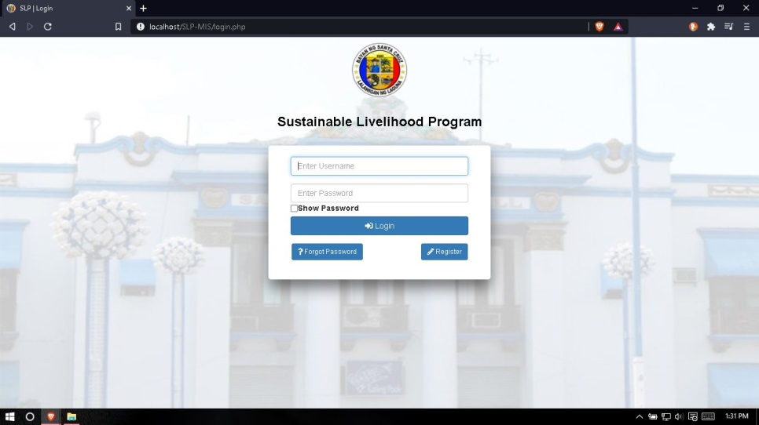**Users’ Manual**

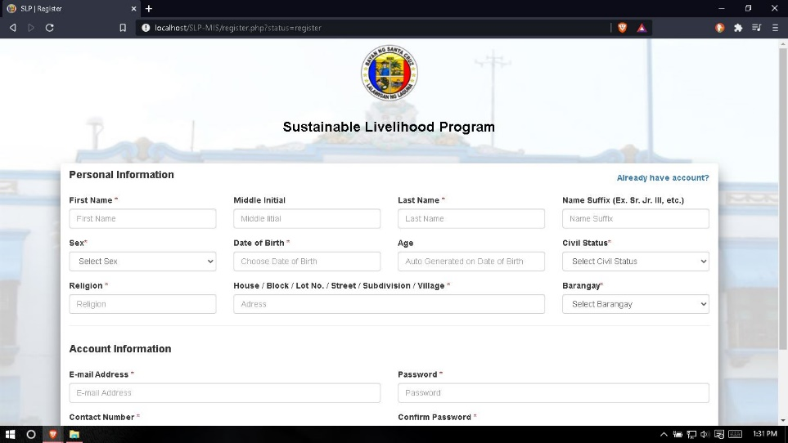**Figure 59.** In this login page, the user needs to input their email and password. If the user don’t have an account, they can register by clicking the register button and they will redirect to register page, but if the user already have an account but he/she forgot the password of their account, they can retrieve it by clicking the forgot password button and they will redirect to the page where they can retrieve their password.

**Figure 60.** In this registration page, user needs to fill-up all the page in order to create new account and login into the system.

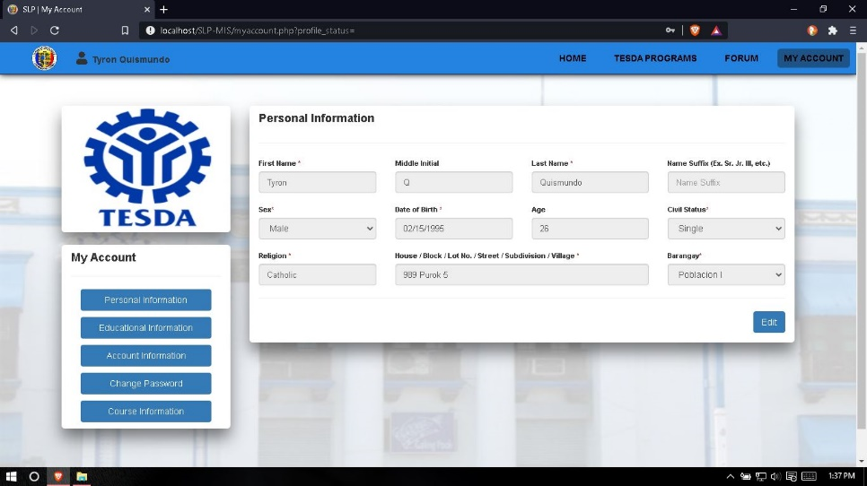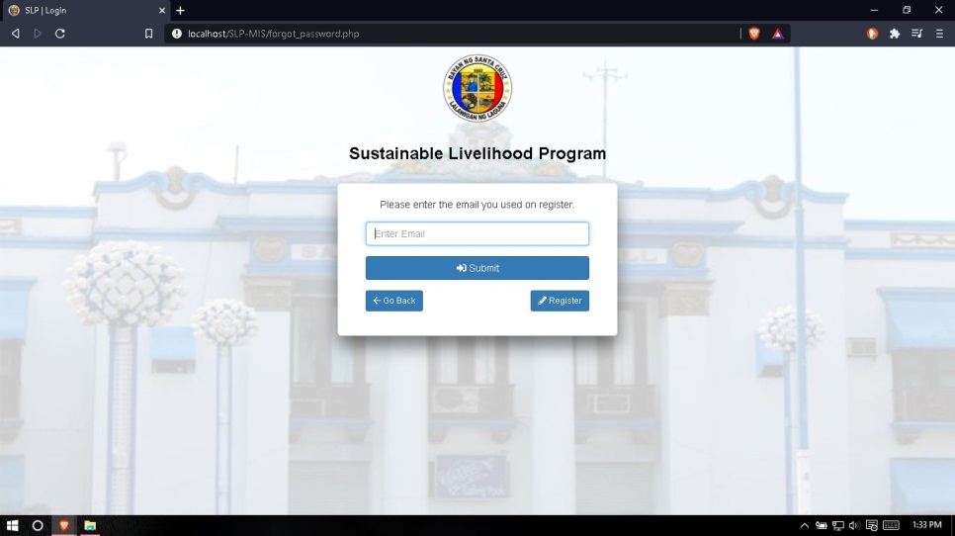 **Figure 61.** In this forgot password page, user need to input the email that he/she used on registration and they will receive an email notification about the retrieval of their password.

**Figure 62.** In this profile page, user can view their own personal information, educational information and account information and they can edit it also by clicking the edit button. They can also change their password in this page by clicking the change password button and input the old password for security and input their desire new password.

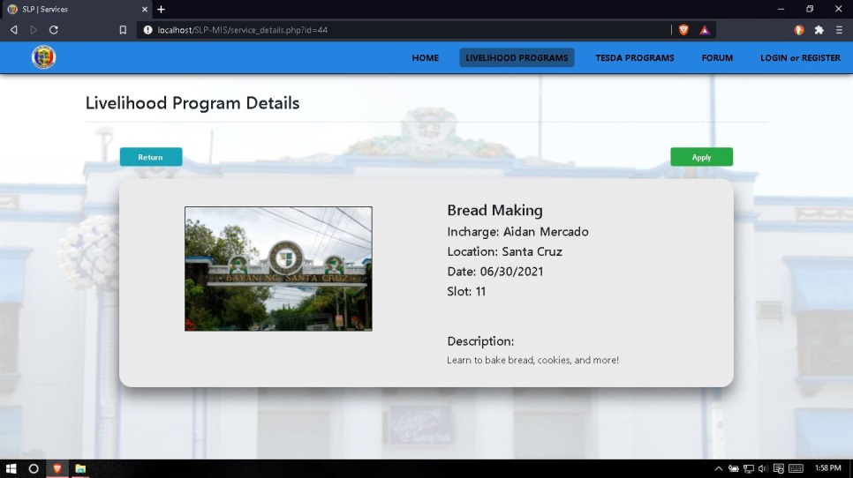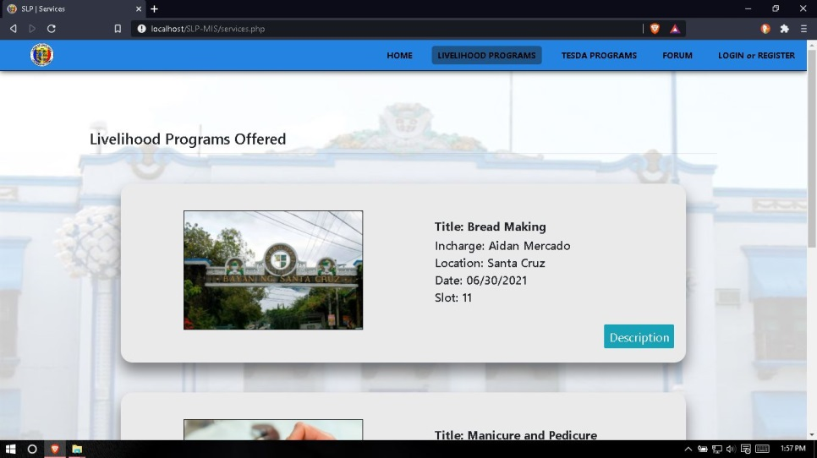**Figure 63.** In this Livelihood Program page, user can select their desire Livelihood Program that they want and they can also view its full information by clicking the description button.

**Figure 64.** In this Livelihood Program details page, the user can view the full information and description of the selected Livelihood program and can apply on it by clicking the apply button and fill-up all the necessary field in order to complete the application and save it for the staff for verification and the user will receive a SMS notification if his/her application is approved.

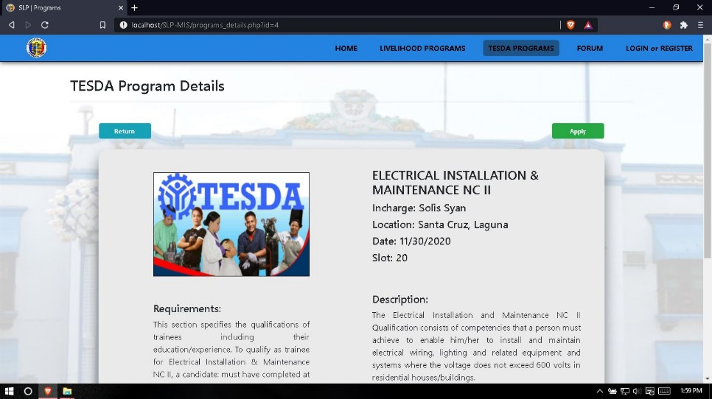 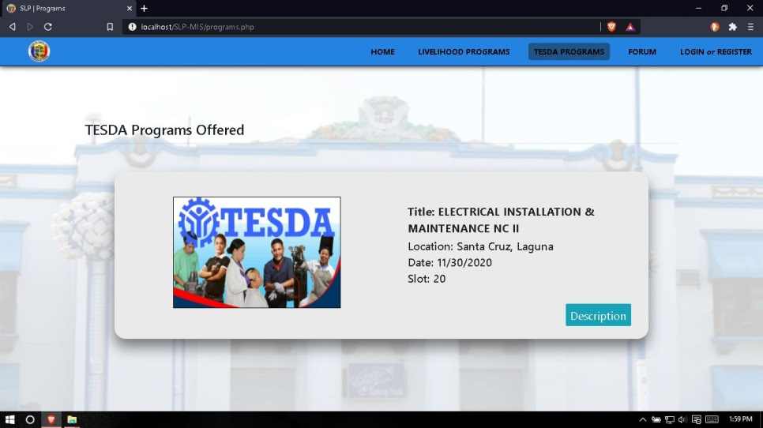**Figure 65.** In the TESDA program page, the user can view all the available TESDA   
program and can view its full information and description by clicking the description button.

**Figure 66.** In this TESDA Program details page, the user can view the full information and description of the selected TESDA Program, the user can also view the requirements needed in order to apply for it. The user can apply on selected TESDA Program by clicking the apply button, the system will ask the user if he/she wants to apply on it and if the user click yes then the application will be sent to the staff for verification and will wait for the uploading of the requirements in his profile page.

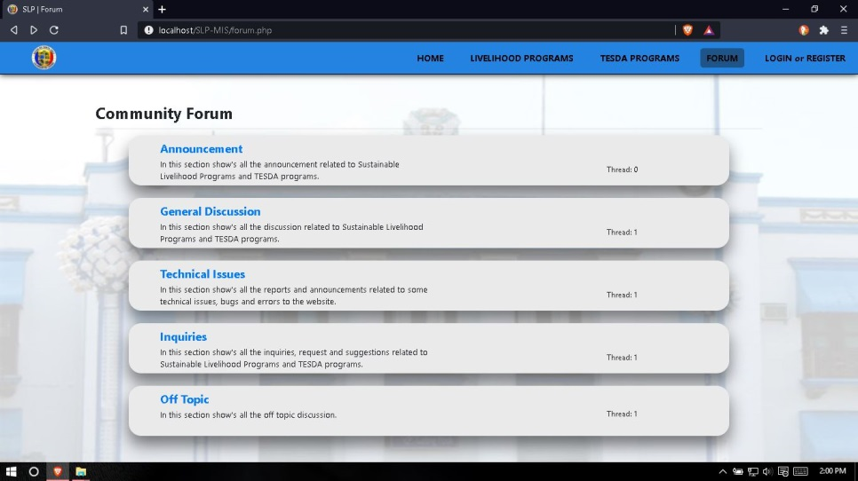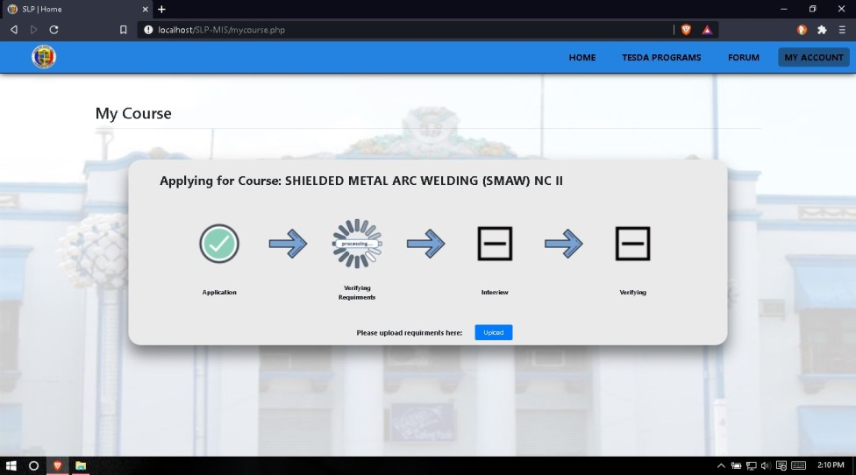**Figure 67.** In this page show the progress of the user’s application, the user will upload the needed requirements in a single file format by clicking the upload button.

**Figure 68.** In this page show the forum of the system, user can view all announcement post and can also post new thread or reply on the selected thread, this page is for community to gain information related to Sustainable Livelihood Program.

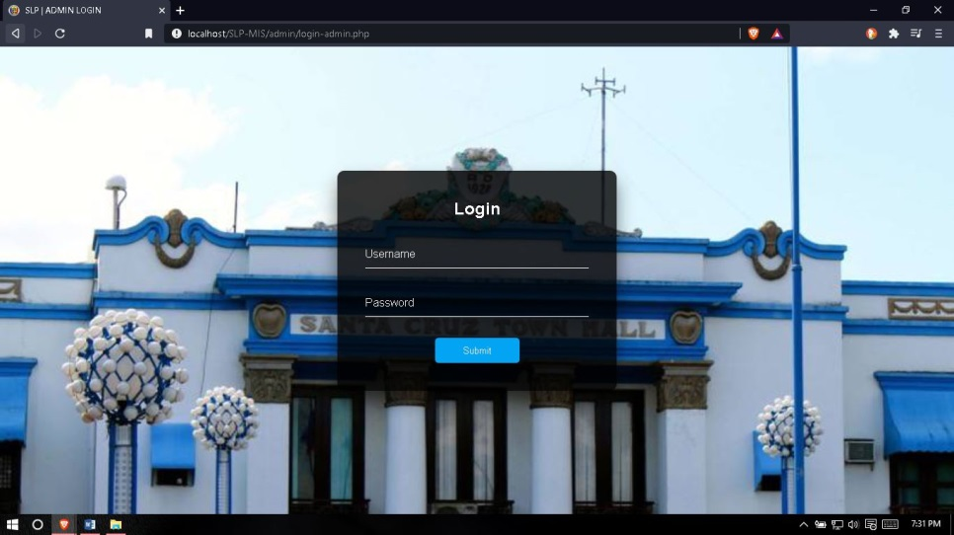

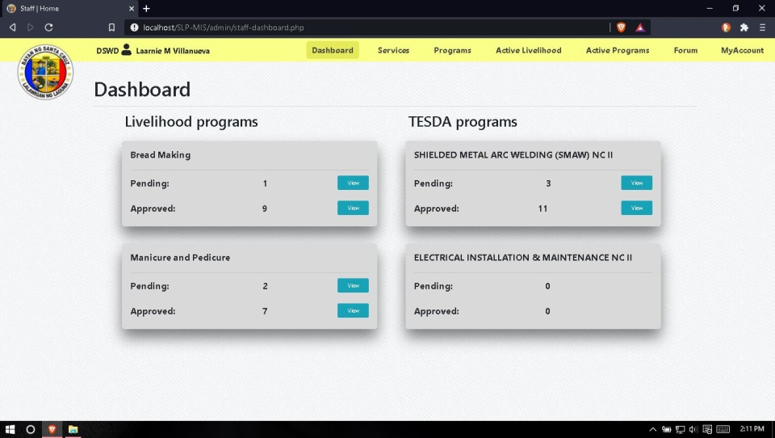**Figure 69.** This page shows the login page for admin, staff, office head and instructors.

**Figure 70.** Staff dashboard shows the ongoing Livelihood and TESDA programs, this page also shows the total counts of pending and approved applicants of each Livelihood and TESDA programs.

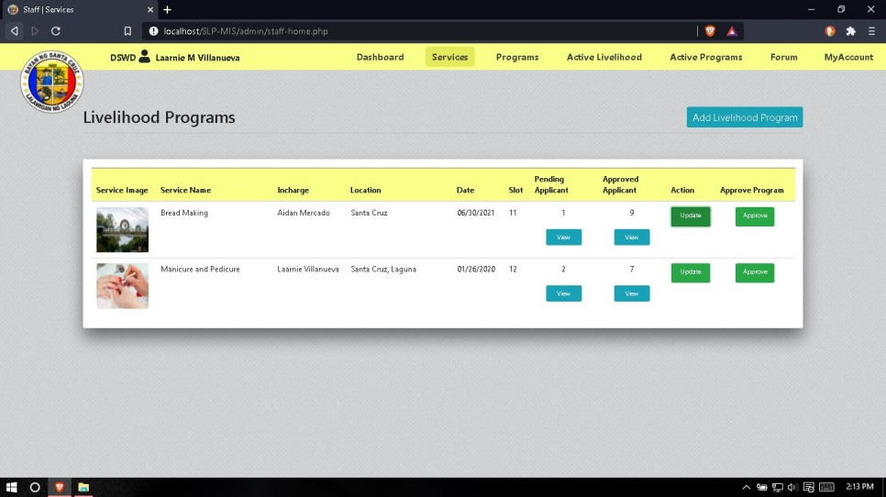

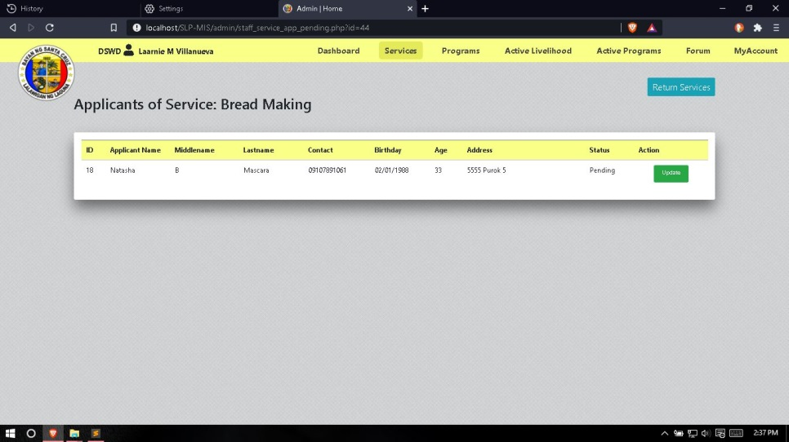**Figure 71.** In this page shows the list of all ongoing Livelihood programs and total counts of each pending and approved applicants. Staff or Admin can also add and edit / update selected Livelihood programs and view pending and approved application list.

**Figure 72.** This page shows the pending applicants of selected Livelihood program, here the staff or admin can view the applicant’s information and approved the application.

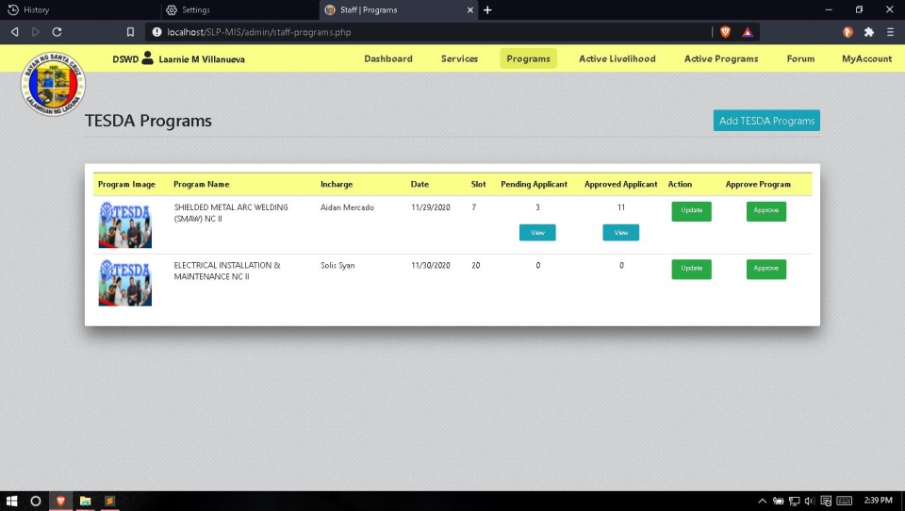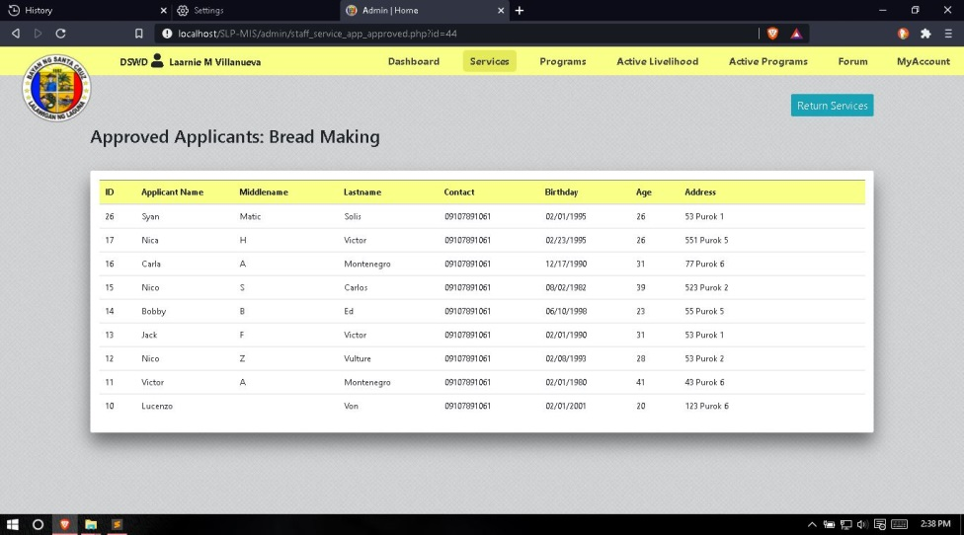**Figure 73.** This page shows the approved list of the selected Livelihood program.

**Figure 74.** In this page shows the list of all ongoing TESDA programs and total counts of each pending and approved applicants. Staff or Admin can also add and edit / update selected TESDA programs and view pending and approved application list.

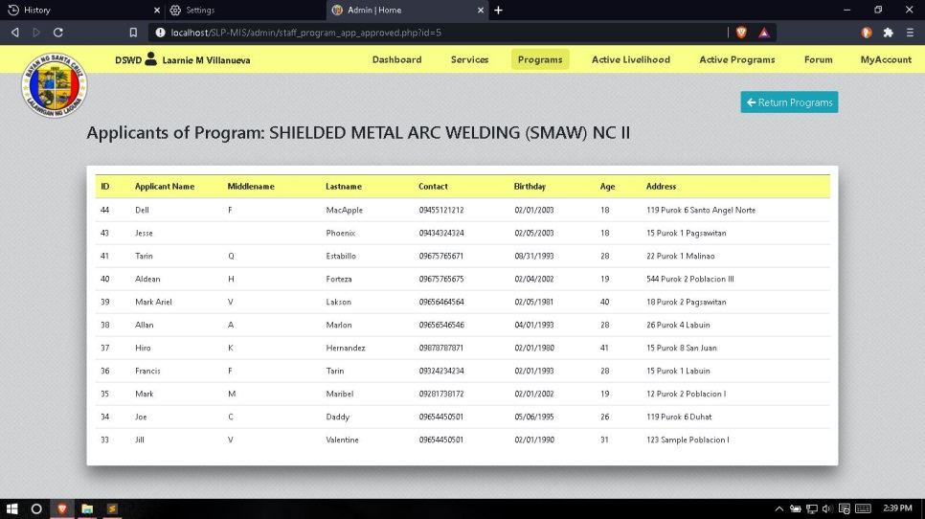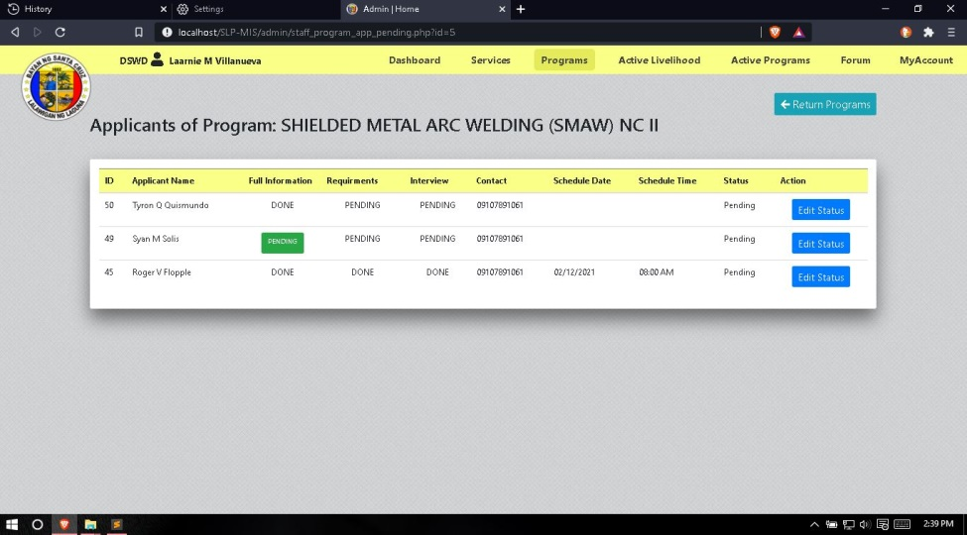**Figure 75.** This page shows the pending applicants of selected TESDA program, here the staff or admin can view the applicant’s information, download applicant’s requirements and set schedule for interview before approving the applicant’s application.

**Figure 76.** This page shows the approved list of the selected TESDA program.

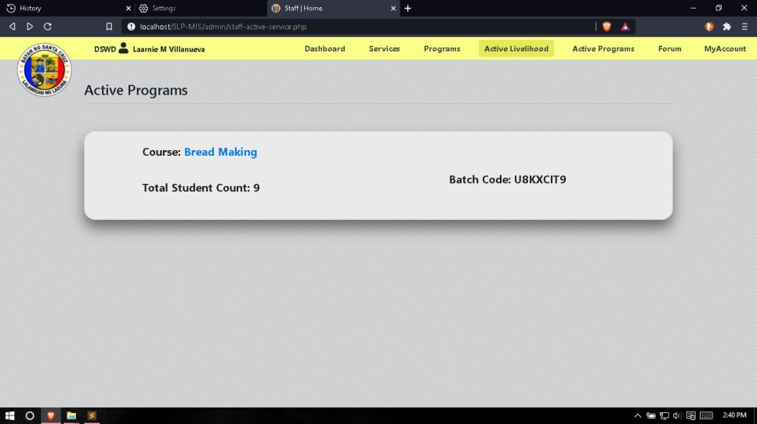**Figure 77.** This page shows the total list of active Livelihood programs alongside is 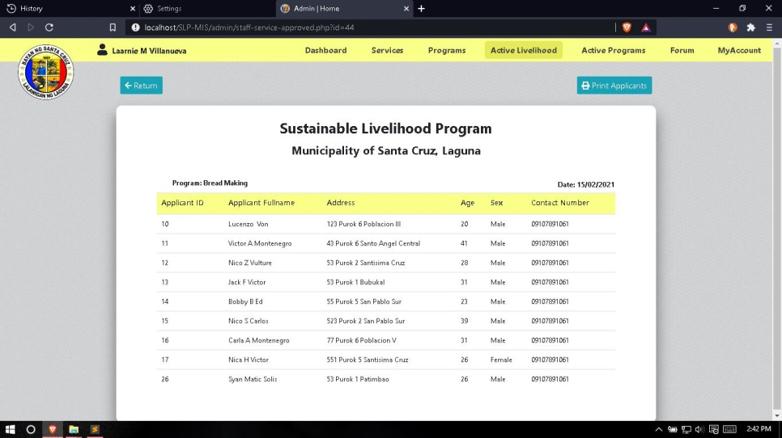the total student count and assign batch code.

**Figure 78.** This page shows the total list of all approved applicants of selected active Livelihood Program, this page will show first before generating report.

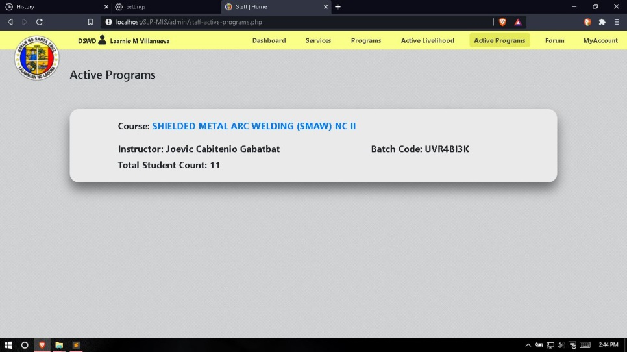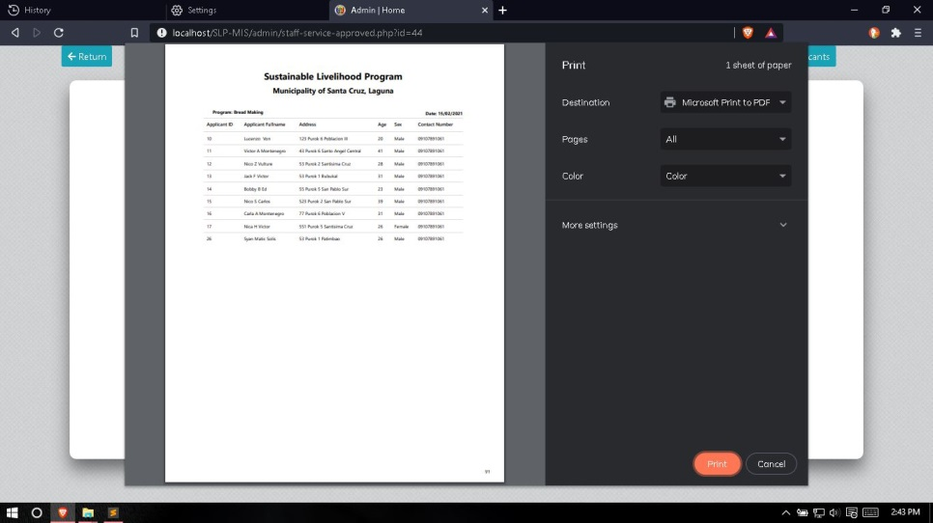**Figure 79.** This page will view the report that will be generated based on the selected Livelihood program.

**Figure 80.** This page shows the total list of active TESDA programs alongside is the assigned instructor, total student count and assign batch code.

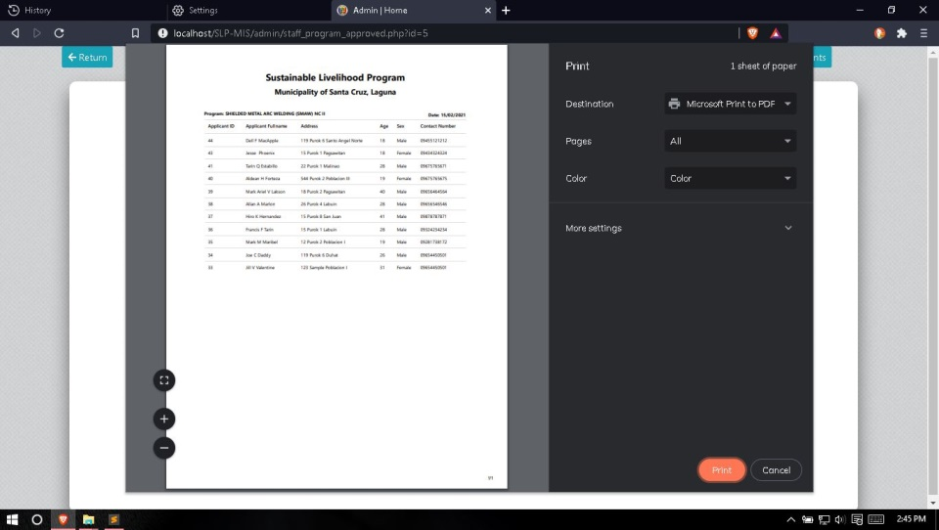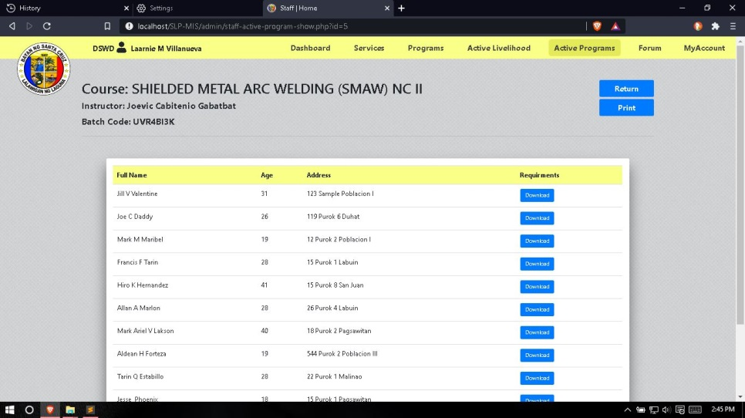 **Figure 81.** This page shows the total list of all approved applicants of selected active TESDA Program, this page can also be the retrieval of the applicant’s requirements and will show first before generating report.

**Figure 82.** This page will view the report that will be generated based on the selected TESDA program.

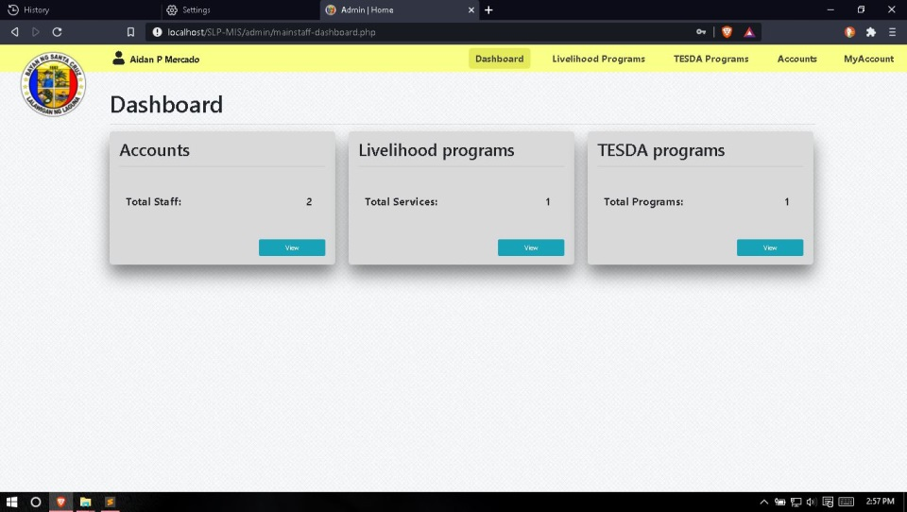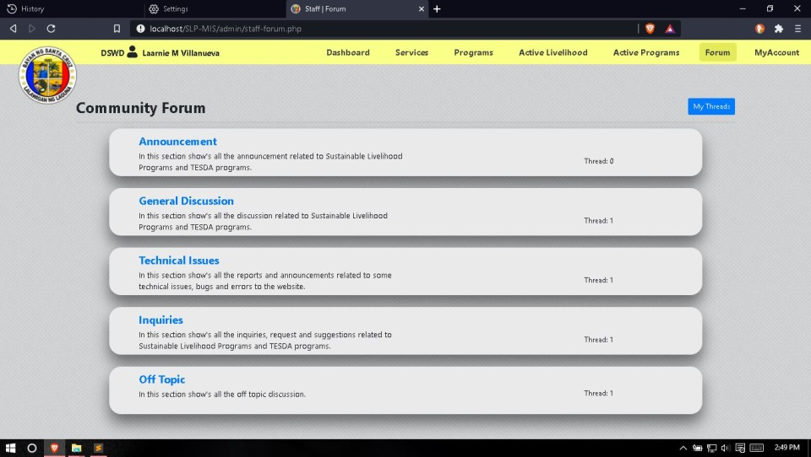**Figure 83.** In this page show the forum of the system, staff or admin can view all announcement post and can also post new thread or reply on the selected thread, this page is for community to gain information related to Sustainable Livelihood Program.

**Figure 84.** Office head dashboard shows the total count of staff accounts and ongoing Livelihood and TESDA programs.

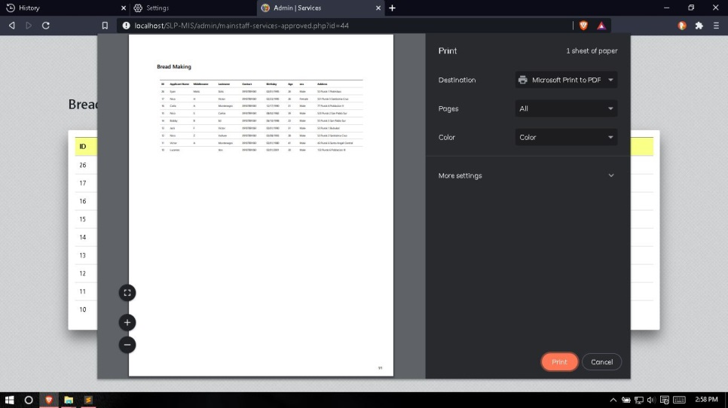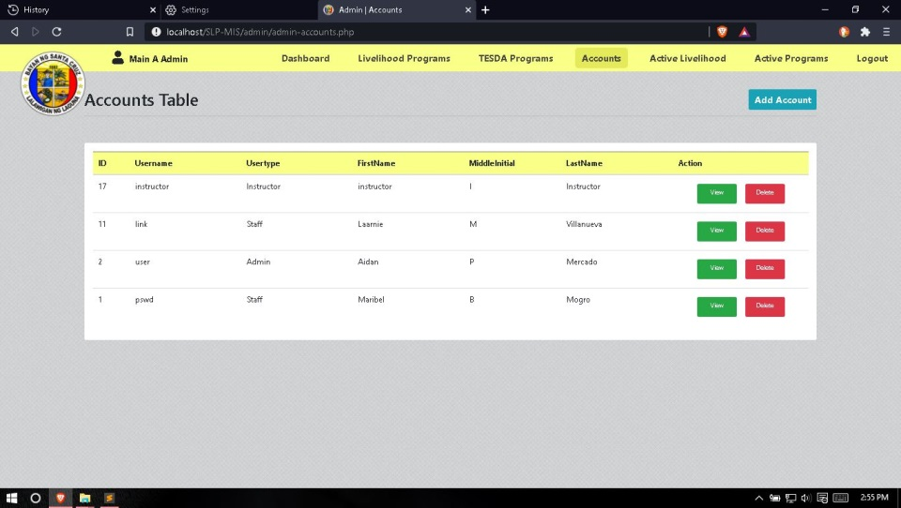**Figure 85.** This page show the table for staff accounts, here the office head can add, edit / update or delete accounts for staff.

**Figure 86.** This page will view the report that will be generated based on the selected Livelihood program of the office head.

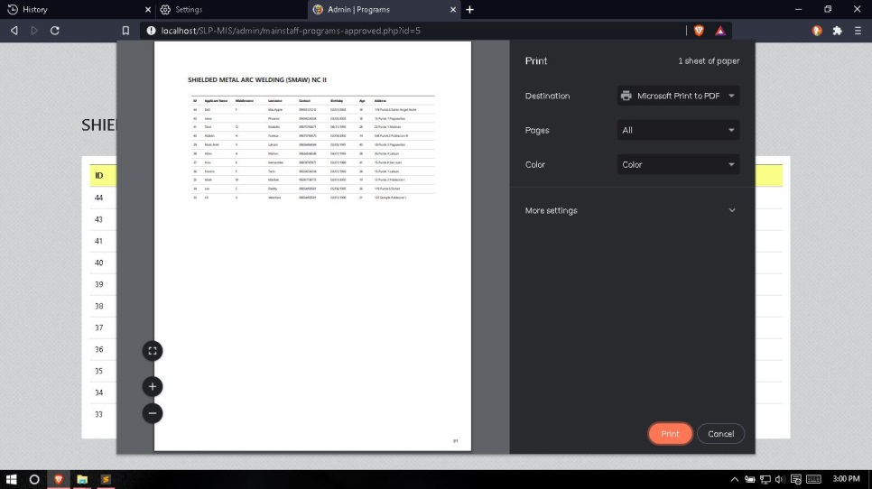

**Figure 87.** This page will view the report that will be generated based on the selected TESDA program of the office head.

**Source Code**

<?php

$id = (int) $_SESSION['id'];

if (isset($_POST['save_edit_personal'])) {

$first_name = $_POST['first_name'];

$middle_name = $_POST['middle_name'];

$last_name = $_POST['last_name'];

$name_suffix = $_POST['name_suffix'];

$sex = $_POST['sex'];

$dob = $_POST['dob'];

$age = $_POST['age'];

$civil = $_POST['civil'];

$religion = $_POST['religion'];

$address = $_POST['address'];

$barangay = $_POST['barangay'];

$update_personal = "UPDATE client SET name = '$first_name', middlename = '$middle_name', lastname = '$last_name', suffix = '$name_suffix', gender = '$sex', birthday = '$dob', age = '$age', civil_status = '$civil', religion = '$religion', address = '$address', barangay = '$barangay' WHERE client_id = '$id'";

$run_save_edit_personal = mysqli_query($conn, $update_personal);

if ($run_save_edit_personal) {

echo "<script>window.location = 'myaccount.php?profile_status=personal_info_update_success';</script>;";

}

else

{

echo "<script>window.location = 'myaccount.php?profile_status=personal_info_update_failed';</script>;";

}

}

if (isset($_POST['save_edit_education'])) {

$educ_primary = $_POST['educ_primary'];

$educ_primary_address = $_POST['educ_primary_address'];

$educ_primary_year = $_POST['educ_primary_year'];

$educ_secondary = $_POST['educ_secondary'];

$educ_secondary_address = $_POST['educ_secondary_address'];

$educ_secondary_year = $_POST['educ_secondary_year'];

$collage = $_POST['collage'];

$collage_address = $_POST['collage_address'];

$collage_date = $_POST['collage_date'];

$collage_degree = $_POST['collage_degree'];

$update_educ = "UPDATE client SET educational_primary = '$educ_primary', primary_address = '$educ_primary_address', primary_date = '$educ_primary_year', educational_secondary = '$educ_secondary', secondary_address = '$educ_secondary_address', secondary_date = '$educ_secondary_year', collage = '$collage', collage_address = '$collage_address', collage_date = '$collage_date', collage_degree = '$collage_degree', status = 'COMPLETE' WHERE client_id = '$id'";

$run_save_edit_educ = mysqli_query($conn, $update_educ);

if ($run_save_edit_educ) {

echo "<script>window.location = 'myaccount.php?profile_status=educ_info_update_success';</script>;";

}

else

{

echo "<script>window.location = 'myaccount.php?profile_status=educ_info_update_failed';</script>;";

}

}

if (isset($_POST['save_edit_account'])) {

$email = $_POST['email'];

$contact = $_POST['contact'];

$edit_account = mysqli_query ($conn, "SELECT * FROM client WHERE client_id = '$id' AND email = '$email' AND contact = '$contact' ") or die (mysqli_error());

$fetch_edit = mysqli_fetch_array ($edit_account);

if ($fetch_edit > 0) {

echo "<script>window.location = 'myaccount.php?profile_status=account_update_failed';</script>;";

}

else

{

$update_account = "UPDATE client SET email = '$email' , contact = '$contact' WHERE client_id = '$id'";

$run_update_account = mysqli_query($conn, $update_account);

if ($run_update_account) {

echo "<script>window.location = 'myaccount.php?profile_status=account_update_success';</script>;";

}

else

{

echo "<script>window.location = 'myaccount.php?profile_status=account_update_failed';</script>;";

}

}

}

if (isset($_POST['change_user_password'])) {

$old_pass = $_POST['old_pass'];

$new_pass = $_POST['new_password'];

$confirm_new_password = $_POST['confirm_new_password'];

$dec_old_pass = md5($old_pass);

$edit_password = mysqli_query ($conn, "SELECT * FROM client WHERE client_id = '$id' AND password = '$dec_old_pass' ") or die (mysqli_error());

$fetch_password = mysqli_fetch_array ($edit_password);

if ($fetch_password) {

if ($new_pass == $confirm_new_password) {

$updated_password = md5($new_pass);

$update_pass = "UPDATE client SET password = '$updated_password' WHERE client_id = '$id'";

$run_update_pass = mysqli_query($conn, $update_pass);

if ($run_update_pass == true) {

$update_pass_tbl = "UPDATE pass_tbl SET password = '$new_pass' WHERE client_id = '$id'";

$run_update_pass_tbl = mysqli_query($conn, $update_pass_tbl);

if ($run_update_pass_tbl == true) {

echo "<script>window.location = 'myaccount.php?profile_status=change_password_success';</script>;";

}

}

else

{

echo "<script>window.location = 'myaccount.php?profile_status=change_password_failed';</script>;";

}

}

else

{

echo "<script>window.location = 'myaccount.php?profile_status=change_password_failed';</script>;";

}

}

else

{

echo "<script>window.location = 'myaccount.php?profile_status=change_password_failed';</script>;";

}

}

?>

<script type="text/javascript">

var min = new Date().getFullYear(),

max = min - 50,

select = document.getElementById('educ_primary_year');

for (var i = min; i>=max; i--){

var opt = document.createElement('option');

opt.value = i;

opt.innerHTML = i;

select.appendChild(opt);

}

</script>

<script type="text/javascript">

var min = new Date().getFullYear(),

max = min - 50,

select = document.getElementById('educ_secondary_year');

for (var i = min; i>=max; i--){

var opt = document.createElement('option');

opt.value = i;

opt.innerHTML = i;

select.appendChild(opt);

}

</script>

<script type="text/javascript">

var min = new Date().getFullYear(),

max = min - 50,

select = document.getElementById('collage_date');

for (var i = min; i>=max; i--){

var opt = document.createElement('option');

opt.value = i;

opt.innerHTML = i;

select.appendChild(opt);

}

</script>

<script type="text/javascript">

$('#new_password, #confirm_new_password').on('keyup', function () {

if ($('#new_password').val() != "" && $('#new_password').val() != $('#confirm_new_password').val())

{

re = /[0-9]/;

if (!re.test($('#new_password').val())) {

$('#alert_box1').prop('hidden', false);

}

else

{

$('#alert_box1').prop('hidden', true);

}

if ($('#new_password').val() != $('#confirm_new_password').val()) {

$('#alert_box2').prop('hidden', false);

}

else

{

$('#alert_box2').prop('hidden', true);

}

}

else

{

$('#alert_box1').prop('hidden', true);

$('#alert_box2').prop('hidden', true);

}

});

</script>

<!-- View Personal Information -->

<script type="text/javascript">

$(document).ready(function() {

$('#perso_info').on('click', function() {

$('#password_change').prop('hidden', true);

$('#acc_info').prop('hidden', true);

$('#education_info').prop('hidden', true);

$('#personal_info').prop('hidden', false);

})

});

</script>

<!-- View Educational Information -->

<script type="text/javascript">

$(document).ready(function() {

$('#educ_info').on('click', function() {

$('#password_change').prop('hidden', true);

$('#acc_info').prop('hidden', true);

$('#personal_info').prop('hidden', true);

$('#education_info').prop('hidden', false);

})

});

</script>

<!-- View Account Information -->

<script type="text/javascript">

$(document).ready(function() {

$('#account_info').on('click', function() {

$('#password_change').prop('hidden', true);

$('#personal_info').prop('hidden', true);

$('#education_info').prop('hidden', true);

$('#acc_info').prop('hidden', false);

})

});

</script>

<!-- View Change Password -->

<script type="text/javascript">

$(document).ready(function() {

$('#change_pass').on('click', function() {

$('#personal_info').prop('hidden', true);

$('#education_info').prop('hidden', true);

$('#acc_info').prop('hidden', true);

$('#password_change').prop('hidden', false);

})

});

</script>

<script>

function isNumberKey(evt){

var charCode = (evt.which) ? evt.which : event.keyCode

return !(charCode > 31 && (charCode < 48 || charCode > 57));

}

</script>

<script>

/* When the user clicks on the button,

toggle between hiding and showing the dropdown content */

function myFunction() {

document.getElementById("myDropdown").classList.toggle("show");

}

// Close the dropdown if the user clicks outside of it

window.onclick = function(event) {

if (!event.target.matches('.dropbtn')) {

var dropdowns = document.getElementsByClassName("dropdown-content");

var i;

for (i = 0; i < dropdowns.length; i++) {

var openDropdown = dropdowns[i];

if (openDropdown.classList.contains('show')) {

openDropdown.classList.remove('show');

}

}

}

}

</script>

**APPENDIX B**

**Request Letters**

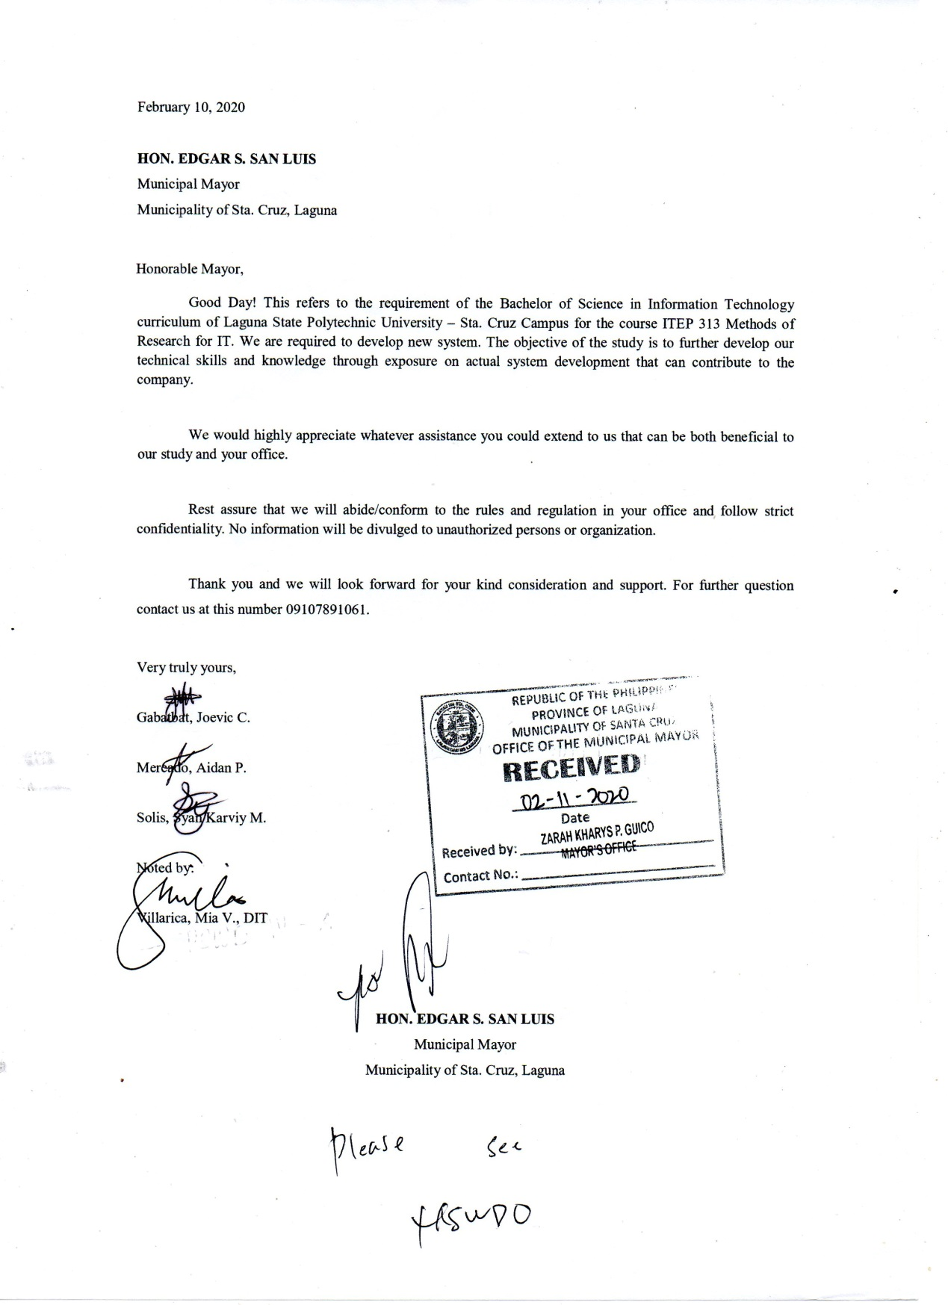

**Preposal Approval**



**Recommendation for FOD**

****Republic of the Philippines

Laguna State Polytechnic University

Province of Laguna

**COLLEGE OF COMPUTER STUDIES**

SUSTAINABLE LIVELIHOOD PROGRAM MANAGEMENT INFORMATION SYSTEM WITH SMS NOTIFICATION

Summary of Recommendations:

|  |  |
| --- | --- |
| **Panelist** | **Recommendations** |
| Mrs. Reynalen C. Justo, MM-ITM | * Crystal report |
| Mr. Mark Bernardino | * DSWD input system * Qualification on system * Staff approval * DMS input * Types of applicants * Community fill-up |
| Mrs. Ma. Laureen Miranda | * Birthday auto compute * Year graduate dropdown * Specific for application * SMS notification |
| Mrs. Alliana Miranda - Ablan | * Margin * Page number * Tech gap analysis * Improve conceptual framework * Scope of the study * Chapter 2 must be next page * Arrange by themes on rrl * Explain how each rrl is connected to the study * Page 9 no year * Avoid using "according to" * Rrl must be done again * Page 18 onwards, no copy pasted and year * Page 30 title must be in sentence case * No synthesis * Chapter 3 no title * Have a short introduction about chapter 3 * Research design is descriptive developmental * Table format in population of the study * How to encourage respondents to use the system * No bibliography |

Submitted by:

Gabatbat, Joevic C.

Mercado, Aidan P.

Solis, Syan Karviy M.

**APPENDIX C**

**JOEVIC CABITENIO GABATBAT  
BACHELOR OF SCIENCE IN INFORMATION TECHNOLOGY**

**EDUCATIONAL BACKGROUND**

* **PRIMARY EDUCATION**

Bagumbayan Elementary School

2007 – 2008

* **SECONDARY EDUCATION**

Felicisimo T. San Luis National High School

2013 – 2014

* **Vocational**

Electrical Installation & Maintenance (NCII)

KCD Technical Institute

2015

* **TERTIARY EDUCATION**

Laguna State Polytechnic University SCC

2017-2020

**OBJECTIVE**To enhance my skill and knowledge in a modernized environment and make contributions to the success of the company.

**ADDRESS**119 Brgy. Cigaras Magdalena, Laguna

**CONTACT**09654450501

**EMAIL**[joe00685@gmail.com](mailto:joe00685@gmail.com)

**DATE OF BIRTH**May 06, 1995

**AGE**25

**GENDER**Male

**CIVIL STATUS**Single

**CITIZENSHIP**Filipino

**SKILLS:**

* Computer literate( such as MS Word, and MS PowerPoint)
* Adobe Photoshop
* Adobe Premier
* Programming (PHP, JavaScript)

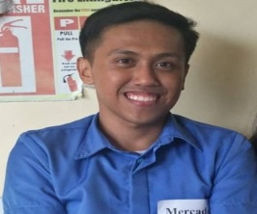**AIDAN PAUCO MERCADO  
BACHELOR OF SCIENCE IN INFORMATION TECHNOLOGY**

**EDUCATIONAL BACKGROUND**

* **PRIMARY EDUCATION**

Bagumbayan Elementary School

2005-2010

* **SECONDARY EDUCATION**

Felicisimo T. San Luis National High School

2011-2014

* **TERTIARY EDUCATION**

Laguna State Polytechnic University SCC

2017-2020

**OBJECTIVE**To enhance my skill and knowledge in a modernized environment and make contributions to the success of the company.

**ADDRESS**Sitio 5 Barangay Bagumbayan Sta. Cruz, Laguna

**CONTACT**09218329183

**EMAIL**[aidanmercado227@gmail.com](mailto:aidanmercado227@gmail.com)

**DATE OF BIRTH**January 21, 1998

**AGE**23

**GENDER**Male

**CIVIL STATUS**Single

**CITIZENSHIP**Filipino

**SKILLS:**

* Computer literate( such as MS Word, and MS PowerPoint)
* Adobe Photoshop
* Programming (PHP)

**REFERENCES:**HON. NORMAN G. MERCADO MIA V. VILLARICA, DIT  
Barangay Captain - 09460718605 Thesis Adviser - 09175039034  
Bagumbayan Sta. Cruz, Laguna LSPU Sta. Cruz Campus

**WORK EXPERIENCE**

* **MACHINE OPERATOR**

TIWI production Calios, Laguna

March 2015 to January 2016

**SYAN KARVIY M. SOLIS   
BACHELOR OF SCIENCE IN INFORMATION TECHNOLOGY**

**EDUCATIONAL BACKGROUND**

* **PRIMARY EDUCATION**

Majayjay Elementary School

2005-2010

* **SECONDARY EDUCATION**

Pedro Guevara Memorial National High School

2011-2014

* **TERTIARY EDUCATION**

Laguna State Polytechnic University SCC

2017-2020

**OBJECTIVE**To enhance my skill and knowledge in a modernized environment and make contributions to the success of the company.

**SKILLS:**

* Computer literate( such as MS Word, and MS PowerPoint)
* Adobe Photoshop
* System Analyst

**ADDRESS**P.Zamora St. Barangay San Miguel. Majayjay,Laguna

**CONTACT**09107891061

**EMAIL**[Mnbvcz717@gmail.com](mailto:Mnbvcz717@gmail.com)

**DATE OF BIRTH**October 24, 1997

**AGE**23

**GENDER**Male

**CIVIL STATUS**Single

**CITIZENSHIP**Filipino